**Practical 01 : Setting Up A Cloud Environment**

**Step 01 :** Go To **AWS Canvas** > **Modules** Section > Find **Sandbox** And Click On The "**Start Lab**" Button. Then, Wait For The "**Start Lab**" Box To Appear.

**Snapshot :**

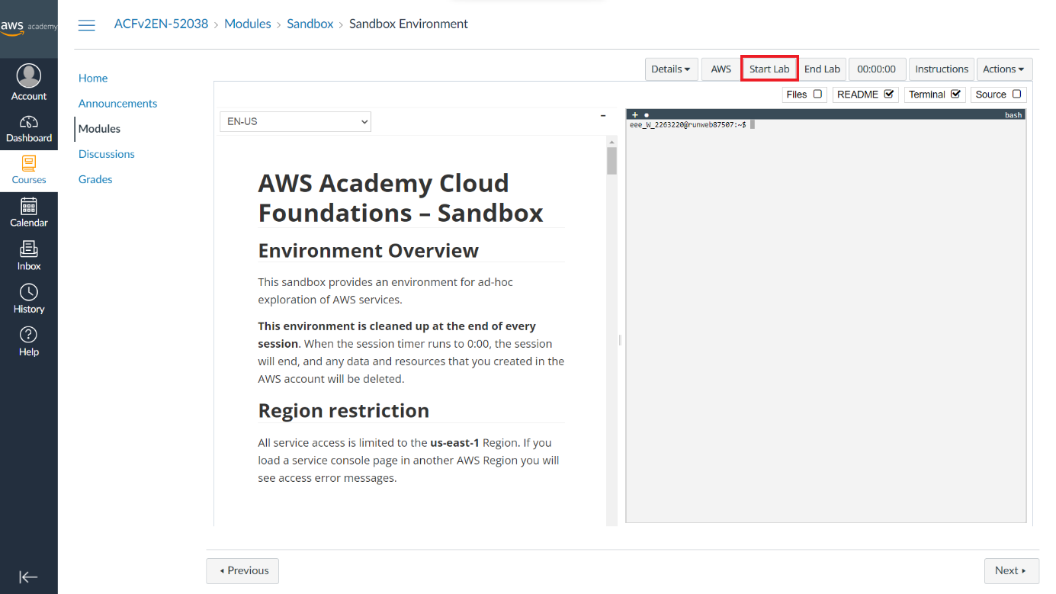

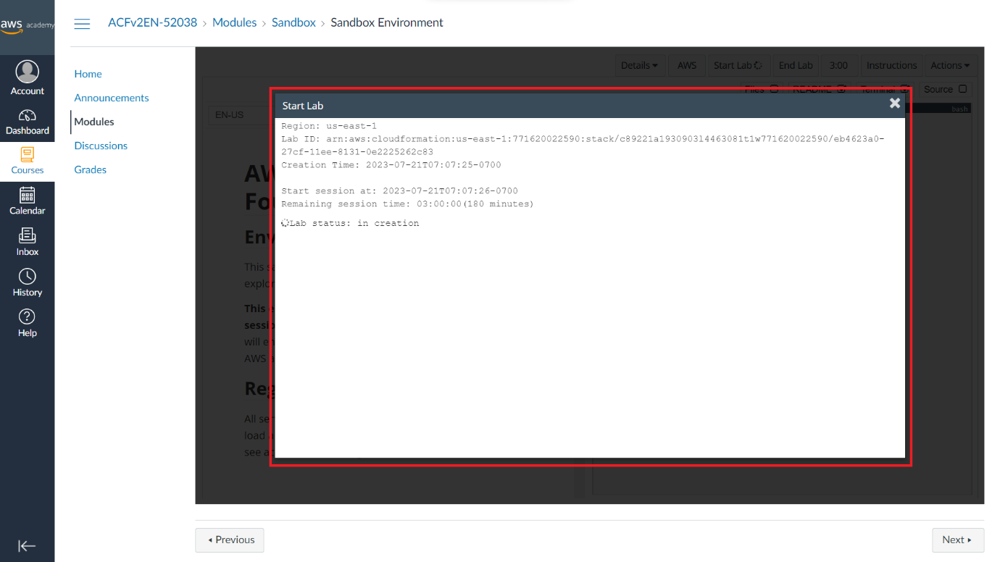

**Step 02 :** After The Lab Status Is Ready, Close The '**Start Lab**' Box And Click On The **AWS** Button

**Snapshot :**

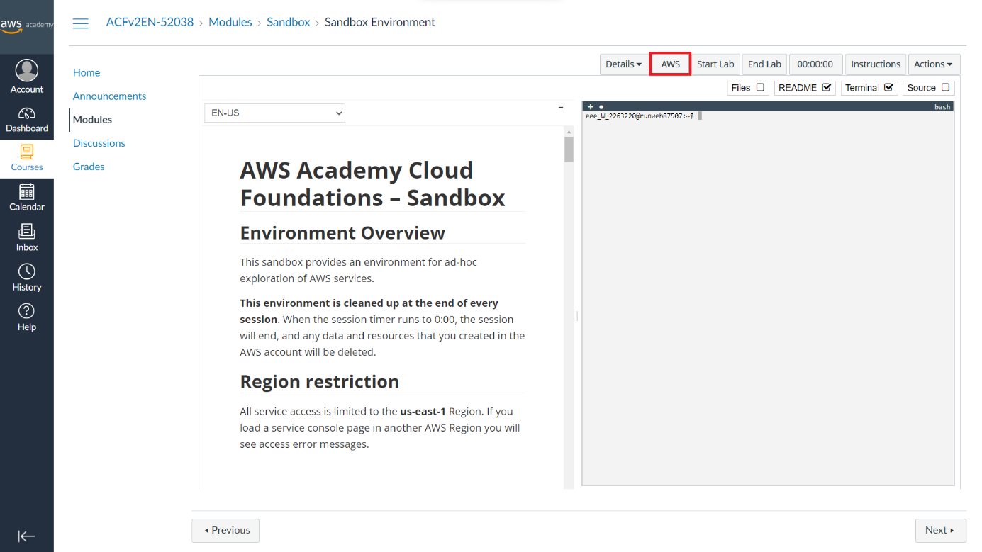

**Step 03 :** AWS Website In New Tab Is Look Like Snapshot

**Snapshot :**

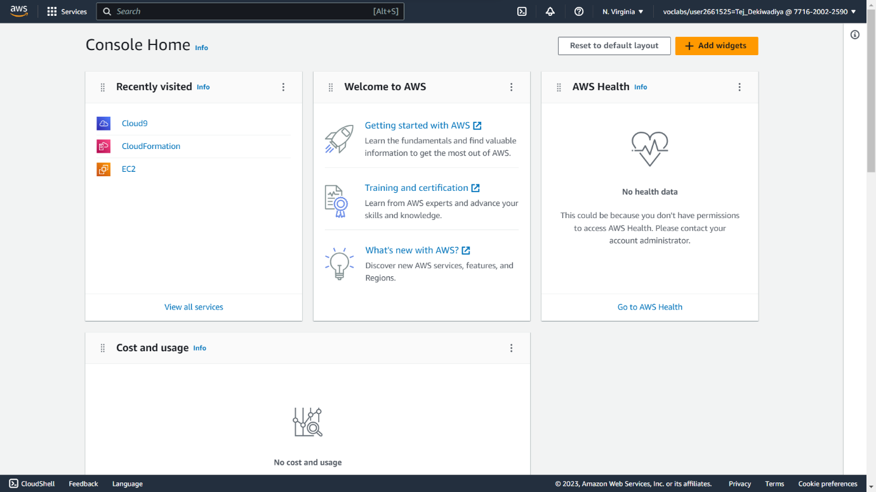

**Step 03 :** Main Part Of This Practical Started From Here. Now, Type "**Cloud9**" In The Search Bar And Open The First Site. Then, Click On The "**Create Environment**" Button To Create An Environment In **AWS**.

**Snapshot :**

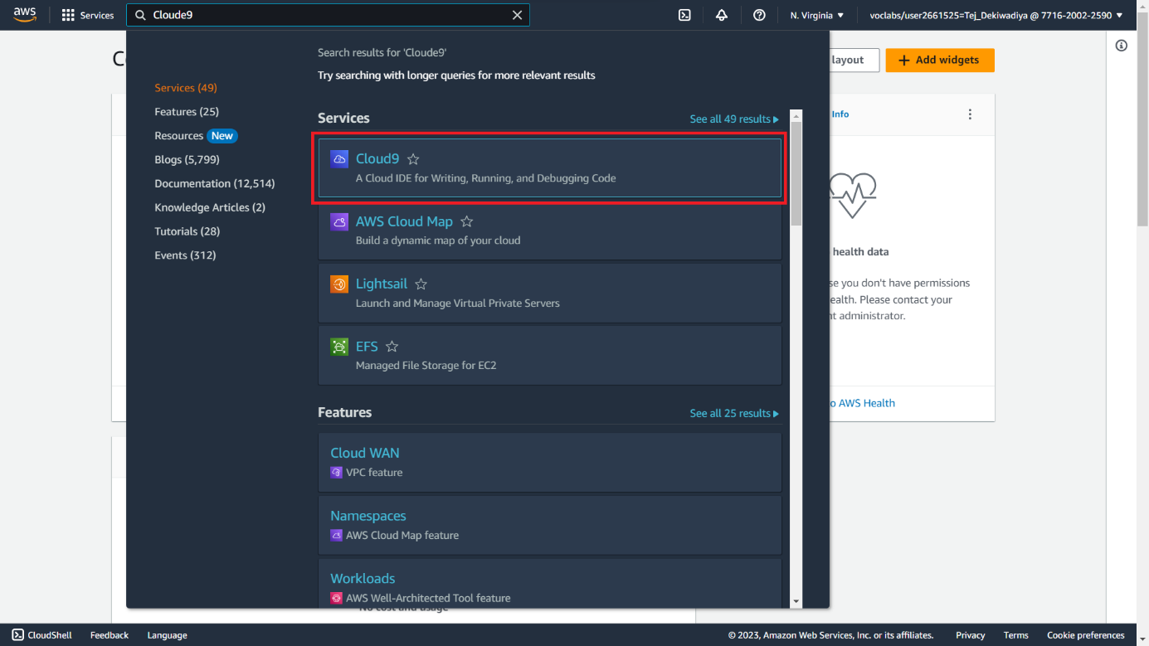

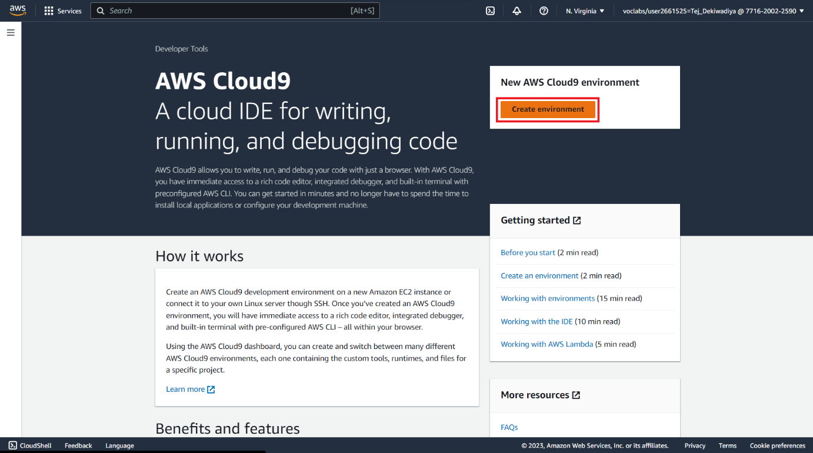

**Step 04** **:** Next Step Is To Configure The Environment. First, Set The **Name** Of The Environment

**Snapshot :**

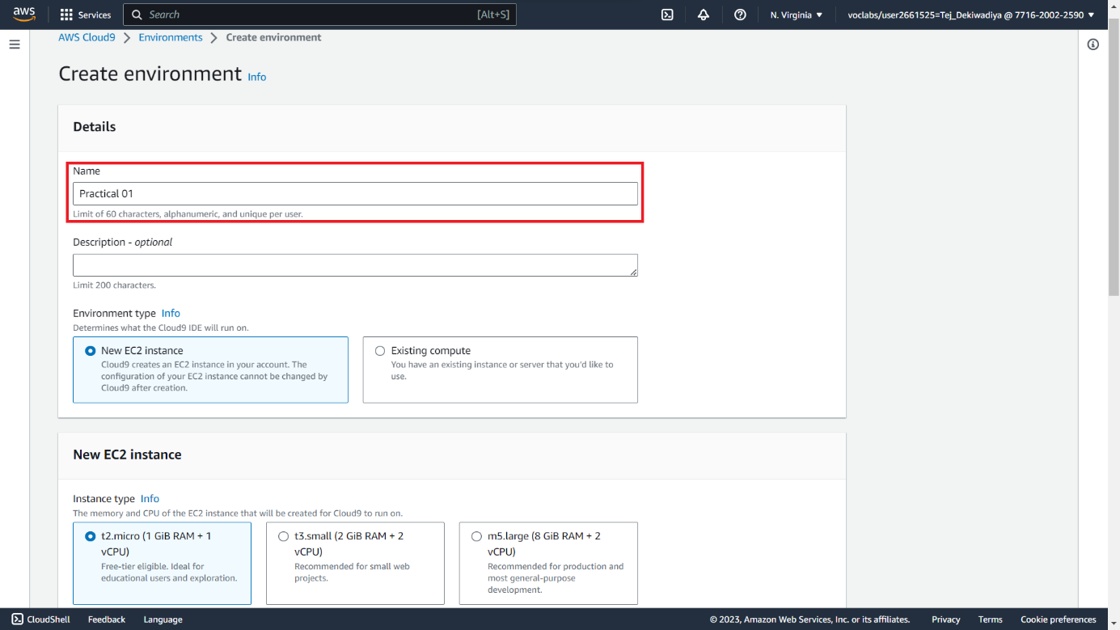

**Step 05 :** Choose The "**Connection To Secure Shell (Ssh)**" Option. Don't Change Any Other Settings, Then Click On The "**Create**" Button To Generate The Environment.

**Snapshot :**

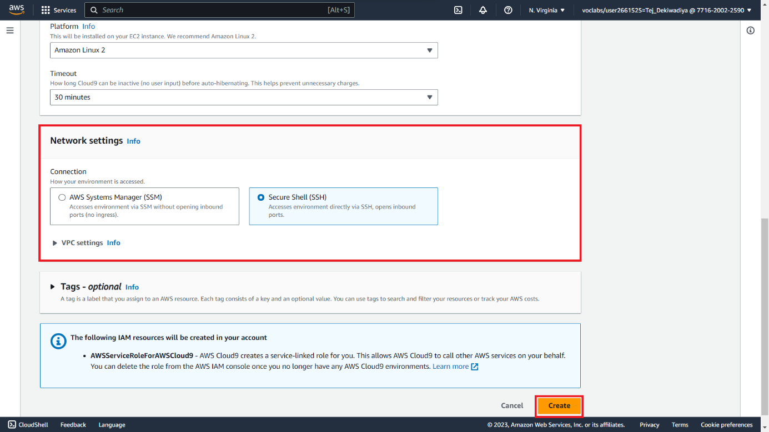

**Step 06 :** Now, Type "**Cloudformation**" In The Search Bar, Open The First Site In The Search Results In A New Tab

**Snapshot :**

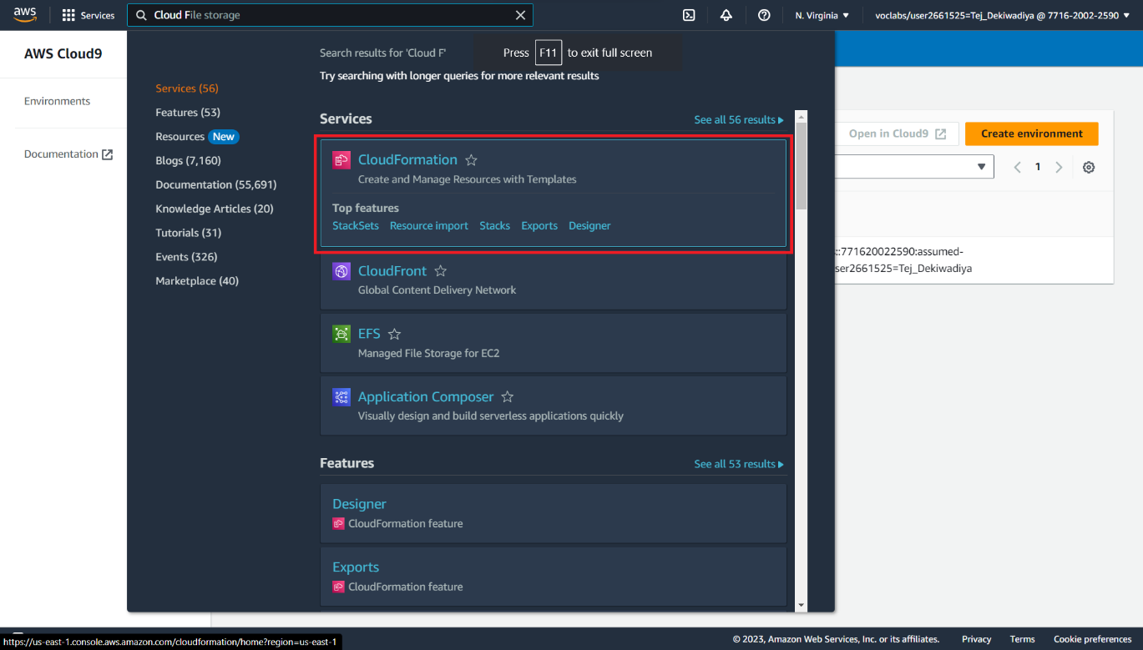

**Step 07 :** Then Check The Status Of The Stacks To See If They Are **Successfully** **Created** Or **Not**.

**Snapshot :**

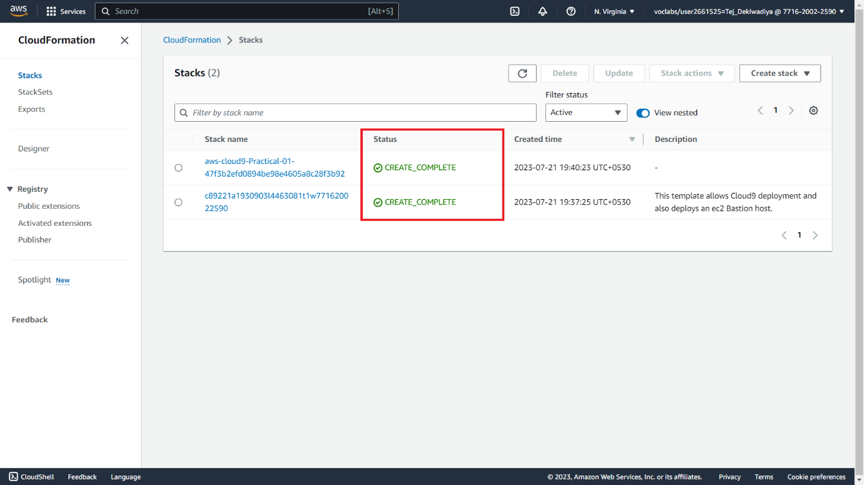

**Step 08 :** After Successfully Creating The Environment, Click On "**Open**" To Entering In The **AWS** **Cloud9** **Environment**.

**Snapshot :**

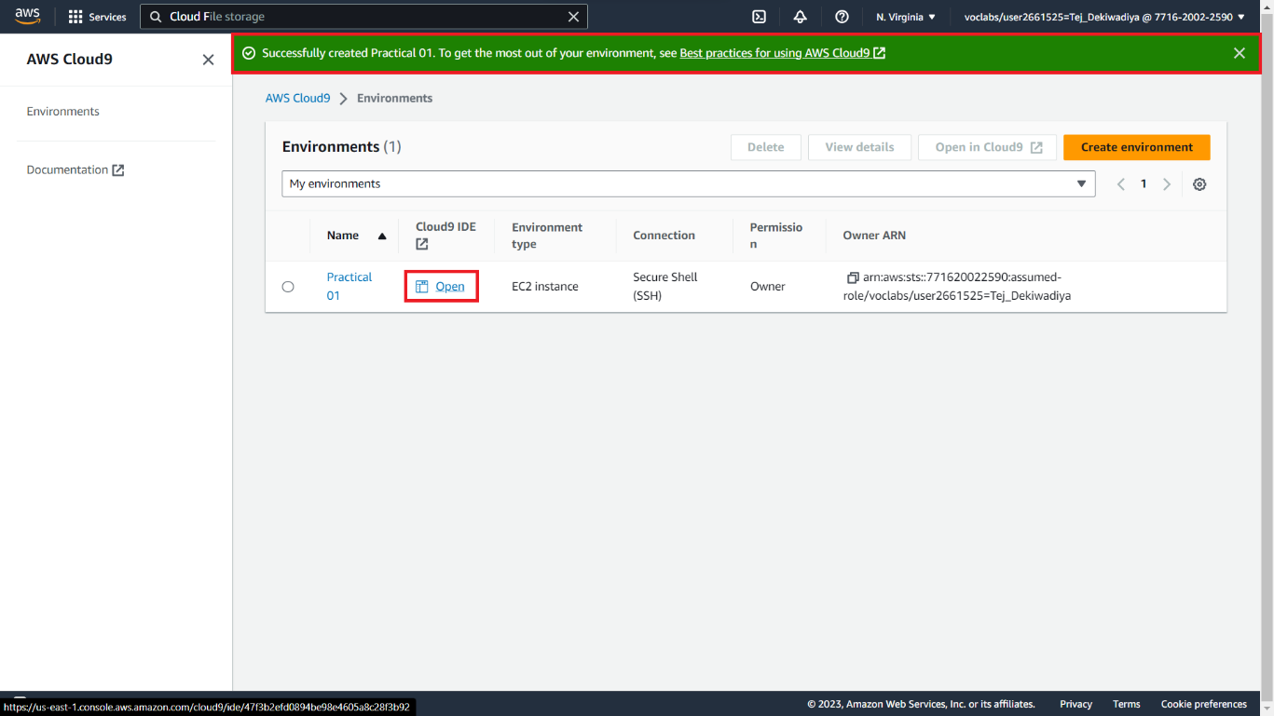

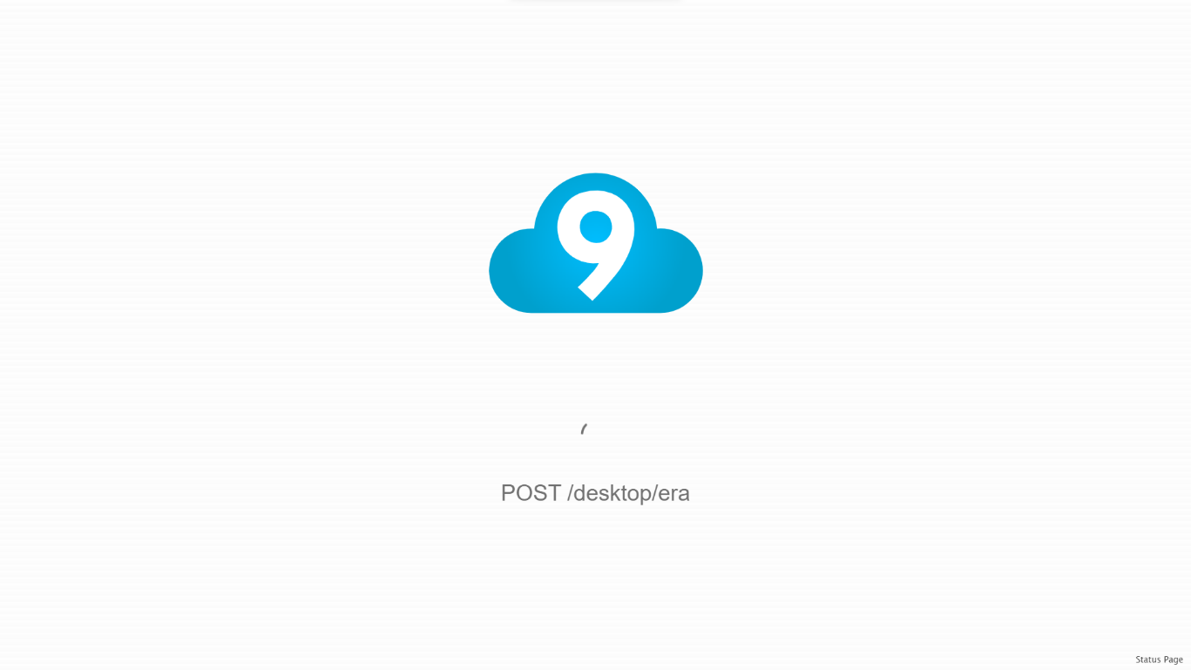

**Step 09 :** Now, You Can See The Welcome Screen Of **AWS Cloud9**.

**Snapshot :**

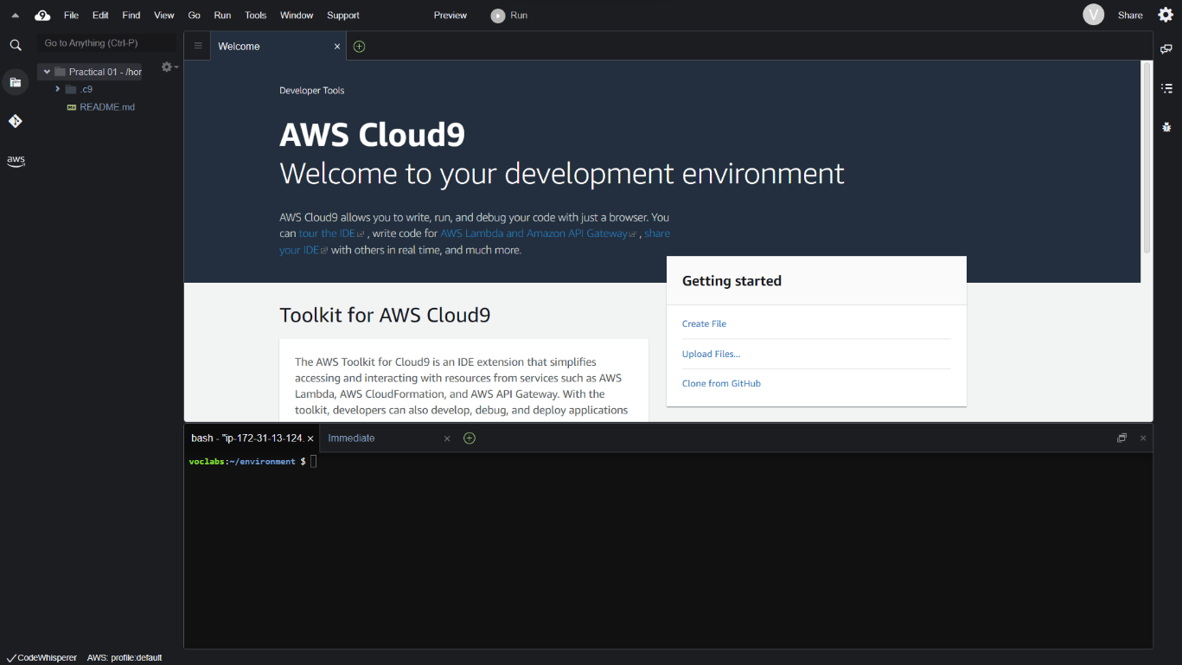

**Step 10 :** In The AWS Cloud9 Environment, Execute Various Linux Commands And Observe Their Outputs.

**Snapshot 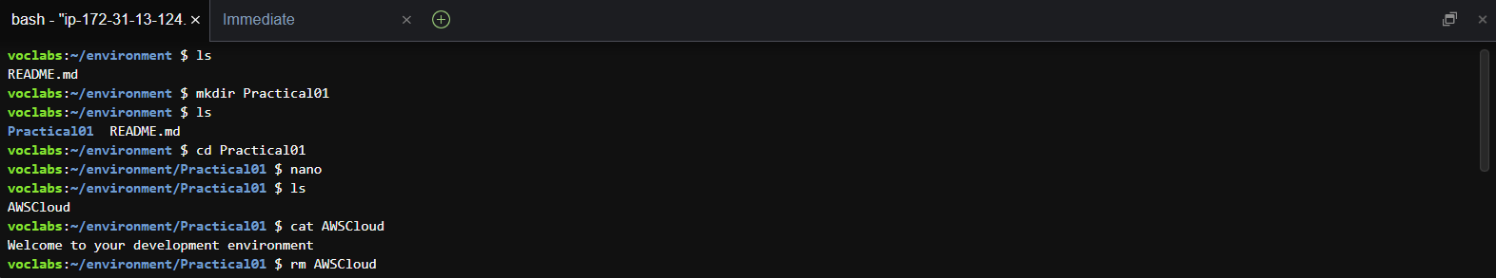:**

**Practical 02 : Deploy Virtual Machine**

**Step 01 :** Go To **AWS Canvas** > **Modules** Section > Find **Sandbox** And Click On The "**Start Lab**" Button. Then, Wait For The "**Start Lab**" Box To Appear.

**Snapshot :**





**Step 02 :** After The Lab Status Is Ready, Close The '**Start Lab**' Box And Click On The **AWS** Button

**Snapshot :**



**Step 03 :** AWS Website In New Tab Is Look Like Snapshot

**Snapshot :**



**Step 03 :** Main Part Of This Practical Started From Here. Now, Type "**Ec2**" In The Search Bar And Open The First Site. Then, Click On The "**Instances (Running)**" In Resources Section.

**Snapshot :**

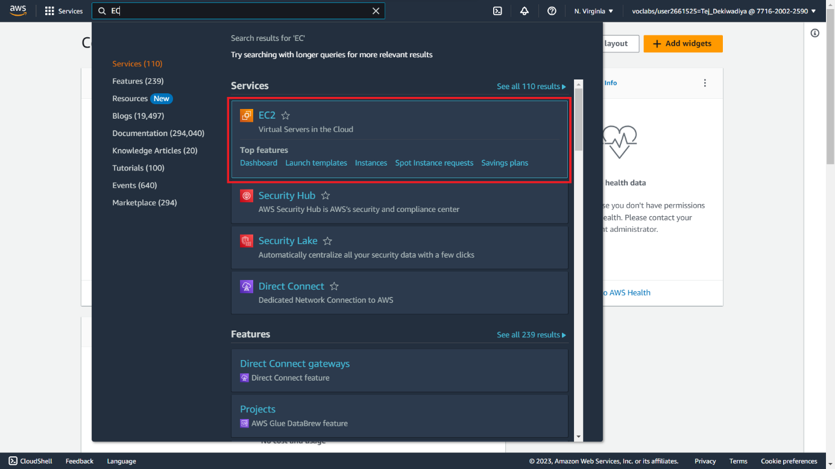

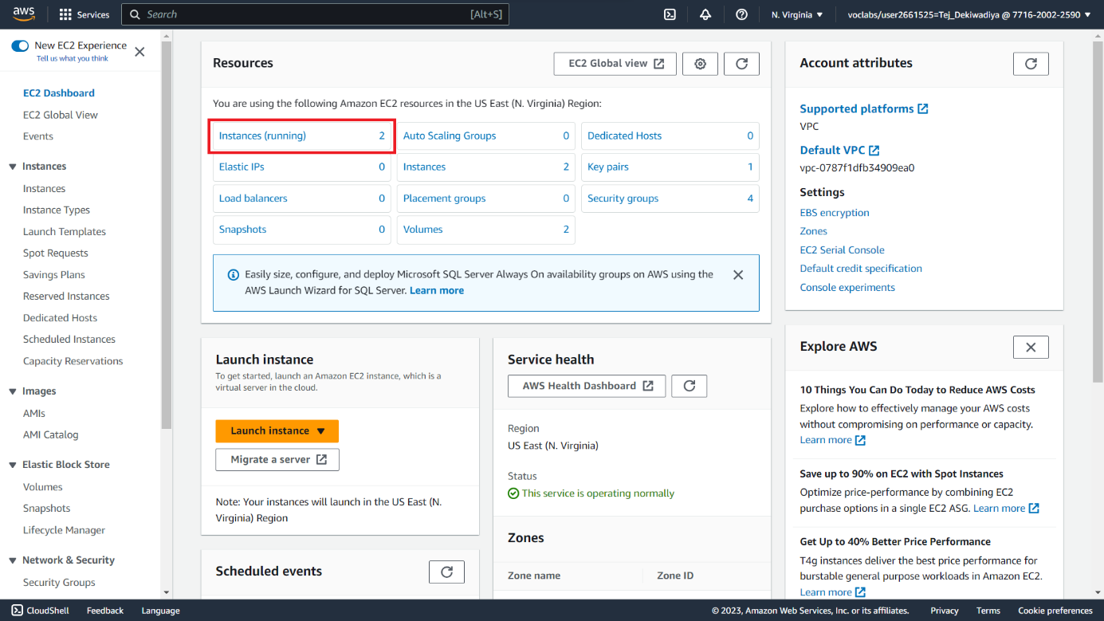

**Step 04 :** Create A New Instance By Clicking On "**Launch Instance**"

**Snapshot :**

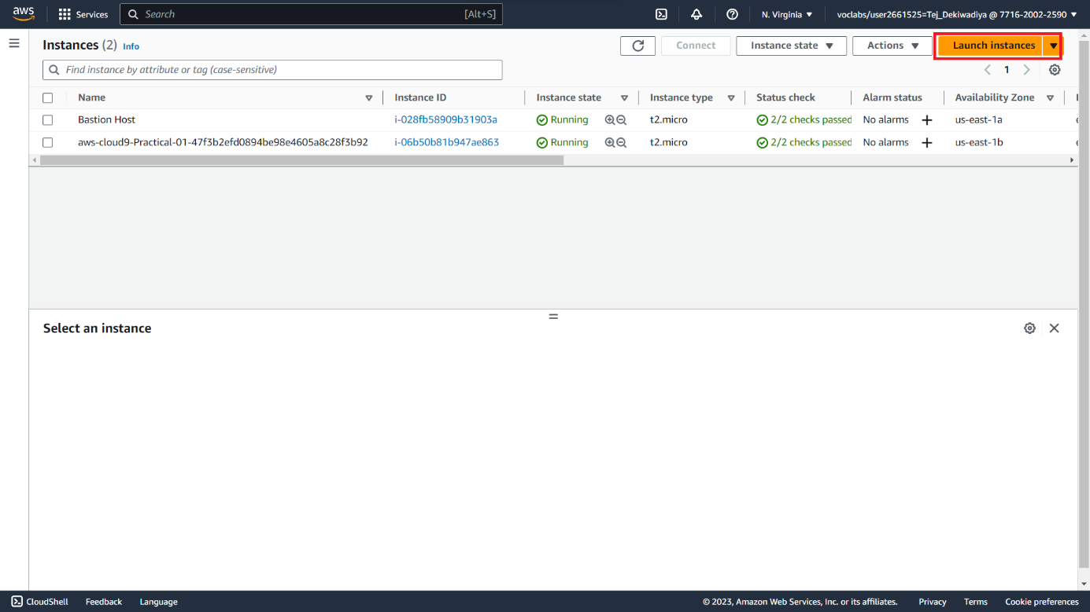

**Step 05 :** Next Step Is To Configure The Instance. First, Set The **Name** Of The Instance

**Snapshot :**

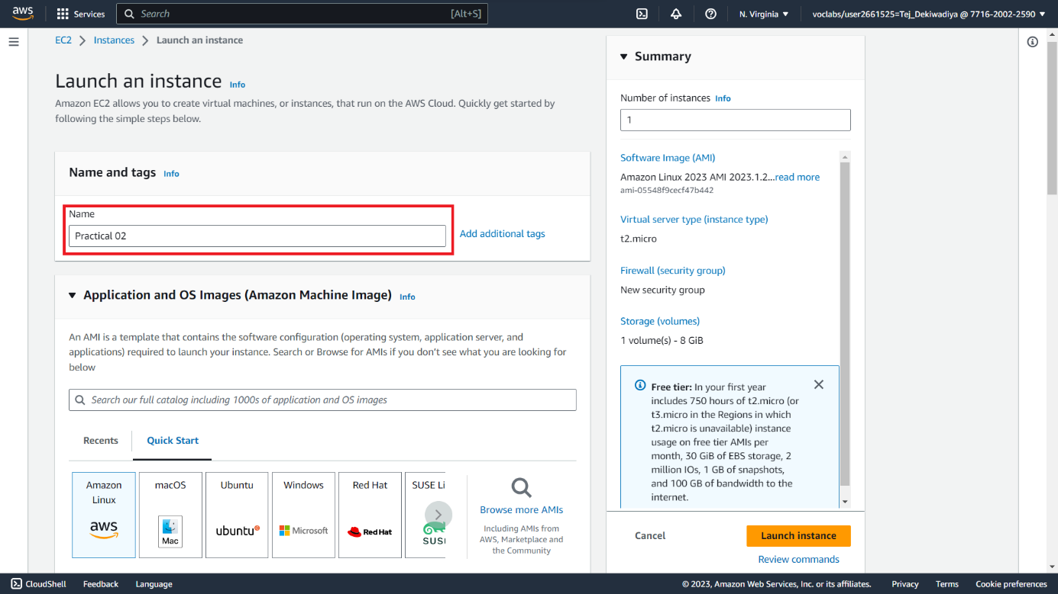

**Step 06 :** Next Step Is To Choose The Application And **OS Images Ubuntu > Ubuntu Server 22.04 LTS**

**Snapshot :**

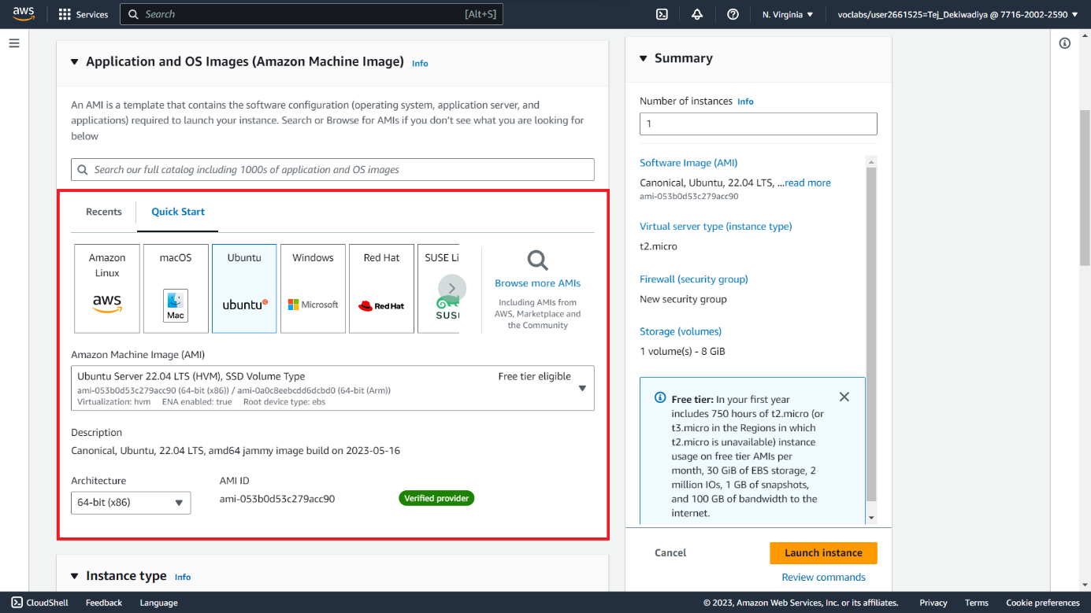

**Step 07 :** Next Step Is To Create New **Key Pair** In Key Pair (Login) Section

**Snapshot :**

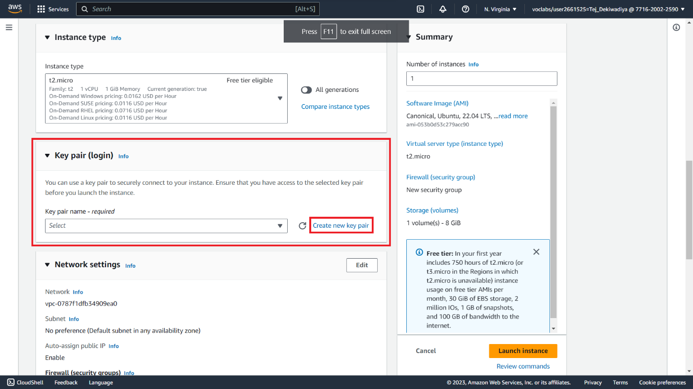

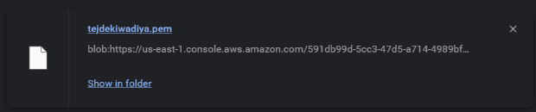**Step 08 :** Provide A **Key Pair** Name And Then Click On "**Create Key Pair**" To Generate The Key Pair. (Downloading One File While Creating)

**Snapshot :**

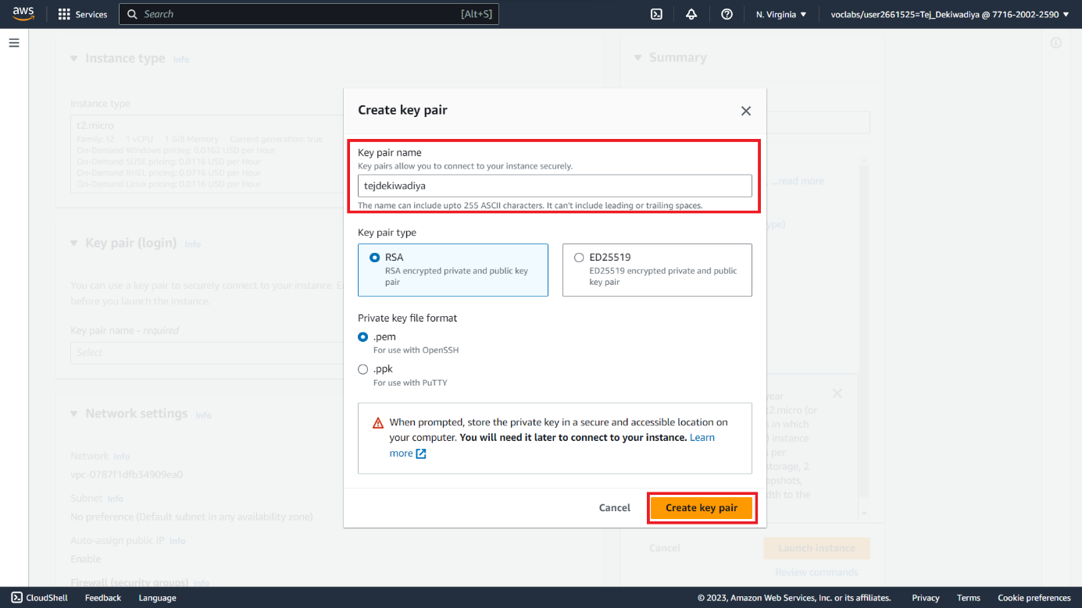

**Step 09 :** Do Not Modify Any Other Instance Settings. Click On "**Launch Instance**" To Proceed.

**Snapshot :**

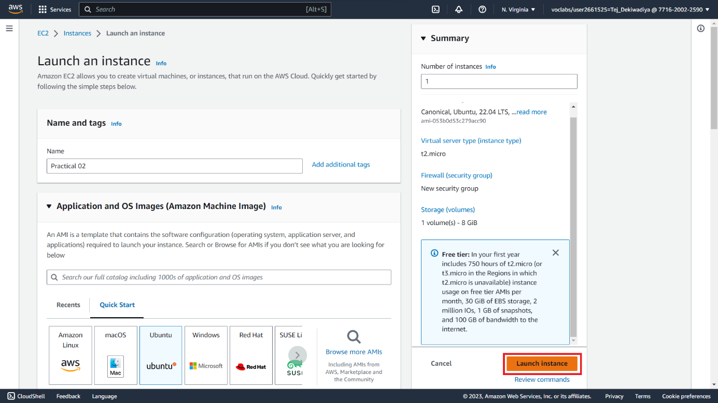

**Step 10 :** The Process Of Launching The Instance Will Begin, And It May Take A Few Seconds To Complete **Successfully**. Once It's Ready, Click On The Instance Id To Launch The Created Instance

**Snapshot :**

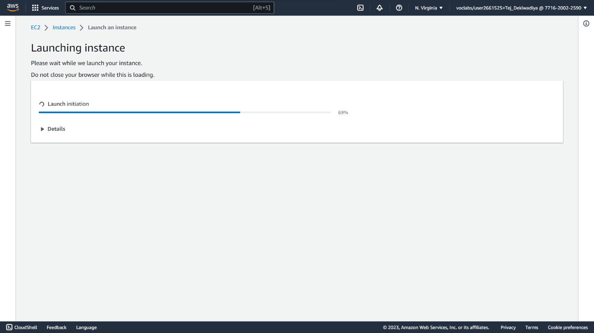

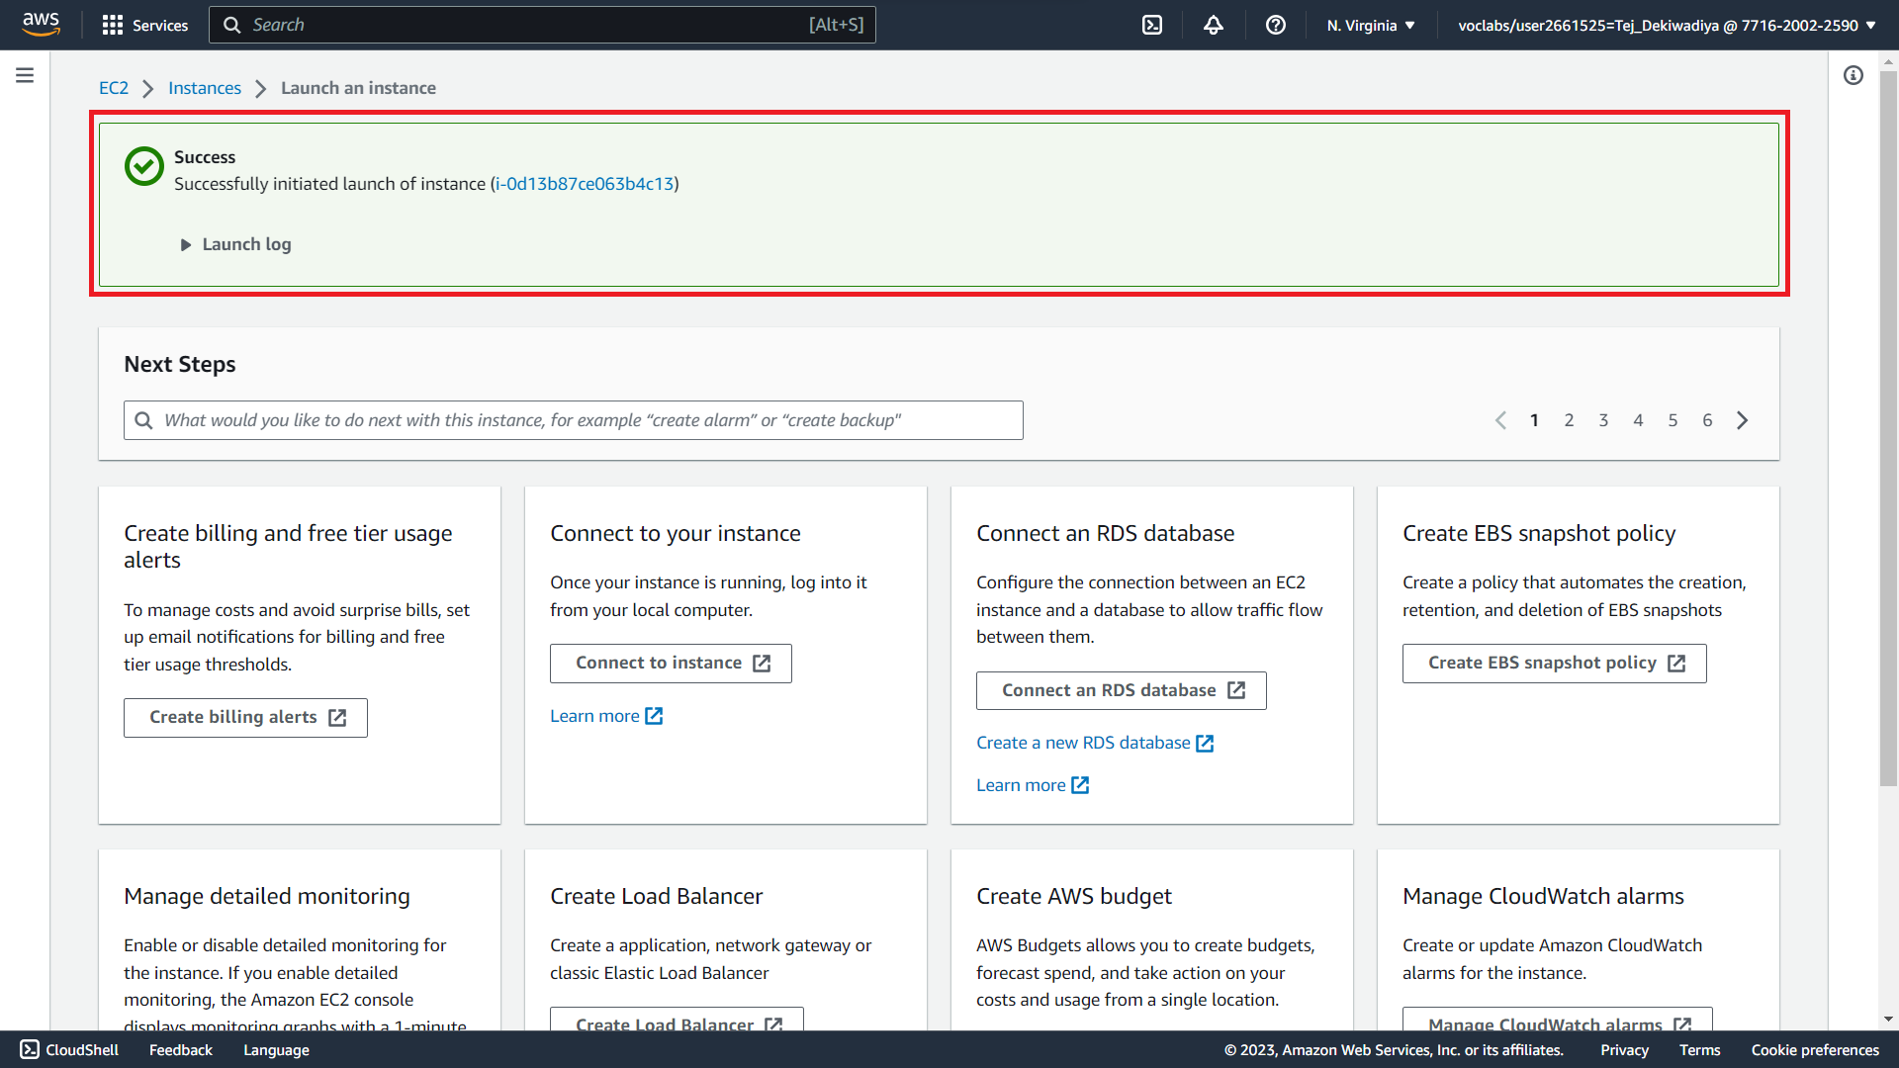

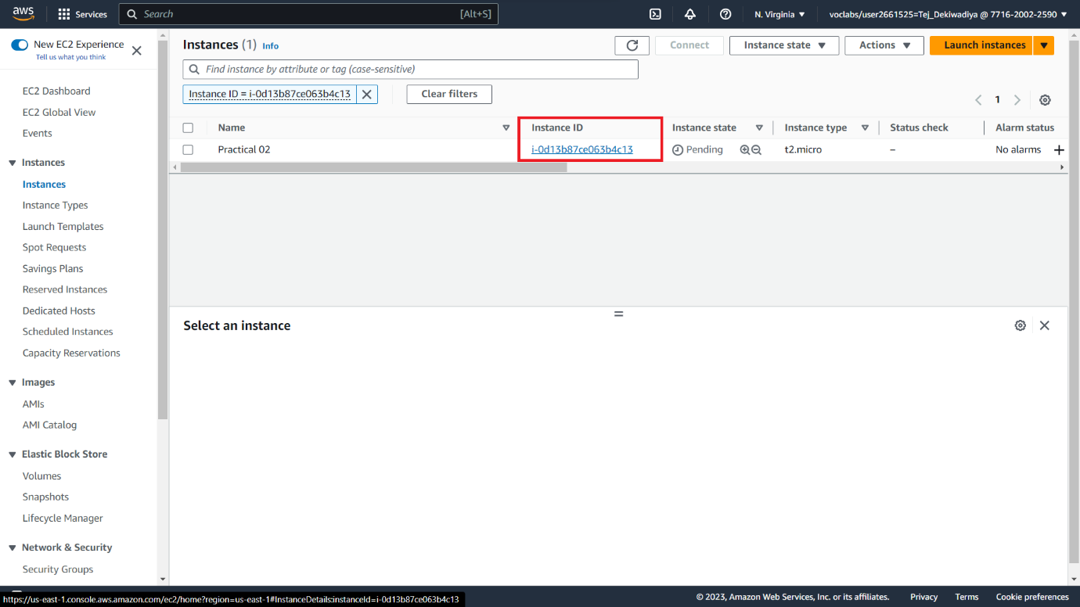

**Step 11 :** After Successfully Launching The Instance, Click On The "**Connect**" Button To Connect To The Instance.

**Snapshot :**

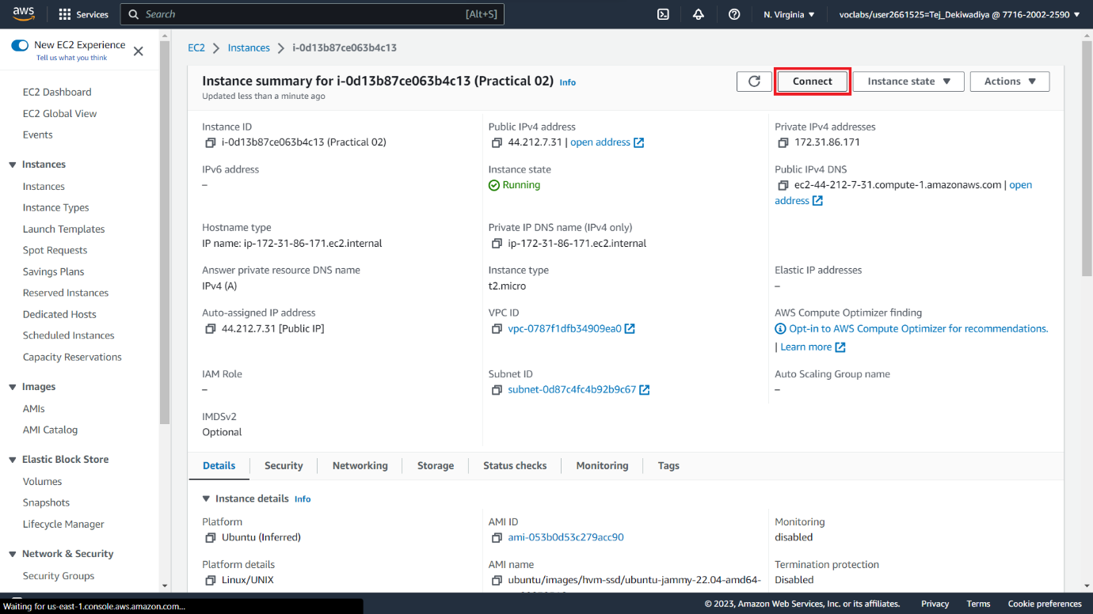

**Step 12 :** After Downloading The Key Pair File During The Creation, Navigate To The Folder In The **CMD** (Or Terminal) And **Execute** The Example Code From The **SSH Client Panel**

**Snapshot :**

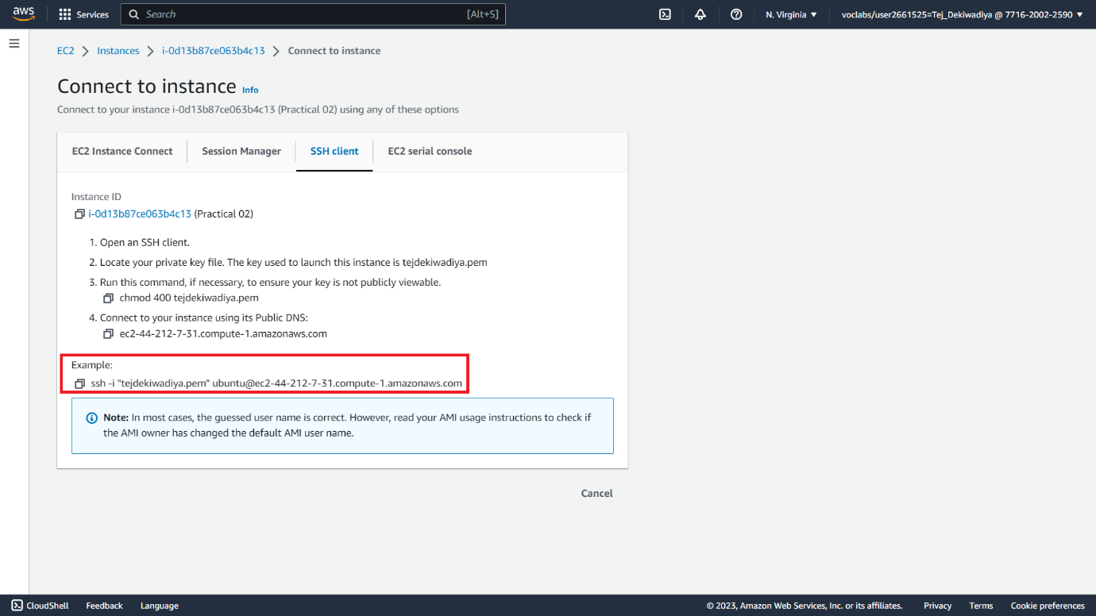

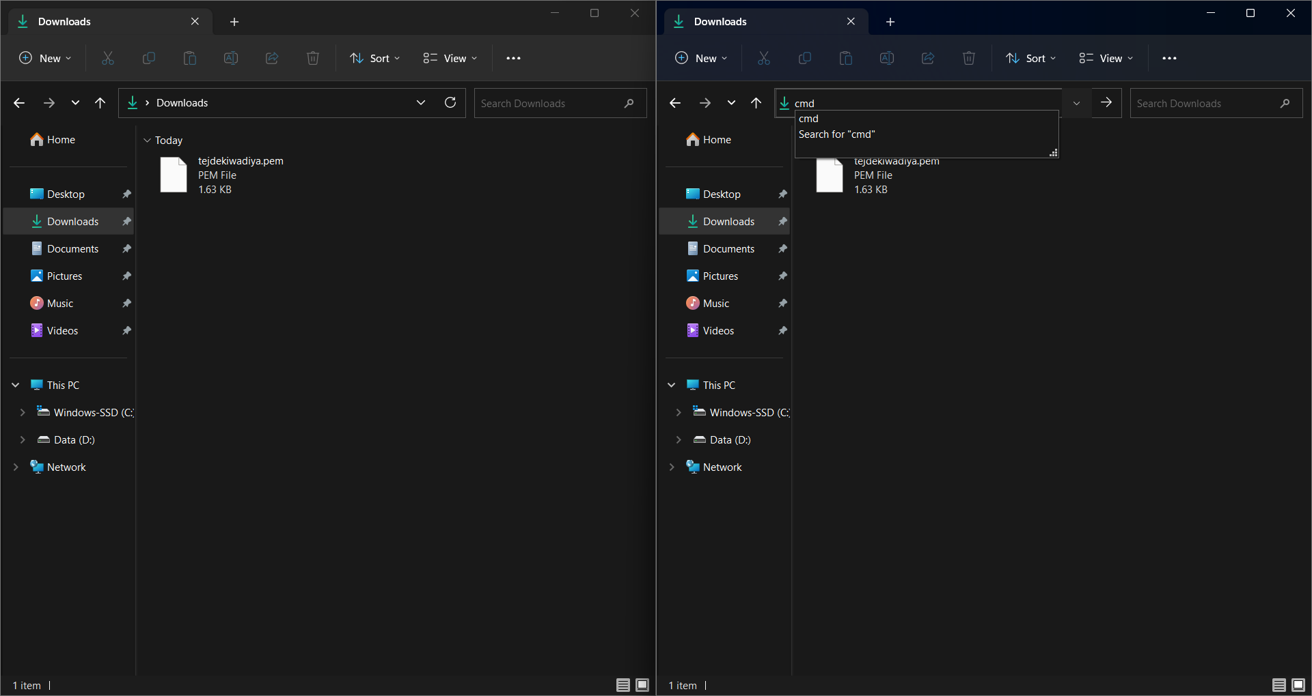

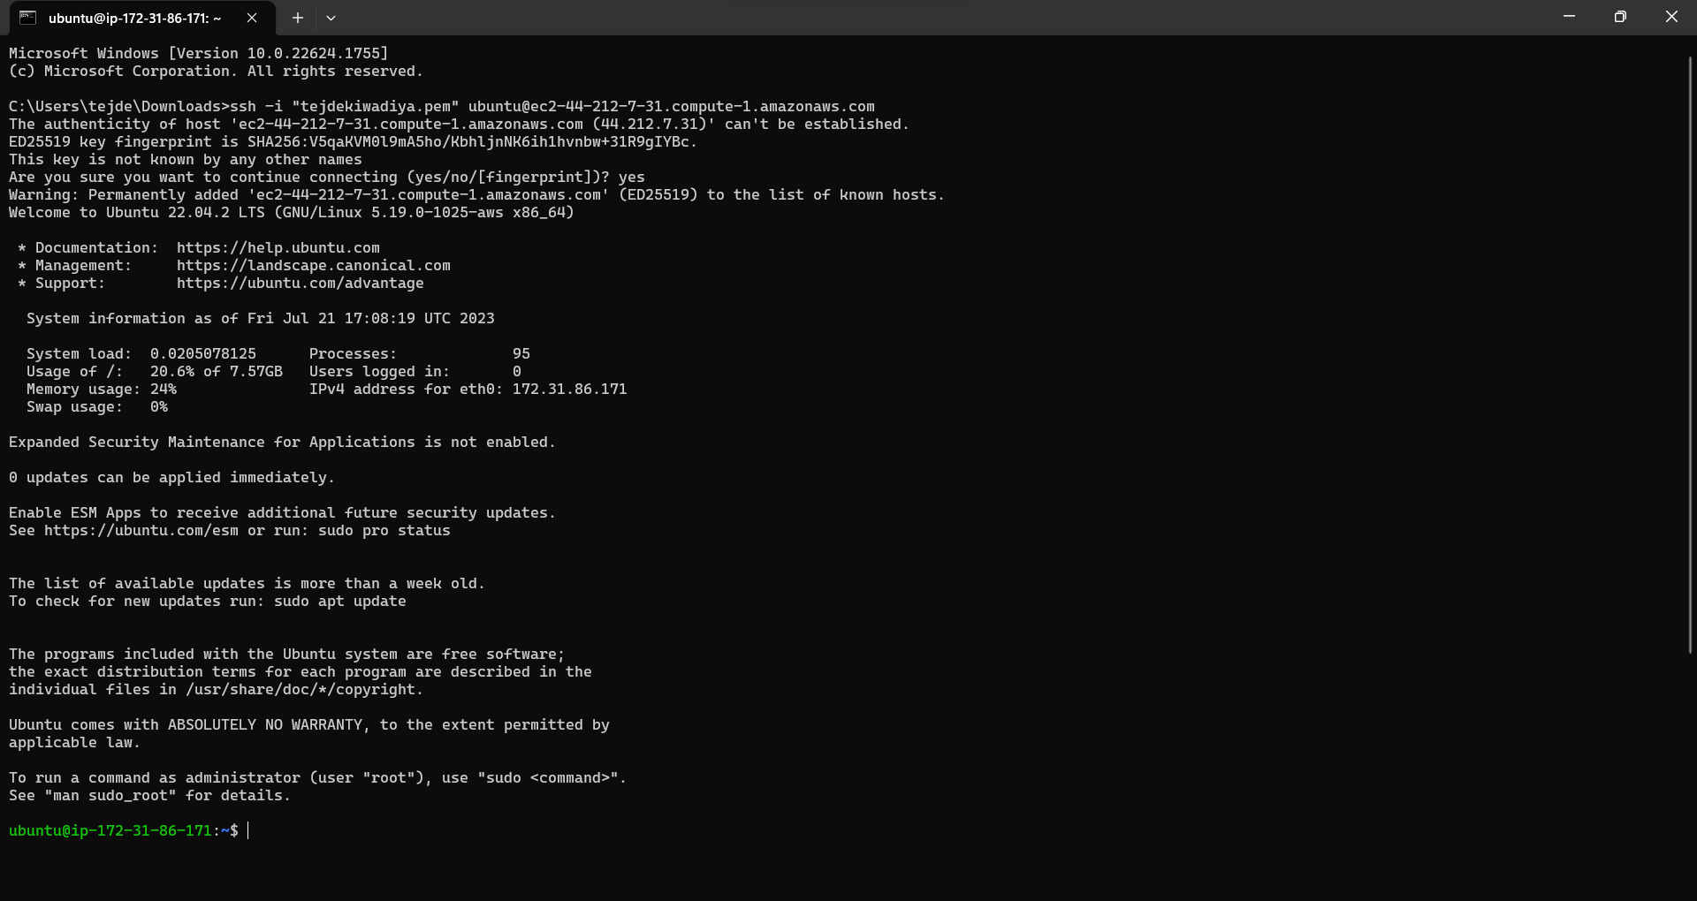

**Step 13 :** After Executing The Example Code, The Instance Will Run In The Terminal Gracefully. Enjoy The **Virtual Machine** **Instance** And **Run** **Linux** **Commands** To Observe Their Outputs.

**Snapshot :**

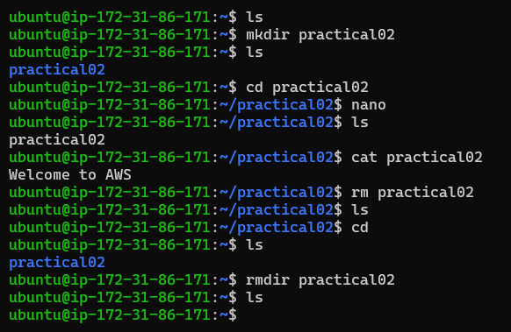

**Practical 03 : Virtual Machine Management**

**Step 01 :** In this practical, I have changed Public IPV4 to an elastic IP address, so for that, right now, I have one existing instance.

**Snapshot :**

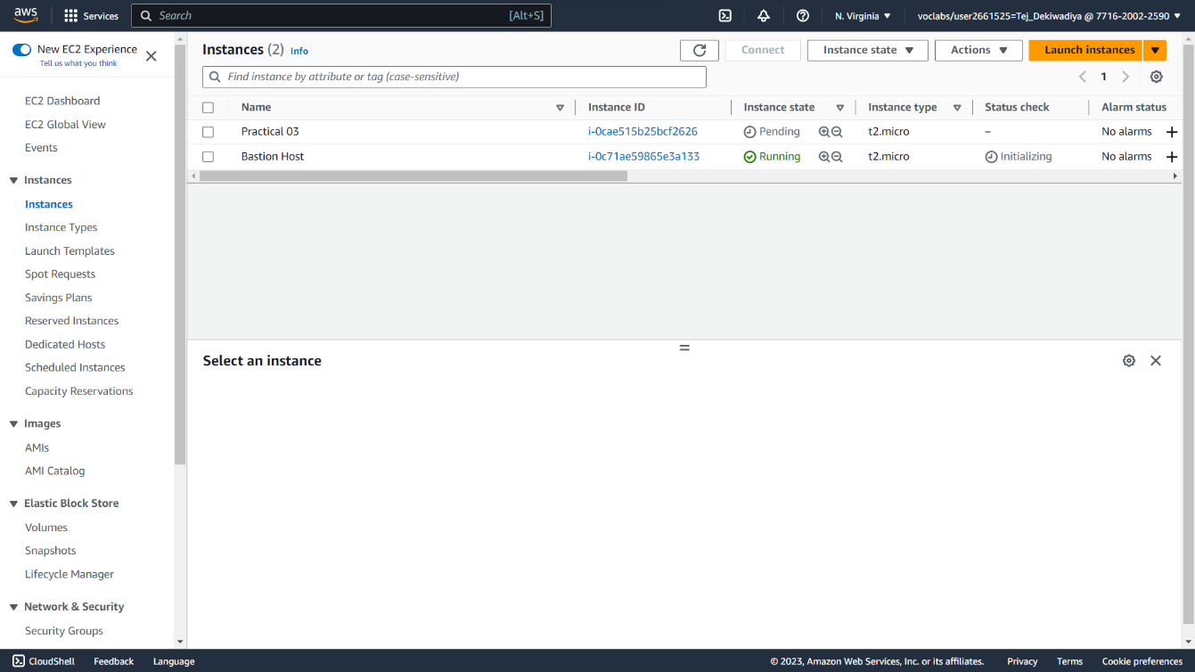

**Step 02 :** Here Instance name is Practical 03 and the address of Public IPV4 is 54.167.203.114

**Snapshot :**

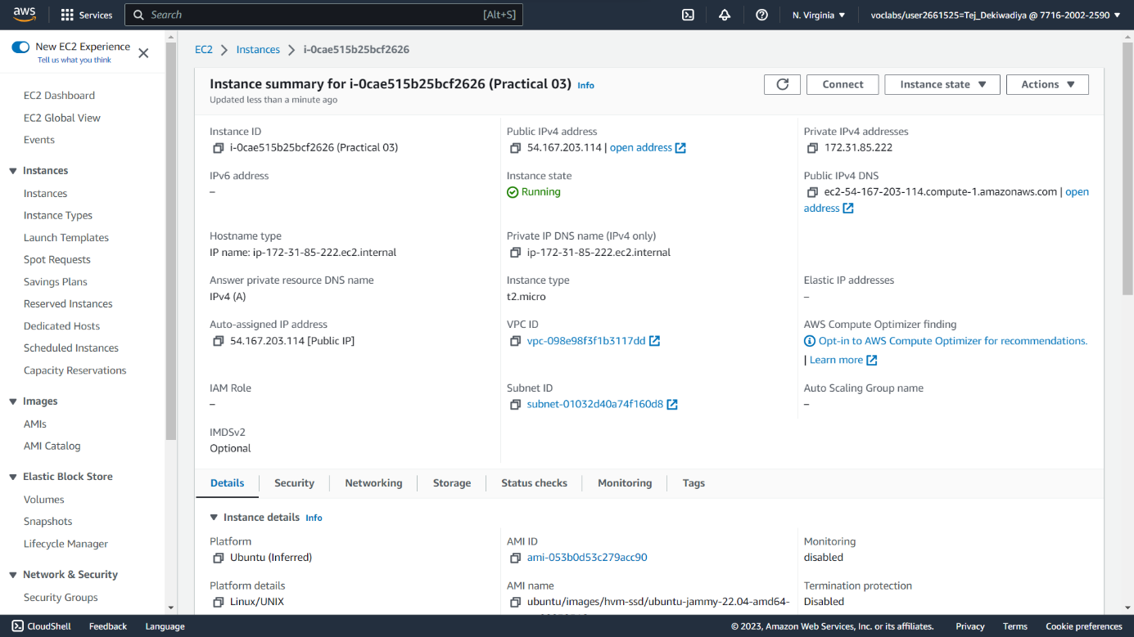

**Step 03 :** Now Open Elastic IP Address Window.

**Snapshot :**

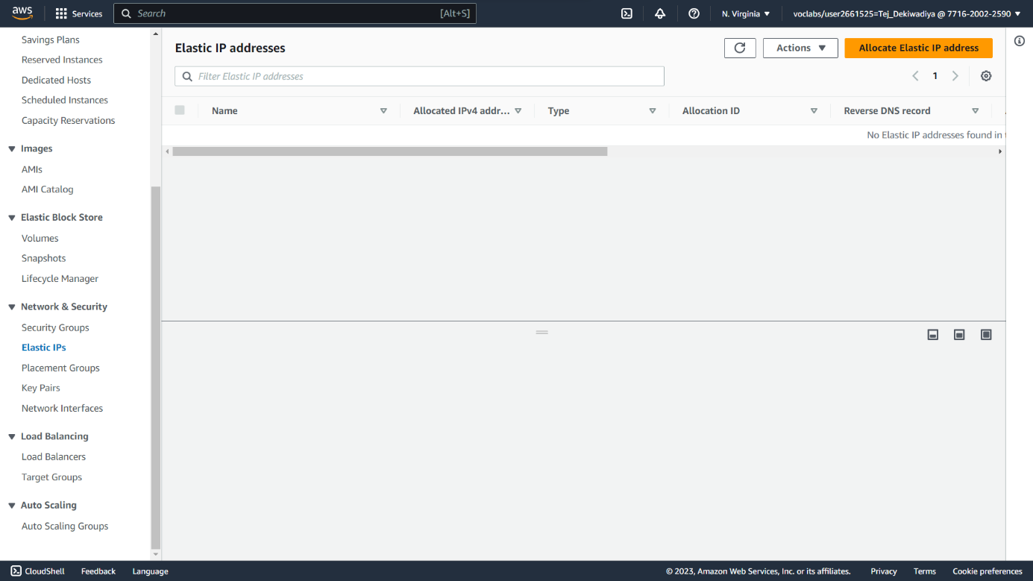

**Step 04 :** After that click on Allocate Elastic IP Address and then Choose Network Border group it means our Instance ID.

**Snapshot :**

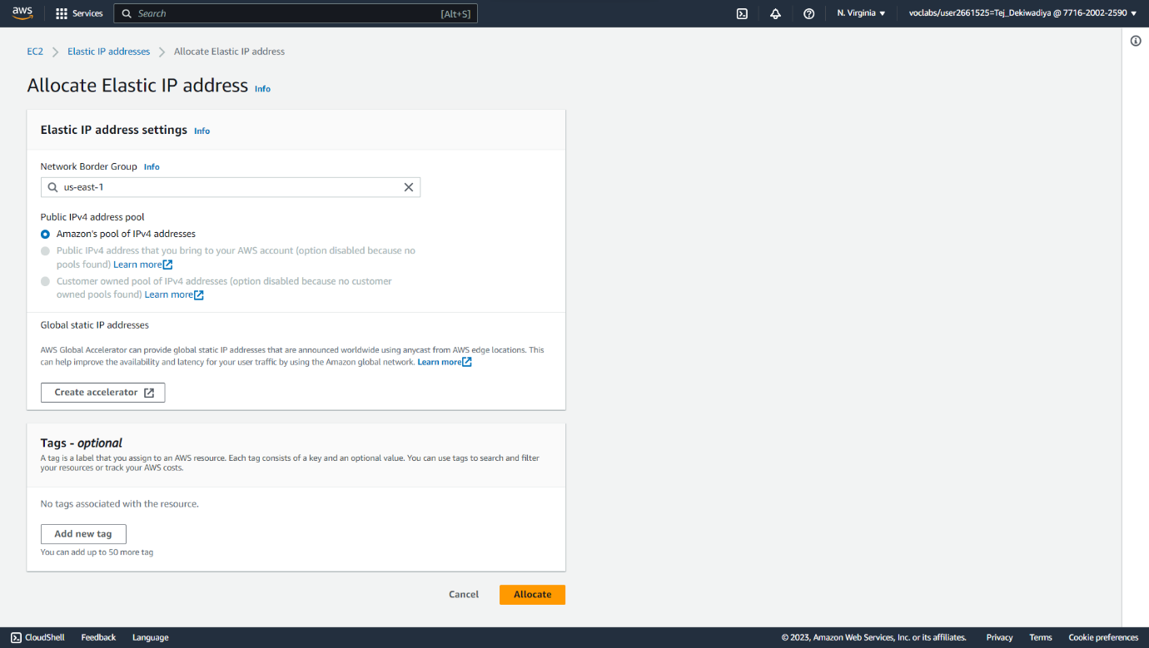

**Step 05 :** Here allocated New Elastic IP Address.

**Snapshot :**

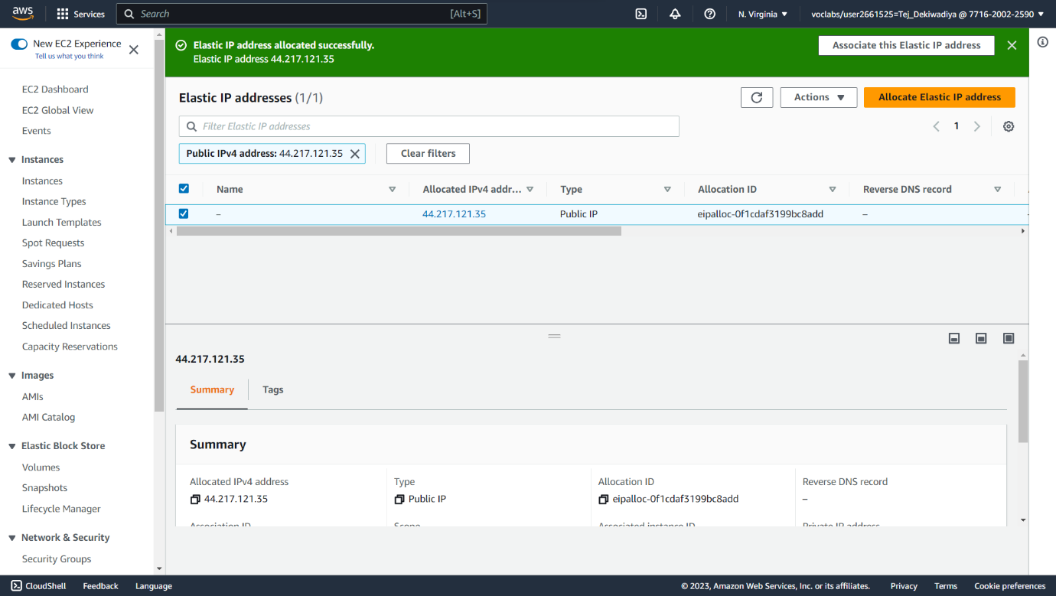

**Step 06 :** In Elastic IP Address tab click on action and choose Associate Elastic IP Address.

**Snapshot :**

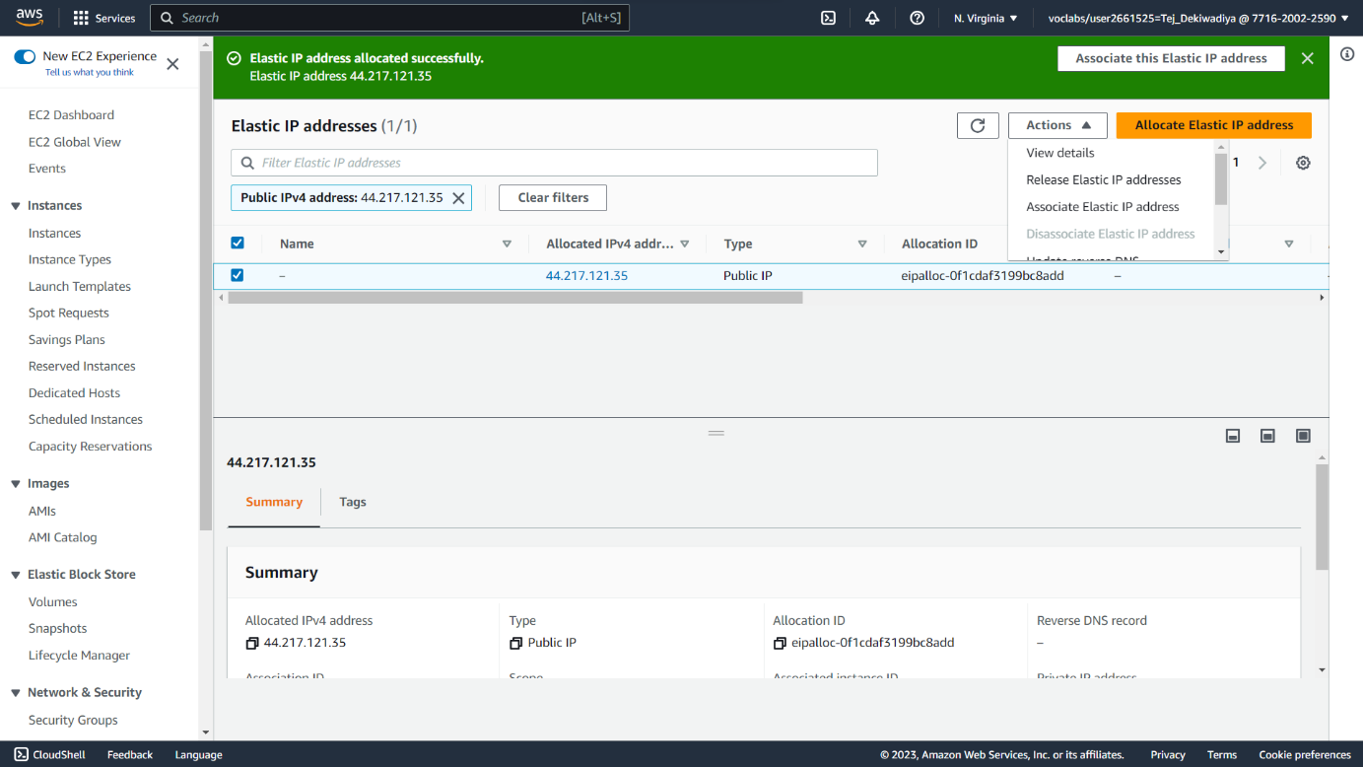

**Step 07 :** Now here in a instance choose our Instance and Submit.

**Snapshot :**

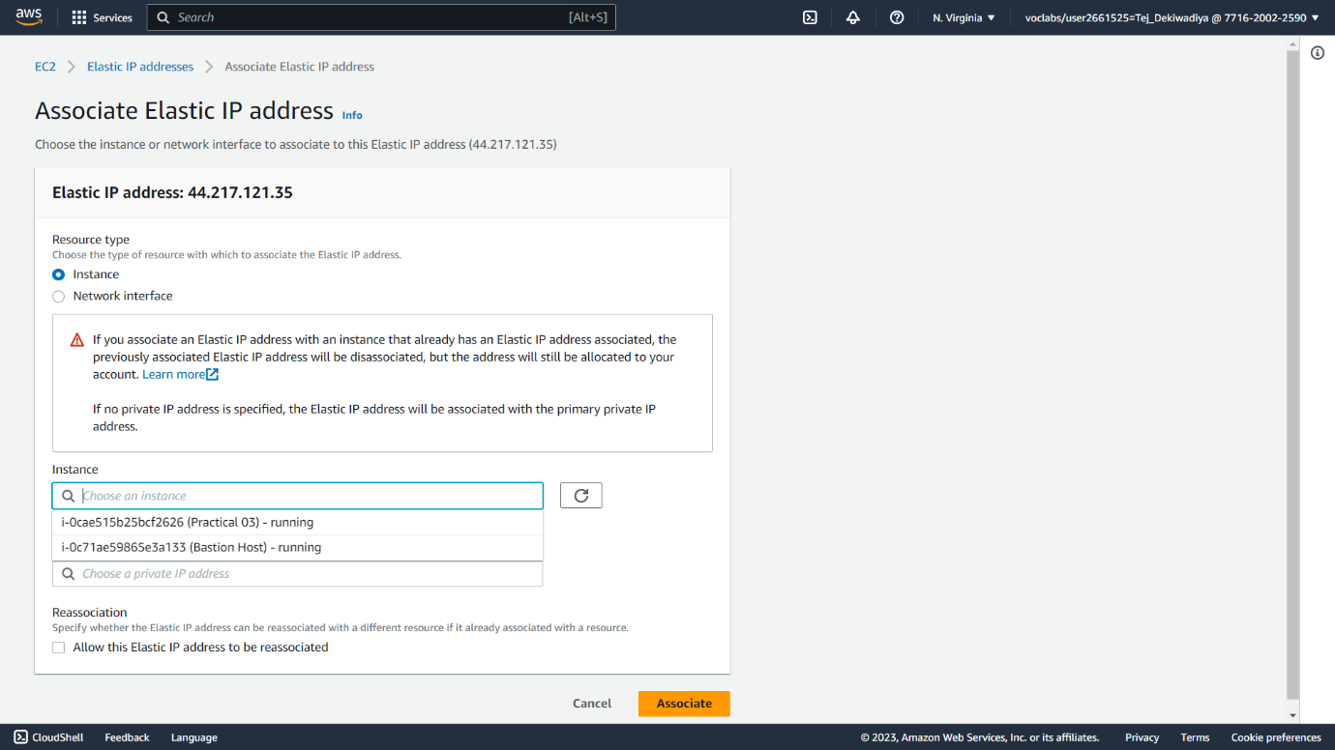

**Step 08 :** At last Public IPV4 Address changed with Elastic IP Address -> 44.217.121.35

**Snapshot :**

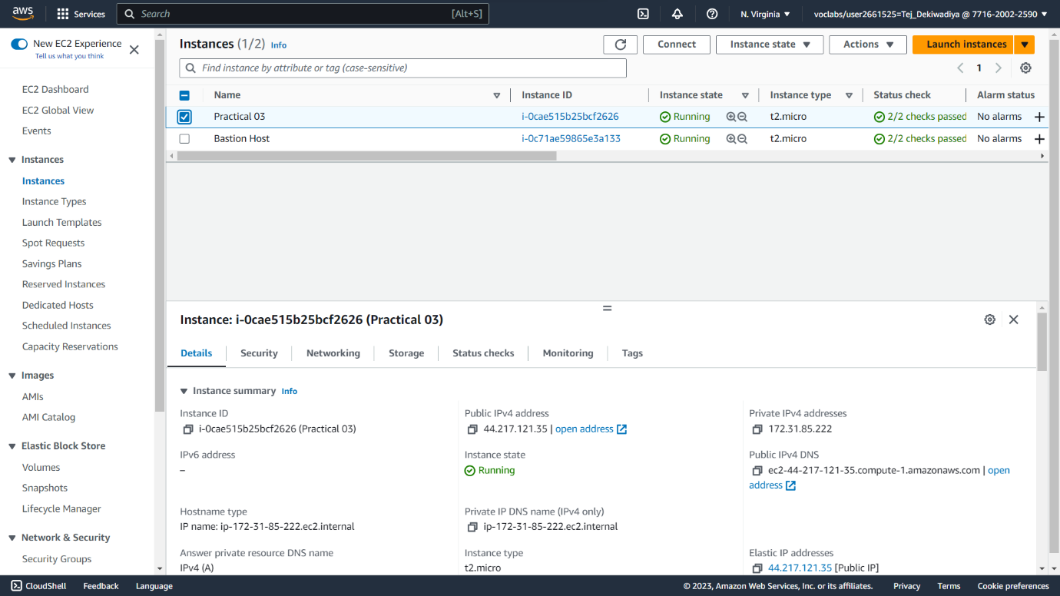

**Step 09 :** At last Public IPV4 Address changed with Elastic IP Address 🡪 44.217.121.35

**Snapshot :**



**Practical 04 : Deploy a Web Application on AWS**

**Step 01 :** Create one new Instance and whenever create Instance choose all the settings by default.

**Snapshot :**

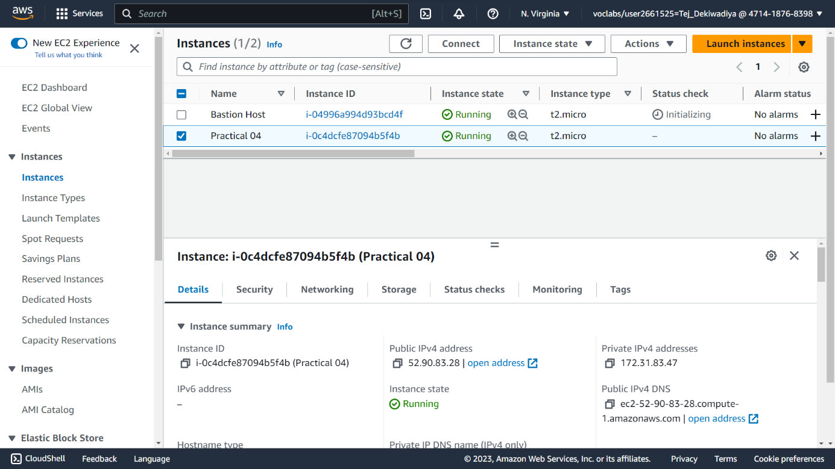

**Step 02 :** Check all the configurations of your Instance .

**Snapshot :**

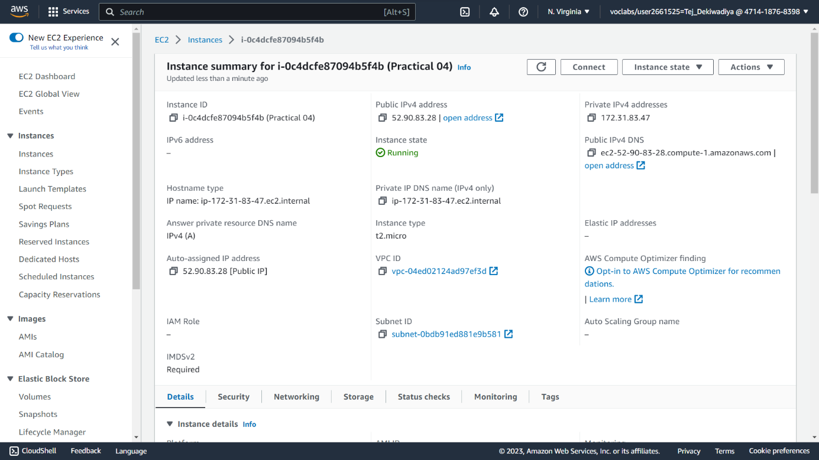

**Step 03 :** Now connect Instance with Terminal.

**Snapshot :**

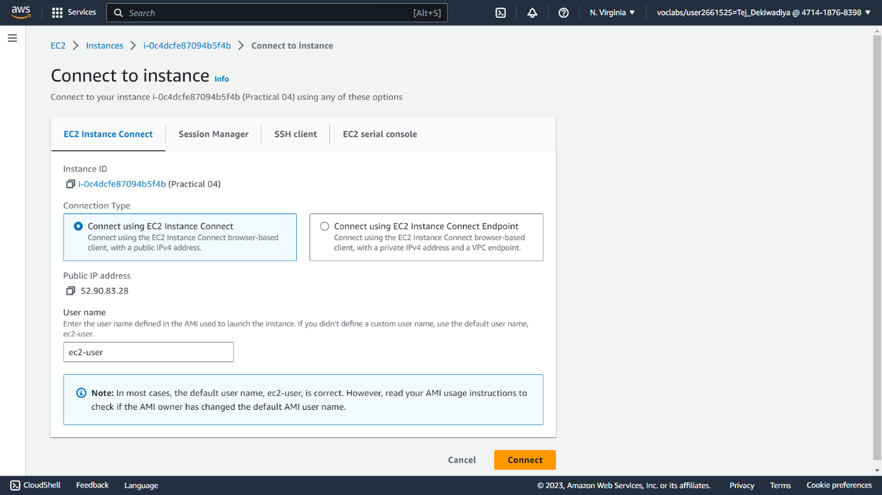

**Step 04 :** Kali default Terminal Opened.

**Snapshot :**

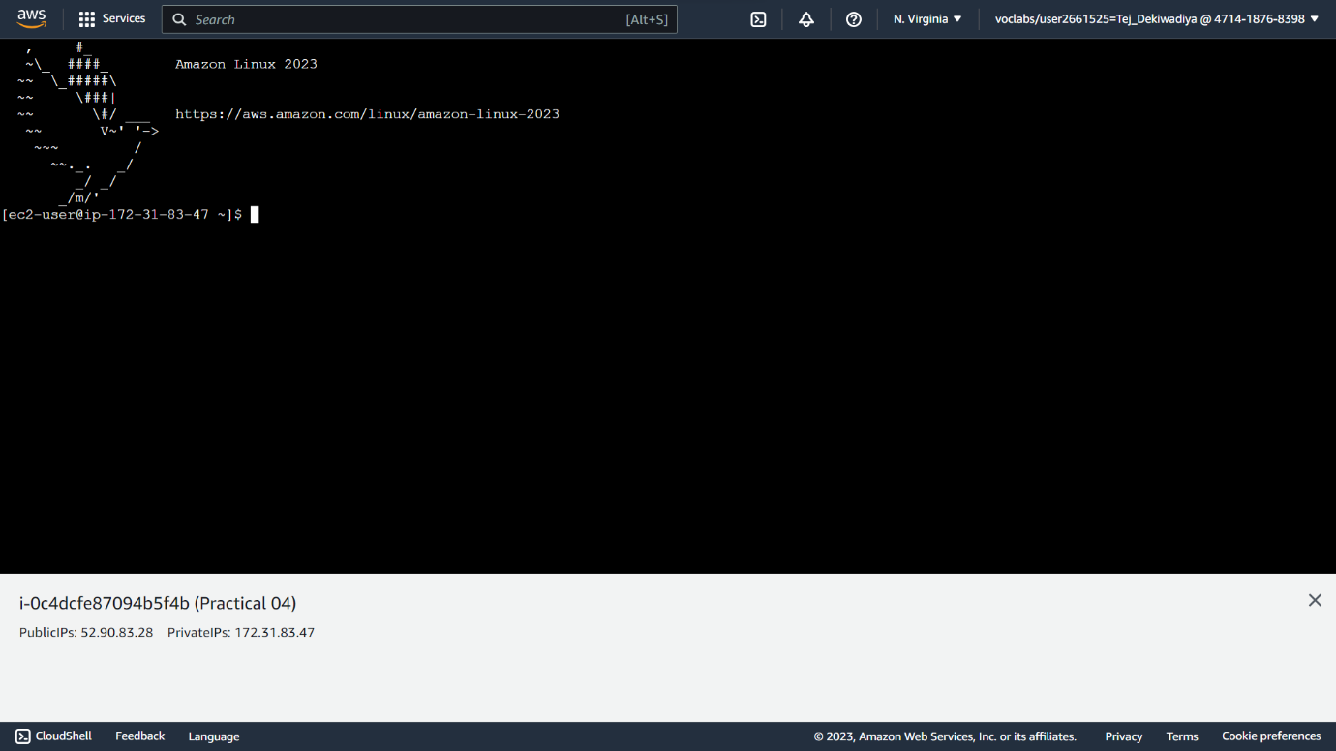

**Step 05 :** Now here first of all take root permission using **sudo su**

After that update the terminal through command **yum update**

Then install httpd using command **yum install httpd**

**Snapshot :**

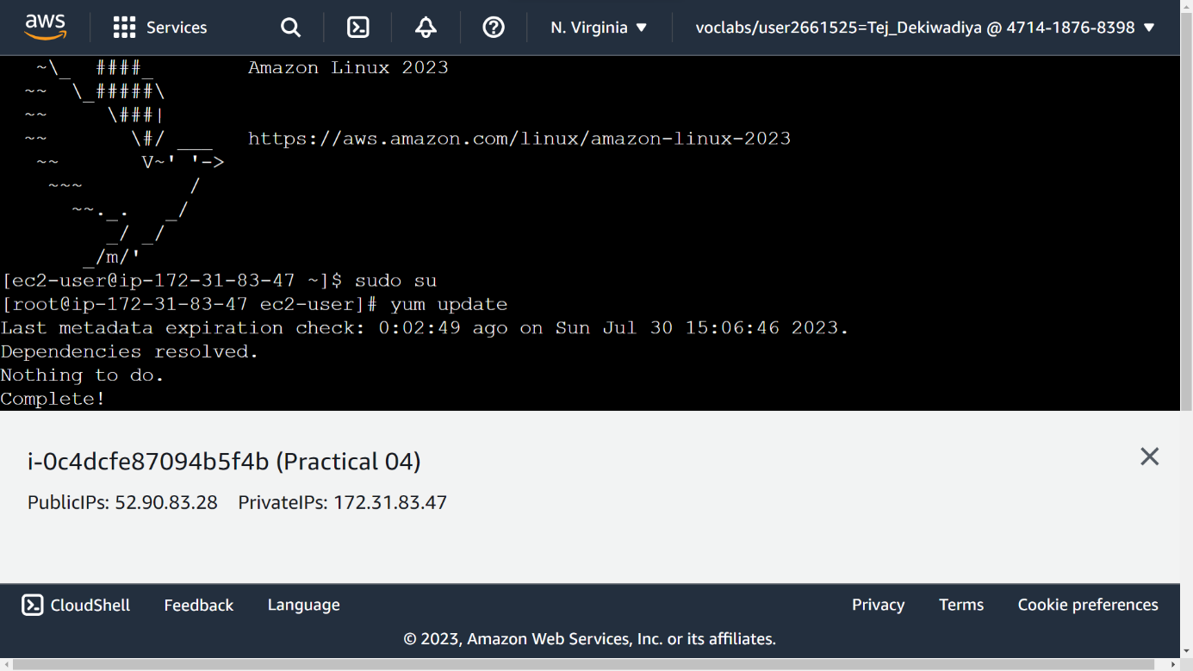

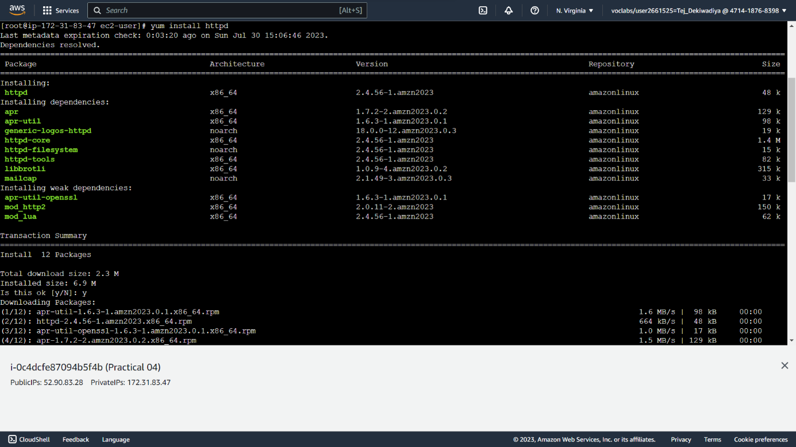

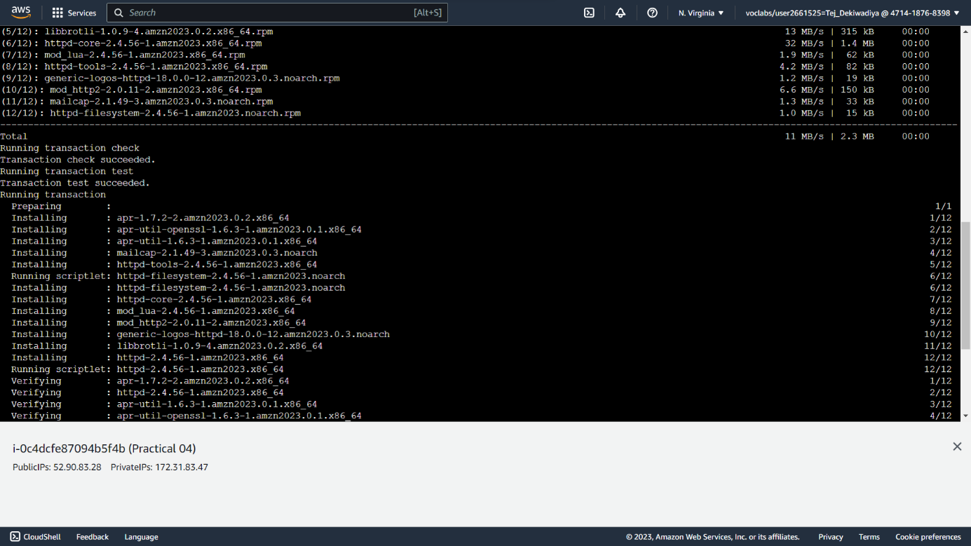

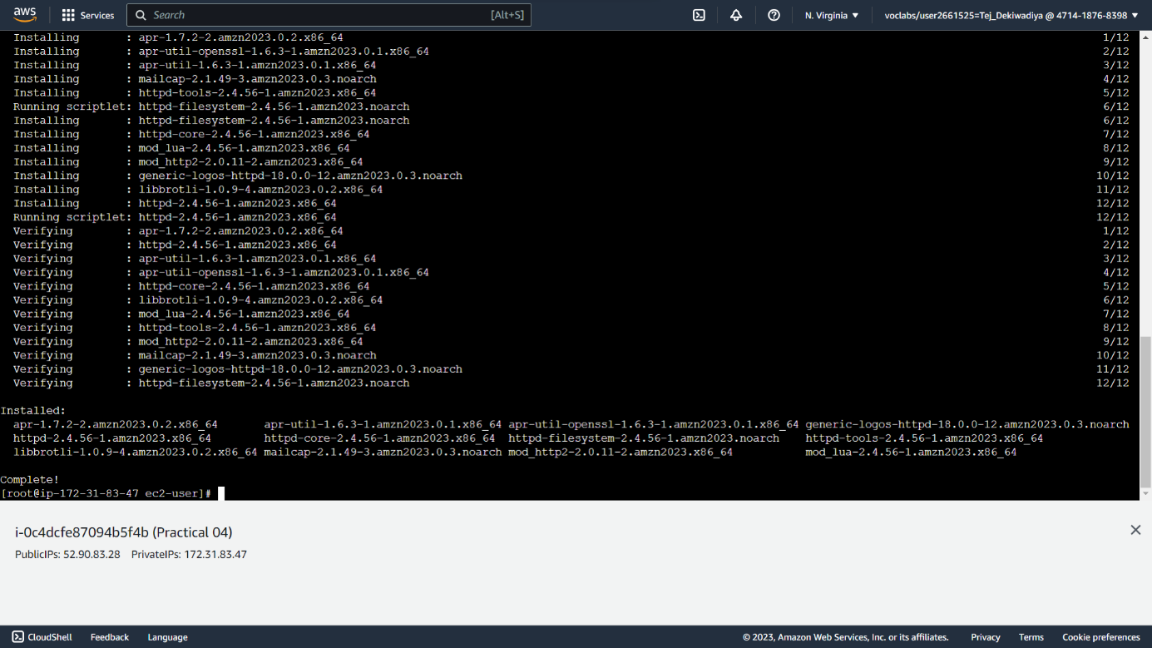

**Step 06 :** Now check the status of **httpd 🡪 systemctl** **status httpd**

Then active the status of **httpd 🡪 systemctl** **enable httpd**

**Snapshot :**

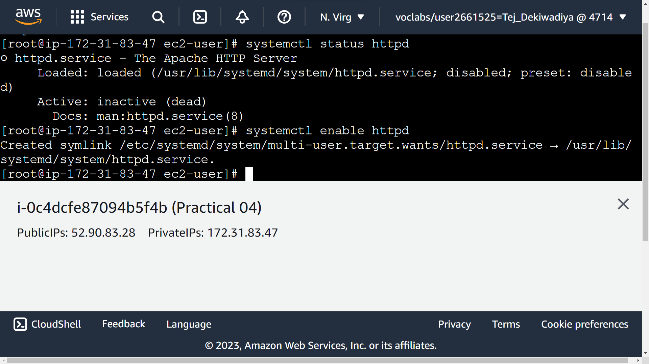

**Step 07 :** Choose any template from Internet and on download button through right click select copy link address.

**Snapshot :**

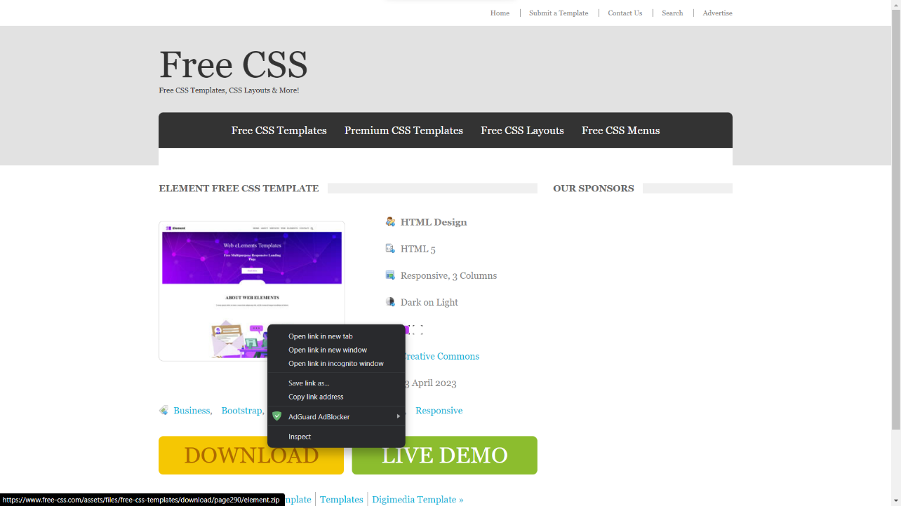

**Step 08 :** Paste url link in terminal 🡪 **wget** **url_link**

In that link attached one zip file after that unzip that file 🡪 **unzip filename**

**Snapshot :**

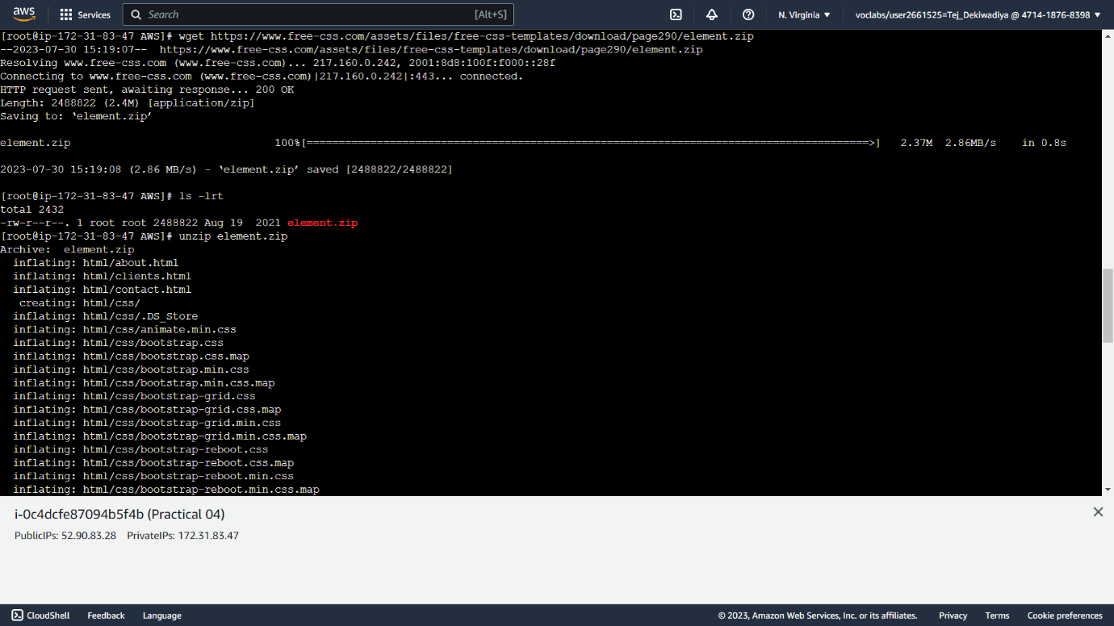

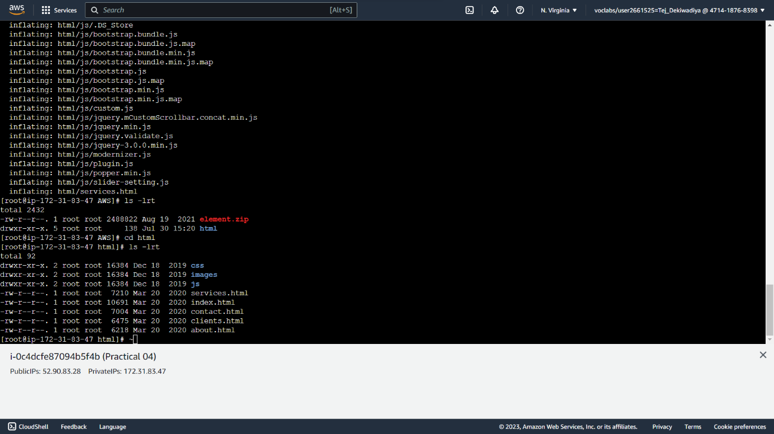

**Step 09 :** Now check all the files 🡪 **ls -lrt**

After that move all the file in particular directory **/var/www/html** 🡪 **mv * /var/www/html/**

And go to that directory 🡪 **cd /var/www/html/**

**Snapshot :**

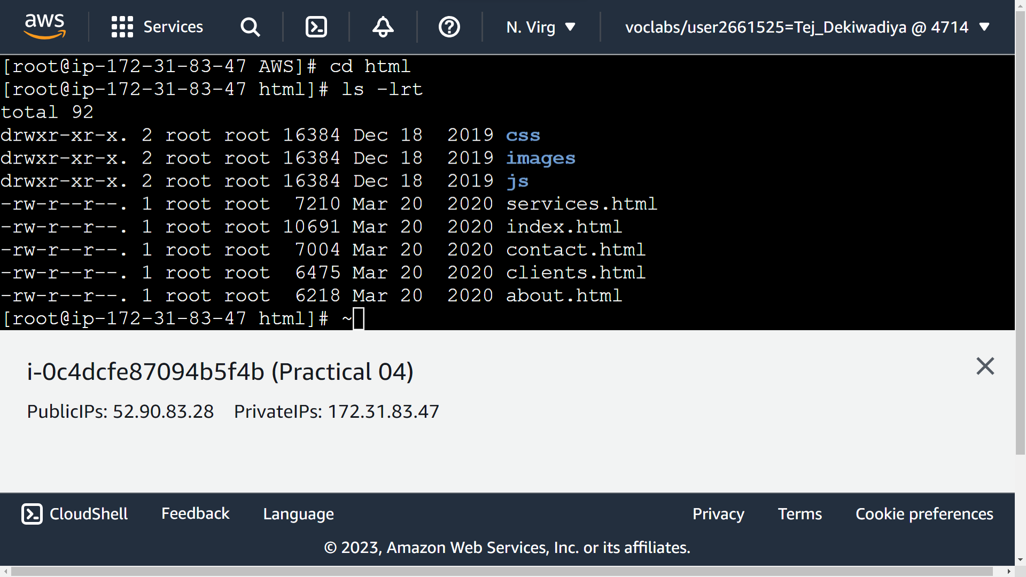

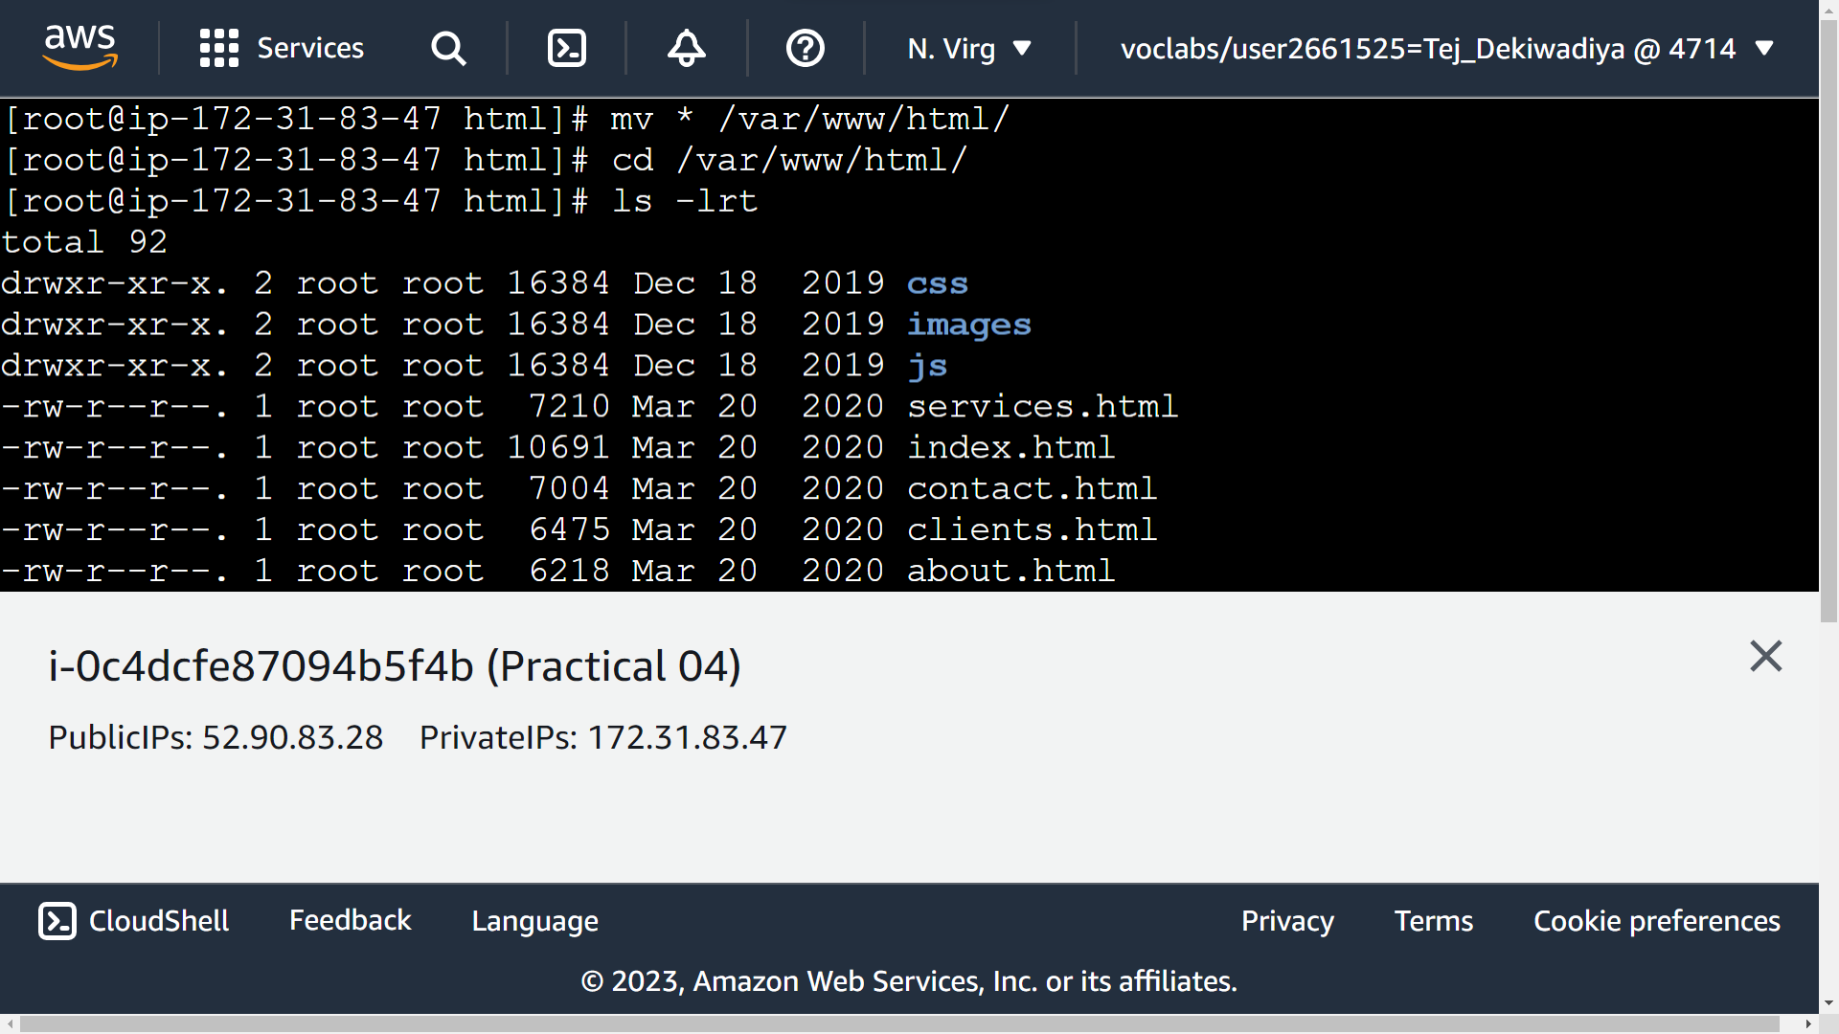

**Step 10 :** Now open Instance Configuration and click on Security then choose Security Group.

**Snapshot :**

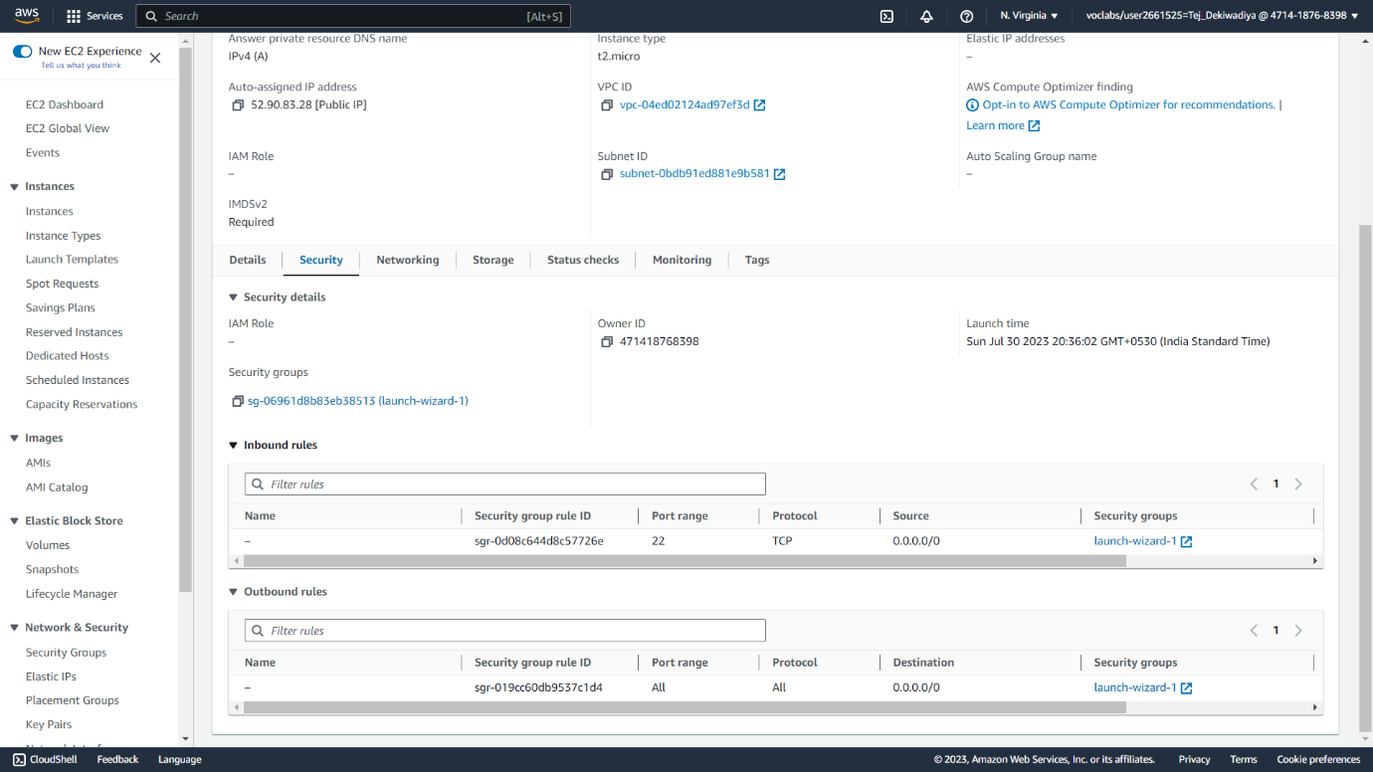

**Step 11 :** Now Here in Inbound Rules only SSH allow right now.

**Snapshot :**

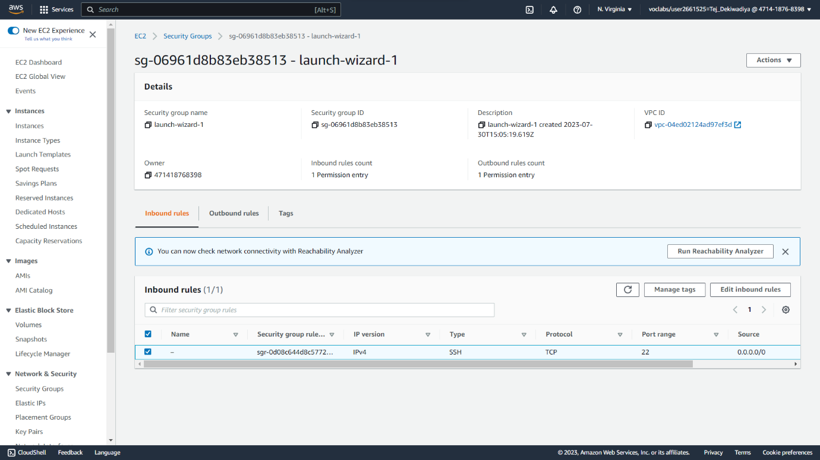

**Step 12 :** Click on Edit Inbound Rules and add HTTP & HTTPS protocol and allow everywhere so for that choose 0.0.0.0/0 then save data.

**Snapshot :**

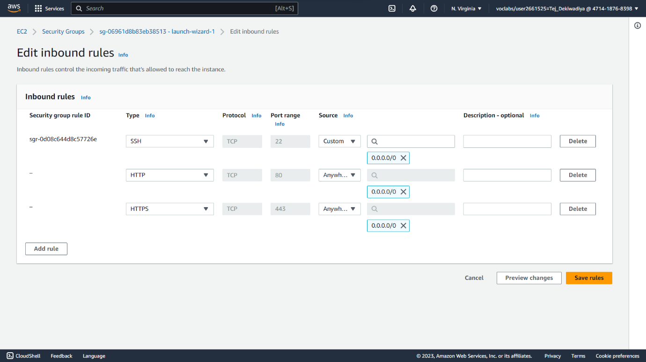

**Step 13 :** Now here All the Added rules are visible.

**Snapshot :**

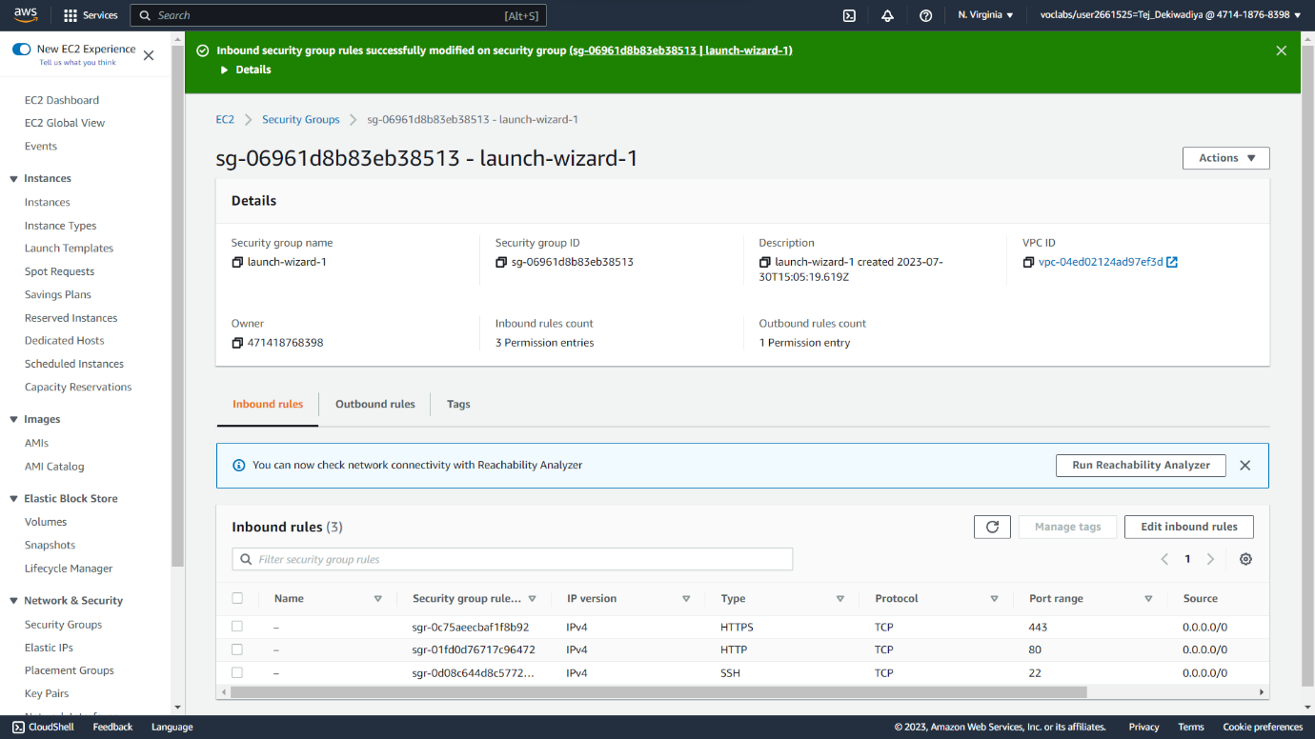

**Step 14 :** At last start httpd service 🡪 **systemctl start httpd**

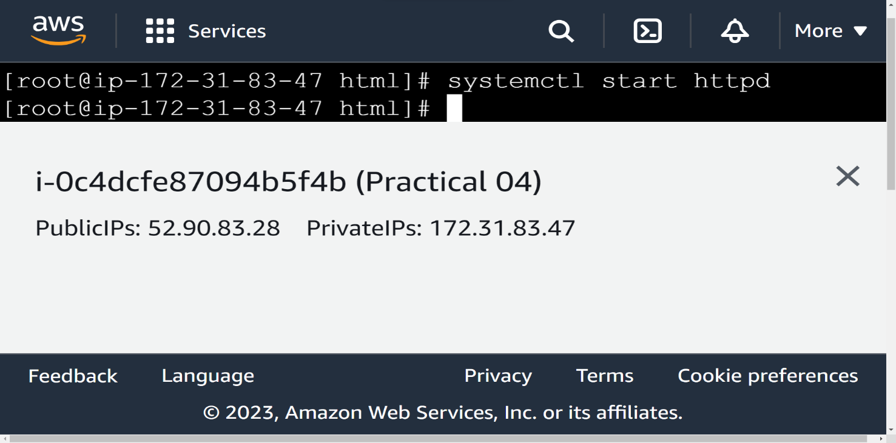**Snapshot :**

**Step 15 :** Finally copy Public IPV4 address new a new tab and run so now our web Site deploy on Cloud Server.

**Snapshot :**

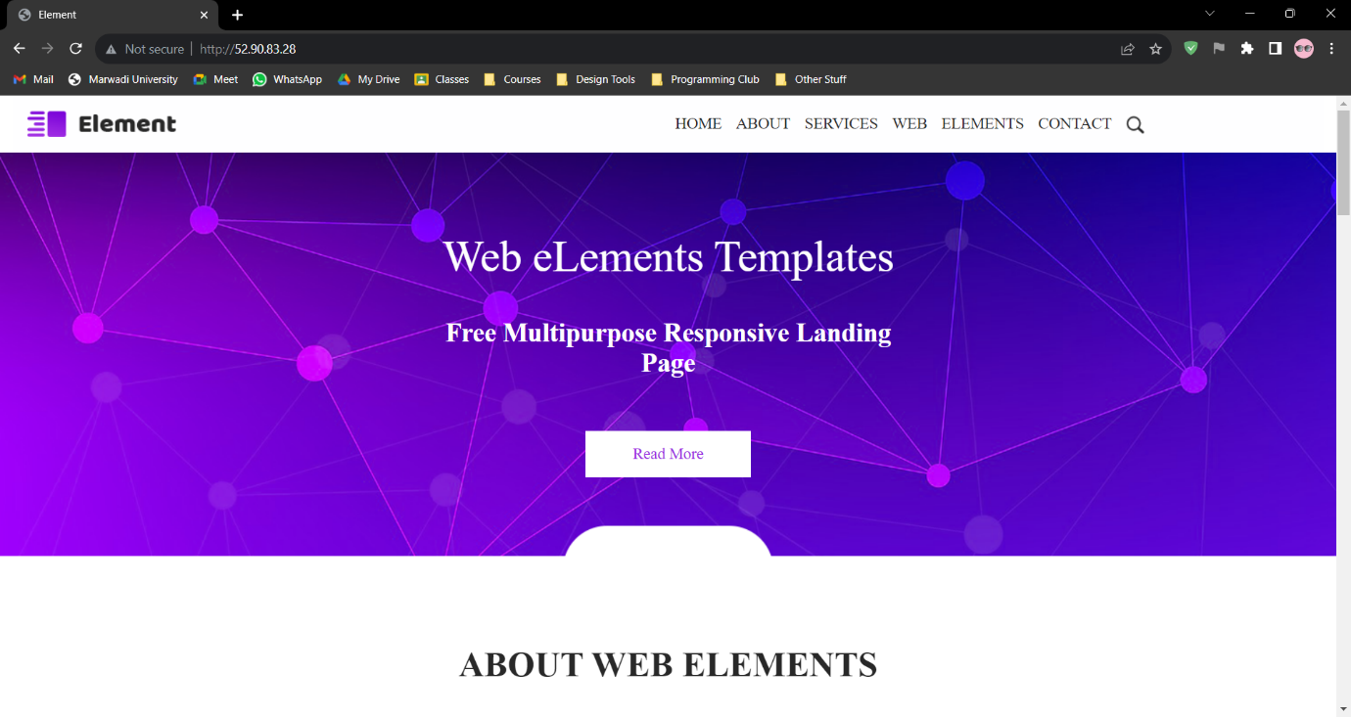

**Practical 05 : Amazon EC2 Instances with Microsoft Windows**

**Step 01 :** Create one new Instance and whenever create Instance choose all the settings by default.

**Snapshot :**

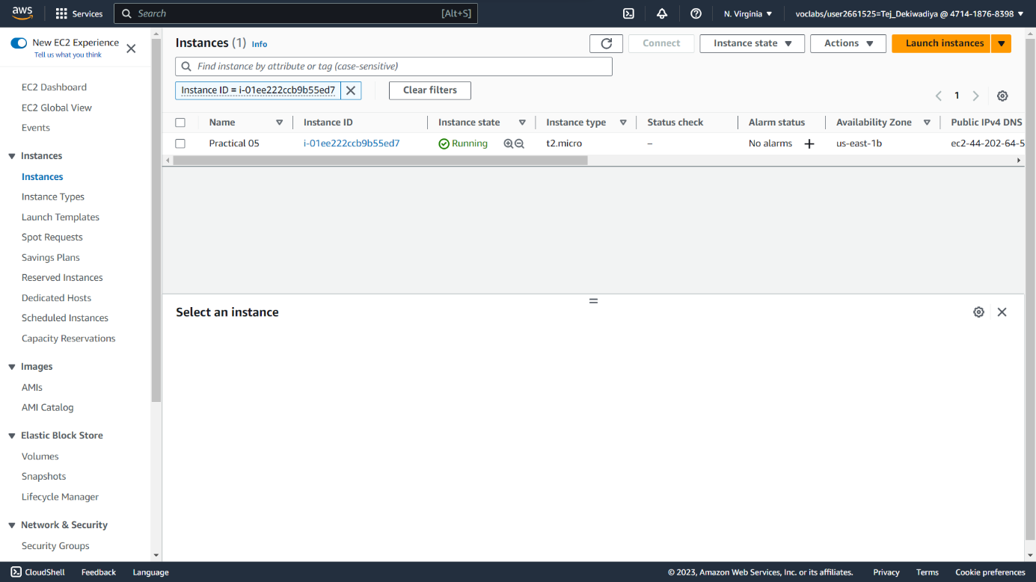

**Step 02 :** After the instance is created go to your instance id and click on ‘connect’

**Snapshot :**

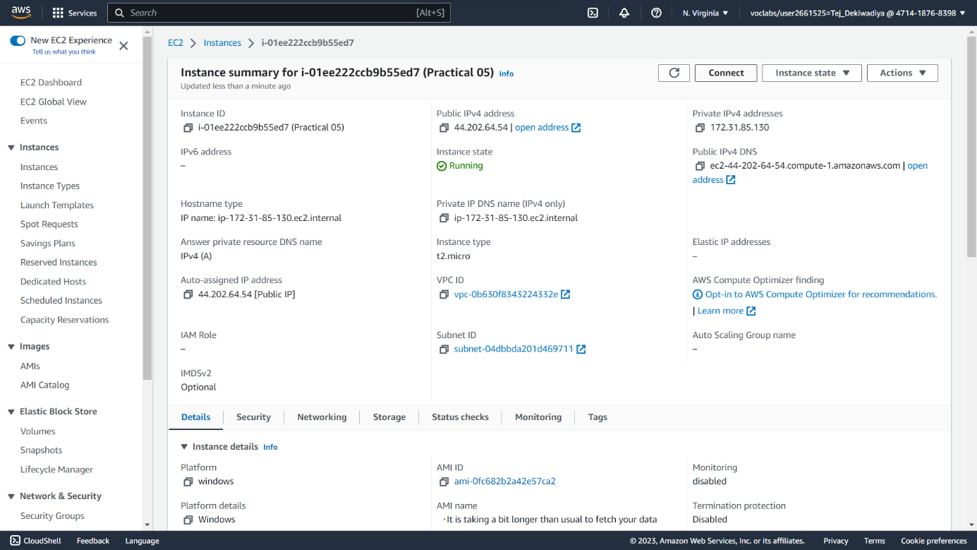

**Step 03 :** Now go to ‘RDP Client’.

**Snapshot :**

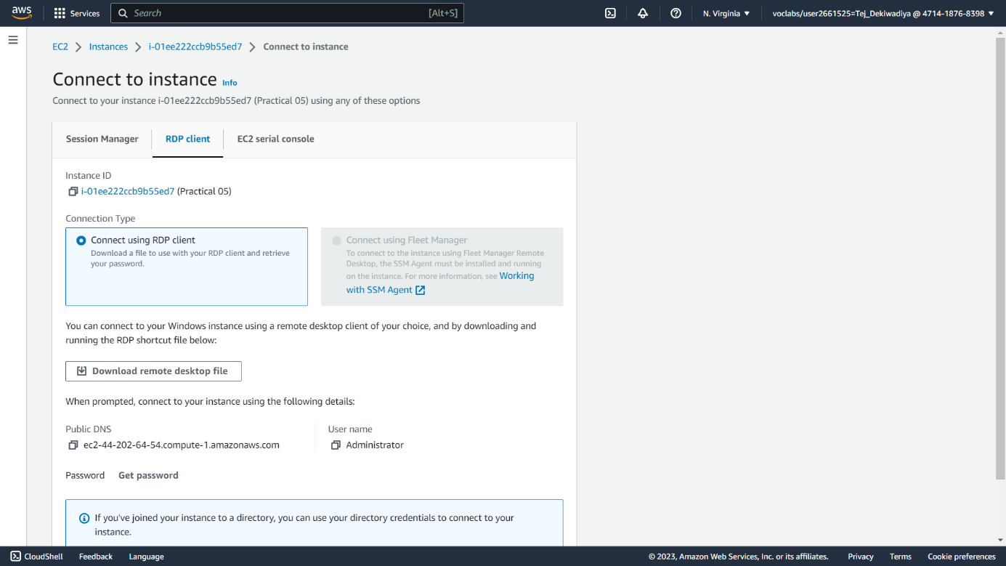

**Step 04 :** Now download the remote desktop file.

**Snapshot :**

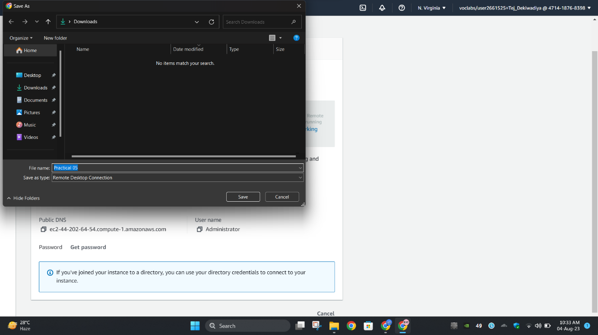

**Step 05 :** After downloading the remote desktop file, go to ‘Get password’.

**Snapshot :**

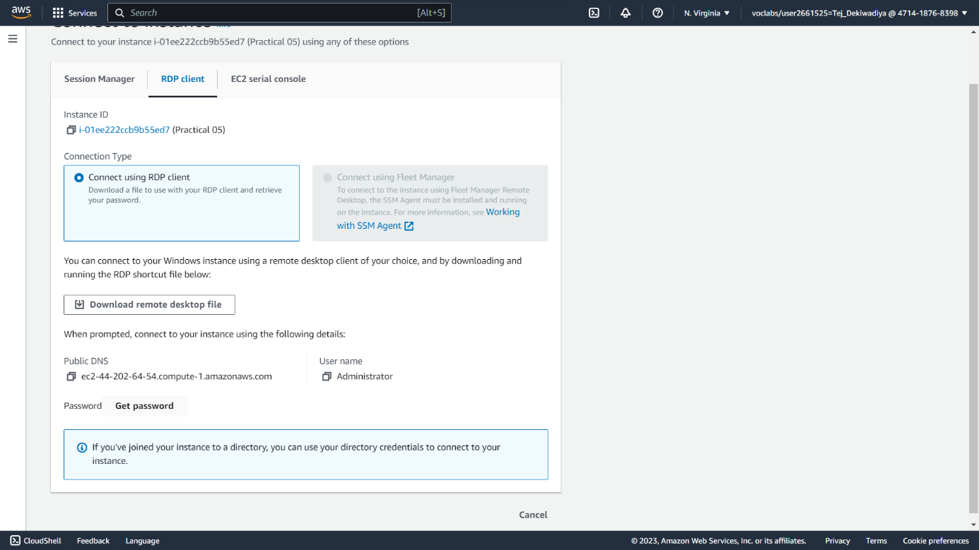

**Step 06 :** Upload private key file and click on Decrypt password.

**Snapshot :**

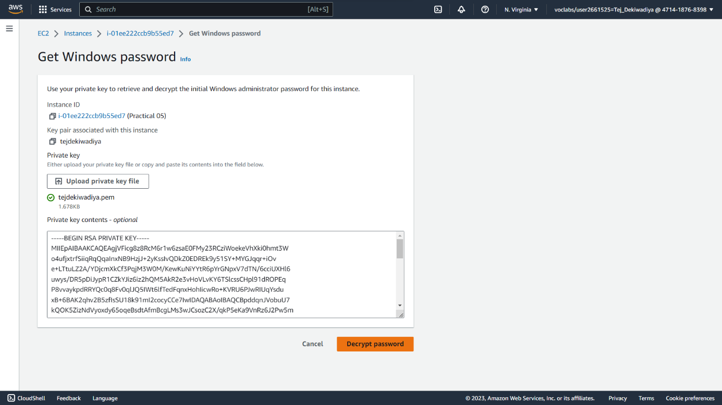

**Step 07 :** Now the password is visible to us. Copy the password.

**Snapshot :**

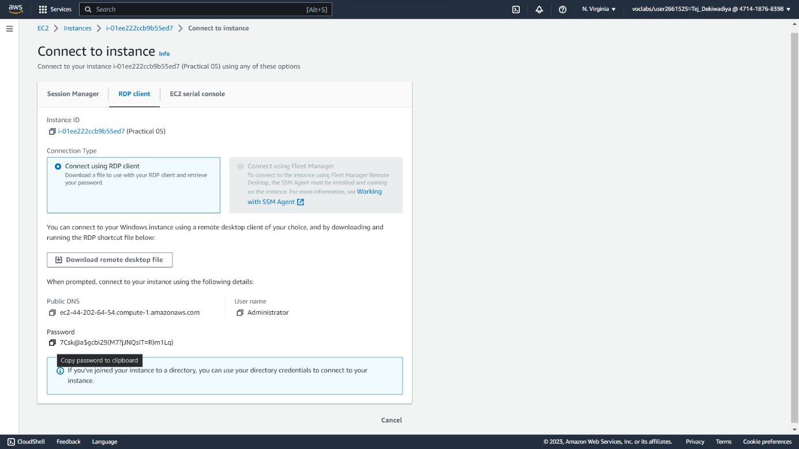

**Step 08 :** Open the remote desktop file and paste the copied password.

**Snapshot :**

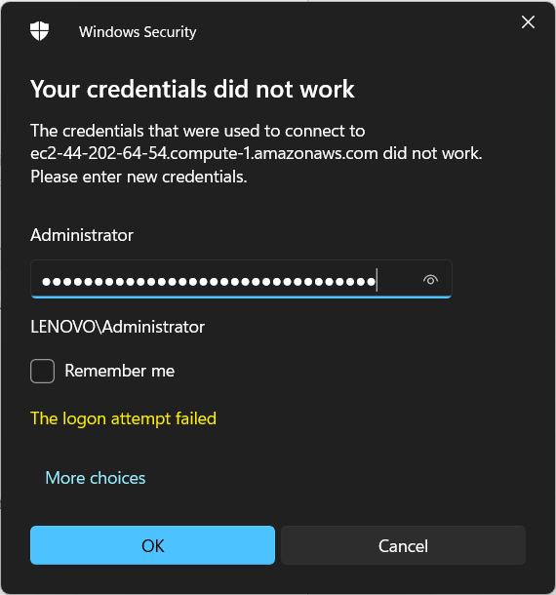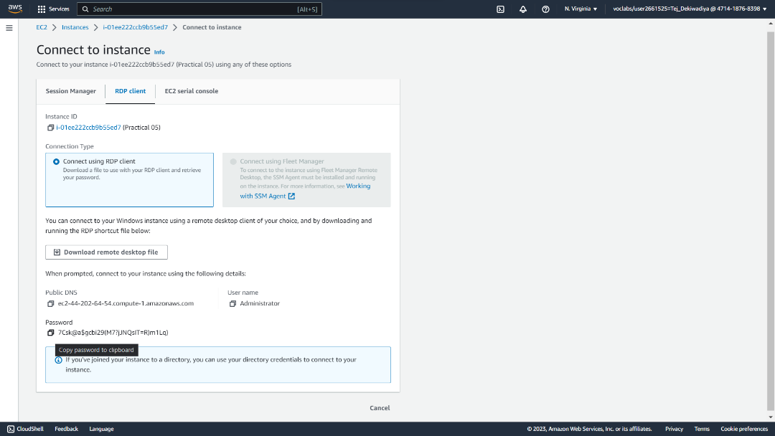

**Step 09 :** Successfully created EC2 instance with Microsoft Windows.

**Snapshot :**

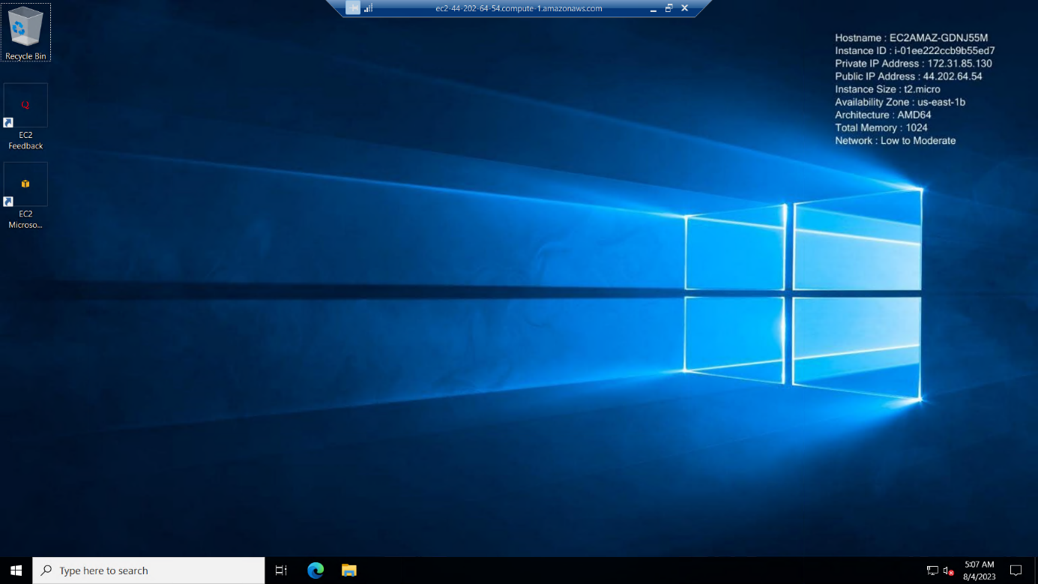

**Practical 06 : Amazon Elastic Block Store**

**Step 01 :** Go to manager panel 🡪 Elastic Block Store 🡪 Volumes. And Check how many exists**.**

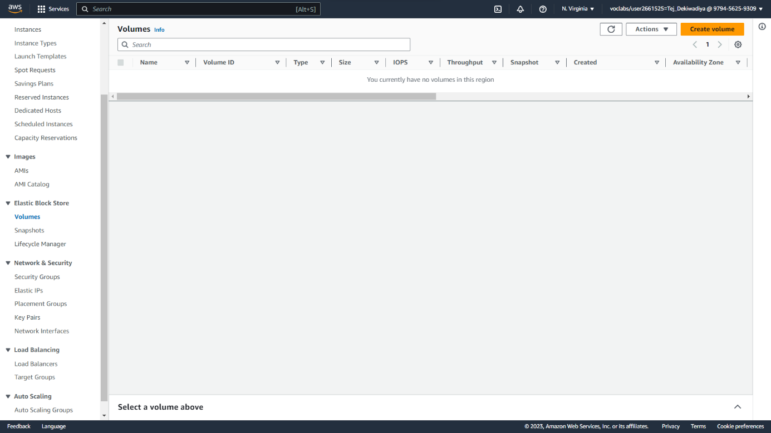**Snapshot :**

**Step 02 :** To Configure The Instance. First, Set The **Name** Of The Instance and Next Step Is To Choose The Application And **OS Images Ubuntu > Ubuntu Server 22.04 LTS**

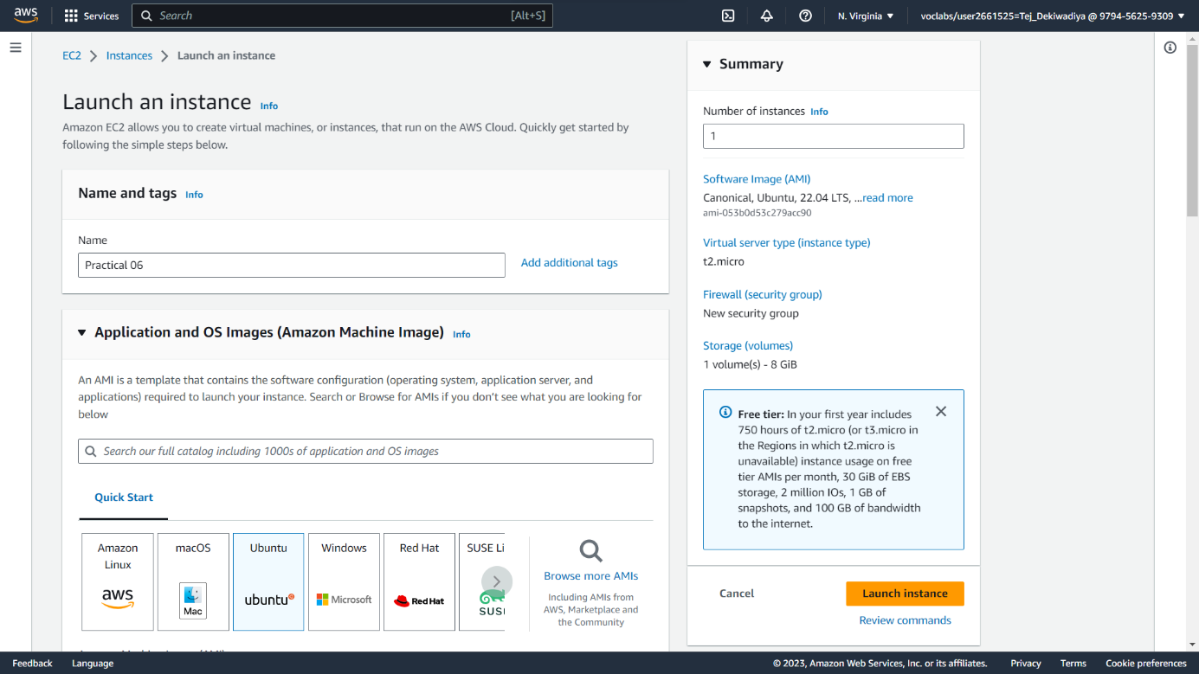**Snapshot :**

**Step 03 :** Next Step Is To Create New **Key Pair** In Key Pair (Login) Section and Provide A **Key Pair** Name And Then Click On "**Create Key Pair**" To Generate The Key Pair. (Downloading One File While Creating)

**Snapshot :**

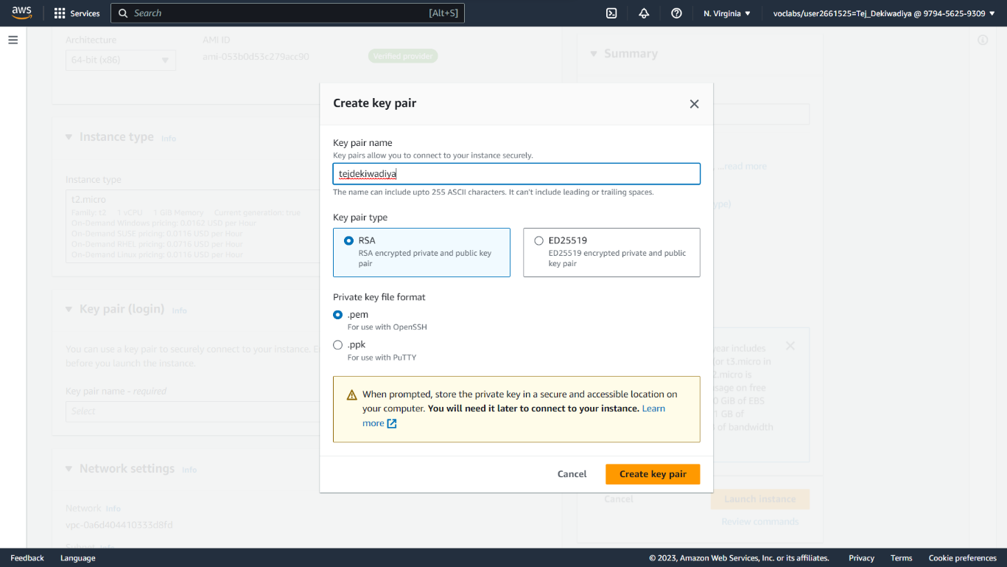

**Step 04 :** The Process Of Launching The Instance Will Begin, And It May Take A Few Seconds To Complete **Successfully**. Once It's Ready, Click On The Instance Id To Launch The Created Instance

**Snapshot :**

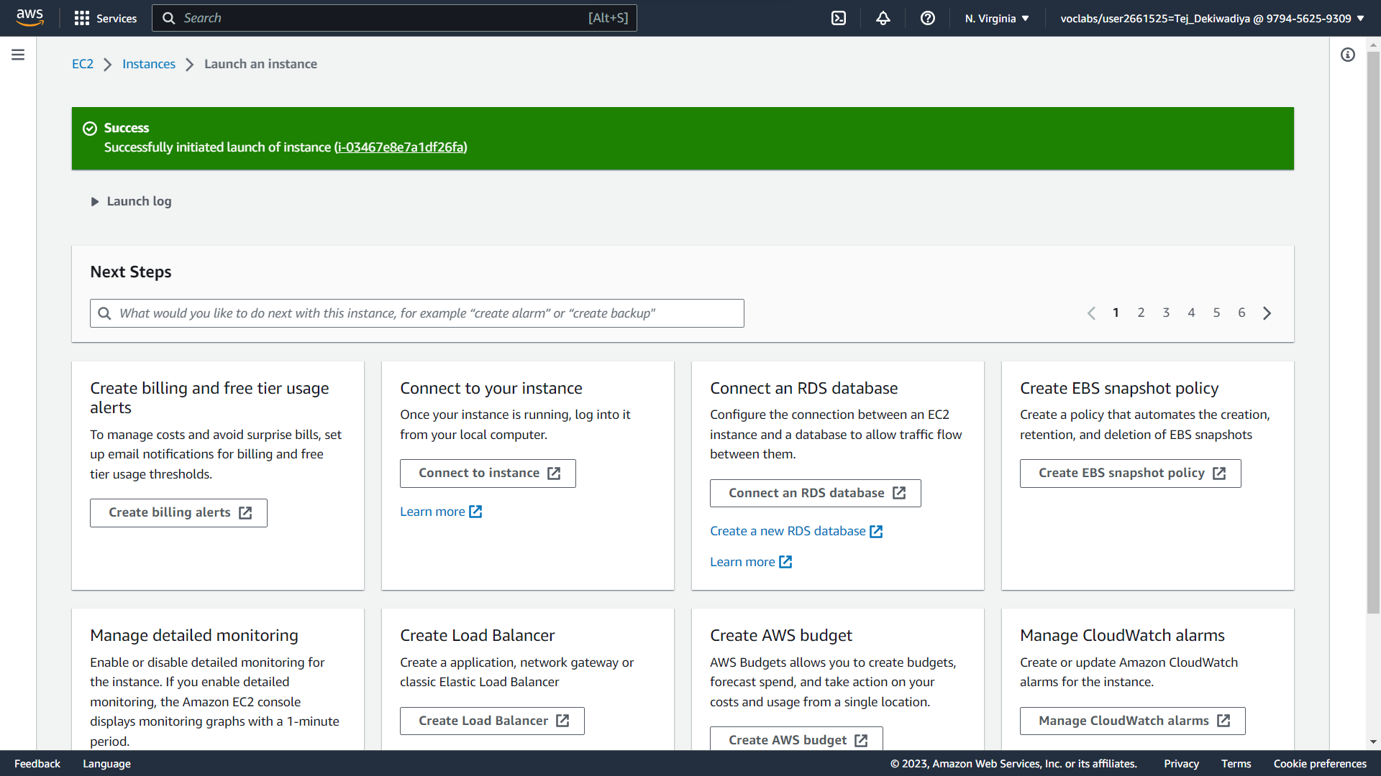

**Step 05 :** After Successfully Launching The Instance, Click On The "**Connect**" Button To Connect To The Instance.

**Snapshot :**

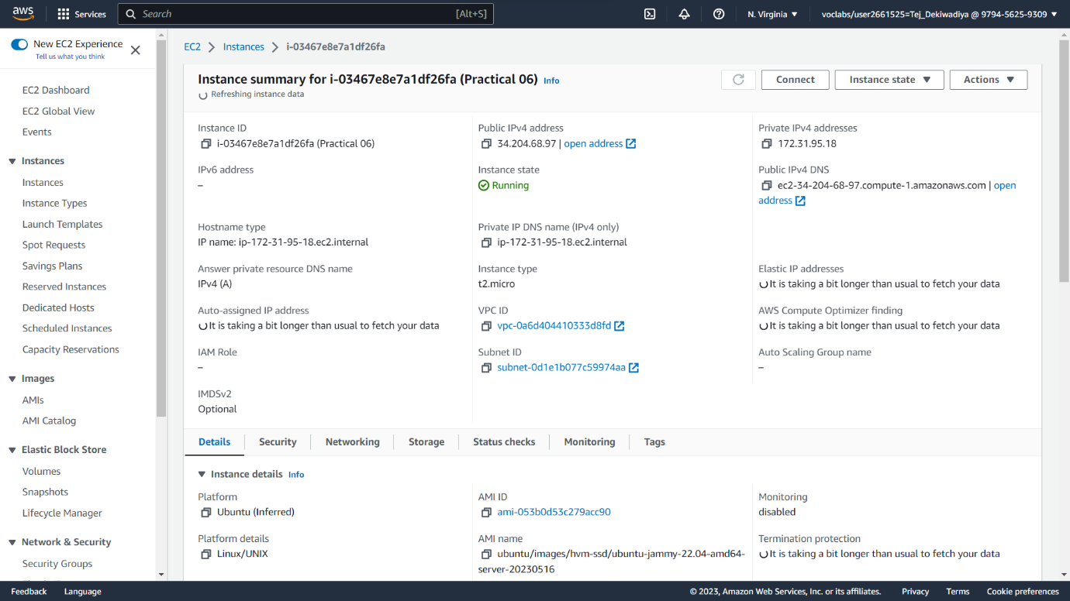

**Step 06 :** Default Terminal Opened.

**Snapshot :**

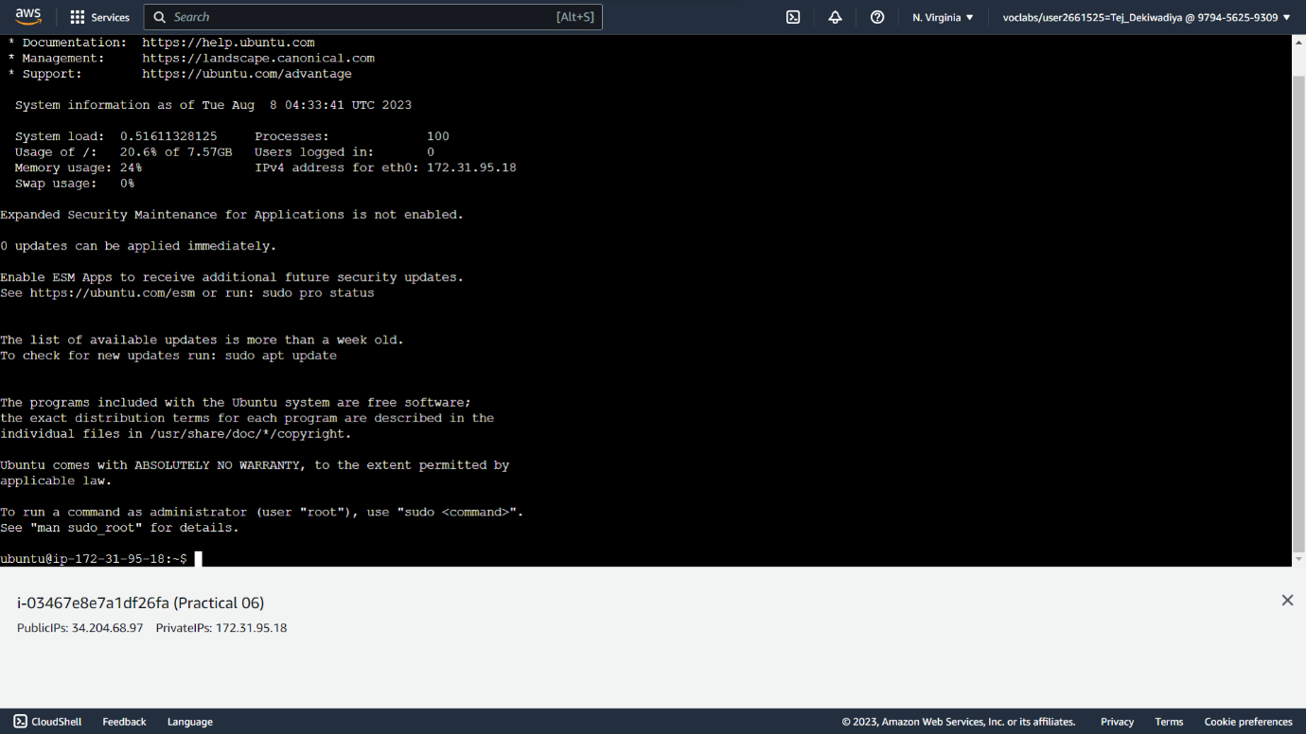

**Step 07 :** Go to manager panel 🡪 Elastic Block Store 🡪 Volumes. And Check the volumes successfully create by us.

**Snapshot :**

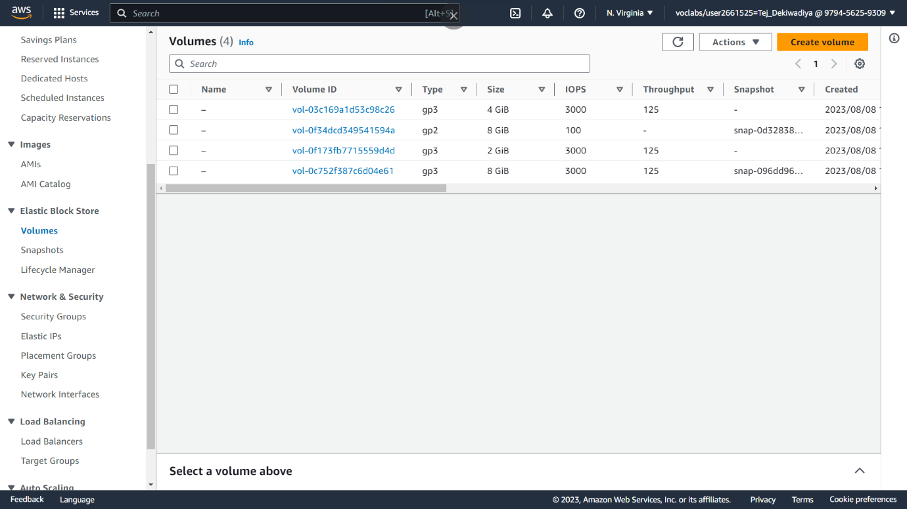

**Step 08 :** Write **lsblk** tocheck list block .

**Snapshot :**

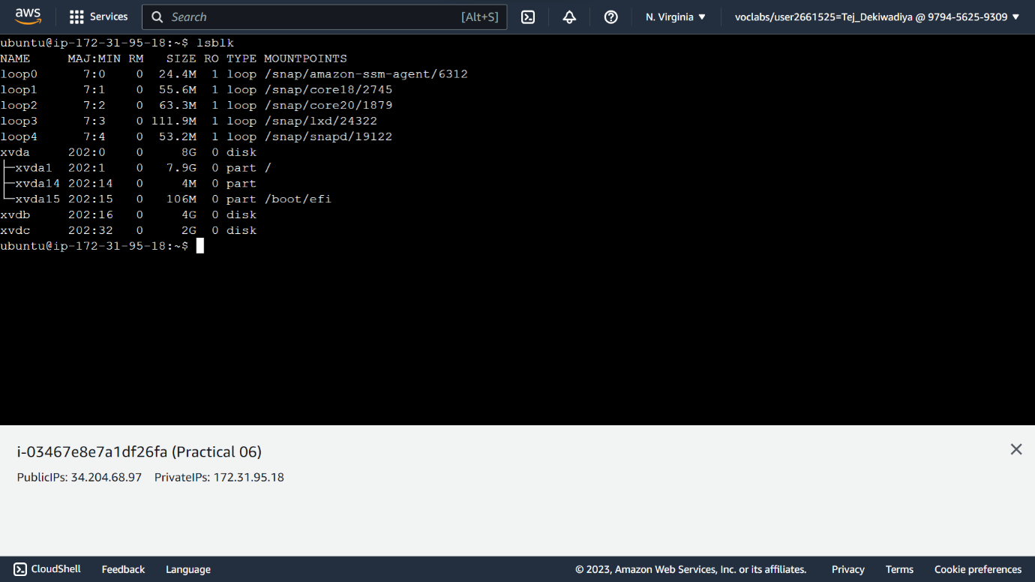

**Practical 07 : Google App Engine**

**1) What is the Google App Engine?**

**Ans:** Google App Engine is a Platform-as-a-Service (PaaS) offering by Google Cloud that allows developers to build, deploy, and manage applications on Google's infrastructure without having to worry about the underlying hardware, networking, and server management. It is designed to simplify the process of developing and hosting web applications, APIs, and other services.

* Key features of Google App Engine include:
* Scalability: App Engine automatically manages the scaling of your application based on the incoming traffic. It can handle sudden spikes in traffic without manual intervention.
* Managed Infrastructure: Developers don't need to worry about provisioning servers, managing networking, or configuring load balancers. Google takes care of these aspects.
* Languages and Runtimes: App Engine supports multiple programming languages such as Python, Java, Node.js, Ruby, Go, and PHP. It also offers various runtime environments for different languages.
* Data Storage: Google Cloud services like Cloud Datastore and Cloud SQL can be integrated for data storage. These services are designed to work seamlessly with App Engine.
* Automatic Updates: Google handles operating system updates and security patches for the underlying infrastructure, freeing developers from these tasks.
* Security: App Engine provides security features like sandboxing, access control, and automatic SSL certificates for secure communication.
* Task Queues: It offers task queues to manage asynchronous tasks, allowing you to offload time-consuming processes from the main application.
* Deployment: Deploying your application is as simple as uploading your code. Google takes care of the deployment process, ensuring that it's distributed across multiple servers for redundancy.
* App Versions: You can deploy multiple versions of your application, which can be useful for testing and rolling out updates gradually.
* Monitoring and Logging: App Engine provides tools for monitoring the performance of your application and analyzing logs to troubleshoot issues.
* Billing: App Engine operates on a pay-as-you-go model, where you're billed based on the resources your application consumes.
* App Engine is suitable for various types of applications, from small prototypes and startups to large-scale, production-grade applications. It abstracts much of the complexity involved in managing infrastructure, allowing developers to focus on writing code and building features.

**2) What is the use of the Google App Engine?**

**Ans:** Google App Engine serves as a Platform-as-a-Service (PaaS) offering that provides a range of use cases for developers and businesses. Here are some common uses of Google App Engine:

* Web Application Hosting: Developers can use App Engine to host and deploy web applications, whether they are simple websites, content management systems, or more complex web services. App Engine's automatic scaling ensures that applications can handle varying levels of traffic without manual intervention.
* API Services: App Engine can be used to create and host APIs (Application Programming Interfaces) that allow different applications to communicate with each other. This is particularly useful for building backend services for mobile apps, web apps, and other client applications.
* Microservices: Developers can break down their applications into smaller, independently deployable services known as microservices. App Engine's managed infrastructure and automatic scaling make it easier to develop, deploy, and manage these microservices.
* Background Processing: App Engine offers task queues that enable developers to offload background processing tasks from the main application. This is useful for handling tasks that are time-consuming and don't need to be executed immediately.
* Data Processing: Developers can utilize App Engine to process and analyze large volumes of data using tools like MapReduce, BigQuery, or other data processing frameworks. This is particularly helpful for applications that require data-intensive operations.
* Prototyping and Testing: App Engine allows developers to quickly prototype and test their ideas without the need to set up and manage complex infrastructure. This can help accelerate the development cycle.
* Scalability: For applications that experience fluctuating traffic patterns, App Engine's automatic scaling ensures that resources are allocated as needed to accommodate varying levels of user activity.
* Content Management Systems (CMS): App Engine can host content management systems that allow users to create, manage, and publish digital content without the need for complex server management.
* Real-time Applications: Applications requiring real-time communication, such as chat applications or collaborative tools, can benefit from App Engine's scalability and support for WebSockets.
* IoT (Internet of Things) Backend: App Engine can serve as a backend for IoT devices, collecting and processing data from various connected devices and sensors.
* Game Backend: Game developers can use App Engine to build and deploy the backend services required for multiplayer games, leaderboards, and user authentication.
* E-commerce: App Engine can be used to host e-commerce platforms, handling the online storefront, product catalog, and checkout processes. In essence, Google App Engine simplifies the process of developing, deploying, and managing web applications and services, allowing developers to focus on writing code and creating innovative features without getting bogged down in the complexities of server management.

**3) What types of services are provided by Google App Engine?**

Ans: Google App Engine provides various services and features to help developers build, deploy, and manage applications. These services can be broadly categorized into the following types:

* **Compute Services:**
* **Standard Environment:**
* This is a runtime environment that supports specific programming languages, such as Python, Java, Node.js, Ruby, and Go. It offers automatic scaling, load balancing, and managed infrastructure. However, it has some limitations in terms of customization and third-party libraries.
* Flexible Environment (App Engine Flex): This environment allows more customization and supports a wider range of programming languages and runtimes. It's based on containers and provides more control over the underlying infrastructure.
* Data Storage and Management:
* Cloud Datastore:
* A NoSQL database service that provides scalable storage for structured data. It is designed to handle large amounts of data with high availability.
* Cloud SQL: A managed relational database service that supports MySQL, PostgreSQL, and SQL Server. It offers automated backups, scaling, and security features.
* Cloud Storage: A scalable object storage service for storing and retrieving large amounts of unstructured data, such as files and media.
* Networking and Integration:
* Network and Load Balancing:
* App Engine manages network traffic and load balancing to distribute incoming requests across multiple instances of your application.
* Cloud Pub/Sub: A messaging service that allows applications to send and receive messages between independent components.
* Cloud Endpoints: A service for building, deploying, and managing APIs, providing tools for generating client libraries and managing API access.
* Security and Identity:
* Identity-Aware Proxy: A service that provides identity-based access control and security for applications running on App Engine.
* App Engine Identity and Access Management (IAM): Allows you to control access to resources within your App Engine applications using IAM roles and permissions. Monitoring and Logging:
* Stackdriver Monitoring: Provides tools to monitor the performance of your application, including resource utilization, response times, and error rates.
* Stackdriver Logging: Offers centralized logging and analysis of application logs, helping you troubleshoot and identify issues. Task Queues and Background Processing:
* Task Queues: App Engine provides task queues for managing asynchronous tasks, allowing you to offload timeconsuming processes from your main application.
* Development and Deployment:
* App Deployment: Deploy your application code to App Engine using the gcloud command-line tool or through continuous integration pipelines.
* App Versions: Deploy multiple versions of your application for different purposes, such as development, testing, and production.
* Runtime Services:
* App Engine Services: In addition to the main application, you can create separate services within the same project to serve different purposes. Each service can have its own configuration and scaling settings. Task Scheduling:
* Cron Jobs: Schedule and automate tasks to run at specified intervals using App Engine's cron service. These services collectively provide a comprehensive platform for building and running web applications, APIs, microservices, and other types of software solutions on Google Cloud's infrastructure, with a focus on minimizing the operational overhead for developers.

**4) Comparison between Google App Engine and AWS**

**Ans:** Google App Engine and Amazon Web Services (AWS) are both cloud computing platforms that offer a range of services for building, deploying, and managing applications. However, they have some differences in terms of features, architecture, and focus. Here's a comparison between Google App Engine and AWS:

* Platform Focus:
* Google App Engine: Google App Engine focuses on providing a Platform-as-a-Service (PaaS) environment, abstracting much of the underlying infrastructure management from developers. It emphasizes ease of use, automatic scaling, and simplified deployment.
* AWS: AWS offers a broader set of services, including Infrastructure-as-a-Service (IaaS), PaaS, and more specialized services. While AWS provides a wide range of infrastructure options, it also offers higher flexibility but often requires more configuration and management.
* Service Models:
* Google App Engine: Primarily offers PaaS services with managed runtimes, automatic scaling, and abstracted infrastructure components.
* AWS: Offers a mix of IaaS, PaaS, and specialized services. AWS Elastic Beanstalk is the closest PaaS equivalent to Google App Engine.
* Compute Services:
* Google App Engine: Provides both Standard and Flexible environments, offering automatic scaling and abstraction of infrastructure. It's particularly suitable for web applications and APIs.
* AWS: Offers Amazon EC2 for virtual machines and AWS Elastic Beanstalk for PaaS-like deployment. AWS Lambda provides serverless compute for event-driven applications.
* Data Storage:
* Google App Engine: Integrates with Google Cloud Datastore (NoSQL), Cloud SQL (relational), and Cloud Storage (object storage).
* AWS: Offers Amazon RDS (relational), Amazon DynamoDB (NoSQL), Amazon S3 (object storage), and more.

* Networking:
* Google App Engine: Provides networking and load balancing for applications.
* AWS: Offers Amazon VPC for custom networking setups, Elastic Load Balancing, and other networking services.
* Serverless:
* Google App Engine: Offers automatic scaling, but serverless computing is more emphasized in Google Cloud Functions.
* AWS: Emphasizes serverless computing with AWS Lambda, allowing you to run code without provisioning or managing servers.
* Containers: Google App Engine: Offers containerization through the Flexible environment, allowing more control over the runtime environment.
* AWS: Provides Amazon ECS (Elastic Container Service) and Amazon EKS (Elastic Kubernetes Service) for container orchestration.

* Managed Services:
* Google App Engine: Provides many managed services, such as Datastore, Pub/Sub, and Stackdriver for monitoring.
* AWS: Offers a wide range of managed services like AWS RDS, DynamoDB, S3, and more.

* Market Share and Ecosystem:
* Google App Engine: Has a smaller market share compared to AWS, but is favored by developers who prefer Google's technologies and services.
* AWS: Dominates the cloud computing market with a wide array of services and a large customer base. In summary, Google App Engine is a PaaS offering focused on simplicity, while AWS offers a broader range of services including both IaaS and PaaS. The choice between them depends on your application's requirements, your familiarity with the platform, and your preference for specific services and ecosystems.

**5) What are the Advantages of using the Google App Engine?**

**Ans:** Using Google App Engine offers several advantages for developers and businesses looking to build and deploy applications. Some of the key advantages include:

* Simplified Development: App Engine abstracts much of the underlying infrastructure, allowing developers to focus on writing code rather than managing servers, networking, and other infrastructure components. This speeds up development and reduces operational overhead.
* Automatic Scaling: App Engine automatically scales your application based on incoming traffic. This means your application can handle fluctuations in user activity without manual intervention. It's particularly beneficial for applications with unpredictable or variable workloads.
* Managed Infrastructure: Google handles hardware provisioning, load balancing, server maintenance, and security patching. This reduces the burden on developers and ensures a high level of availability and reliability.
* Multiple Runtimes: App Engine supports multiple programming languages and runtimes, including Python, Java, Node.js, Ruby, Go, and more. This allows developers to work in their preferred language without constraints.
* High Availability: Google's infrastructure is designed for high availability and fault tolerance. App Engine applications are distributed across multiple data centers, reducing the risk of downtime due to hardware failures.
* Data Storage Options: App Engine integrates with Google Cloud Datastore for NoSQL data storage and Cloud SQL for relational databases. This simplifies data management and allows you to choose the best fit for your application's data needs.
* Security Features: App Engine provides security features such as sandboxing, automatic SSL certificates, and Identity-Aware Proxy for controlling access to resources. Google's security expertise helps protect your application and data.
* Integrated Services: App Engine seamlessly integrates with other Google Cloud services, including Pub/Sub for messaging, Cloud Storage for file storage, and Stackdriver for monitoring and logging.
* Task Queues: App Engine offers task queues that enable you to offload time-consuming tasks to be executed asynchronously. This ensures responsiveness and optimal resource utilization.
* Deployment and Versioning: You can deploy multiple versions of your application and easily switch between them. This facilitates testing, gradual rollouts, and quick fixes.
* Cost Efficiency: With pay-as-you-go pricing, you only pay for the resources you use. App Engine's automatic scaling and efficient resource allocation contribute to cost savings.
* Elasticity: App Engine's ability to scale up or down based on demand means you don't need to over-provision resources, which can lead to cost savings during periods of lower usage.
* Vendor Lock-In Mitigation: While vendor lock-in is a consideration for any cloud provider, using App Engine within Google Cloud provides a level of familiarity and consistency if you're already using other Google Cloud services.
* Global Reach: Google Cloud has data centers located around the world, allowing you to deploy your application closer to your target audience for reduced latency and improved user experience.
* In summary, Google App Engine offers simplicity, automatic scaling, managed infrastructure, and a range of services that make it a powerful platform for developing and deploying web applications, APIs, and services. It's particularly suitable for developers who prioritize speed, ease of use, and efficient resource management.

**Practical 08 : Creating and configuring database instance**

**Step 01 :** In the AWS Management Console, on the Services menu, choose VPC

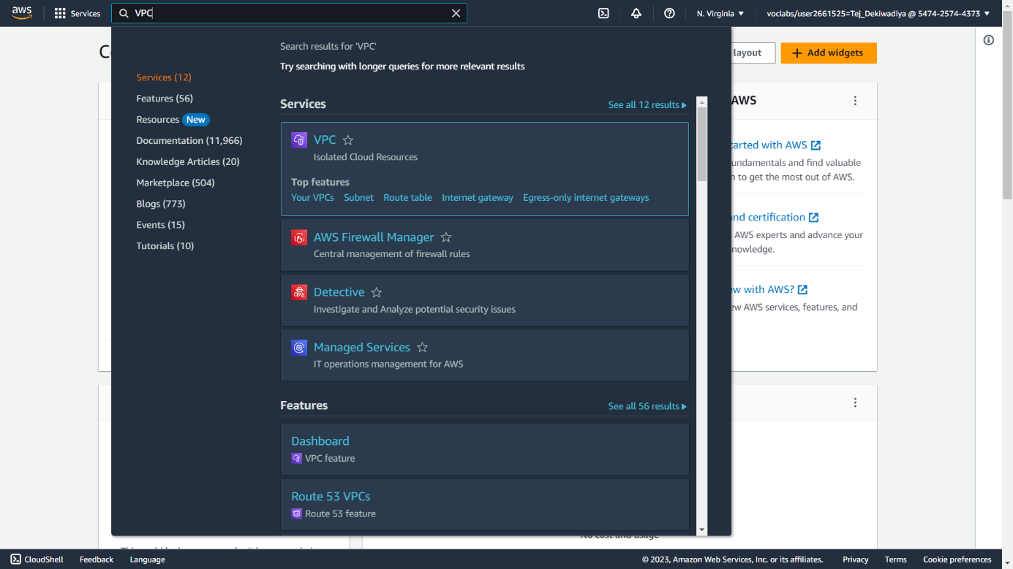**Snapshot :**

**Step 02 :** In the left navigation pane, choose Security Groups.

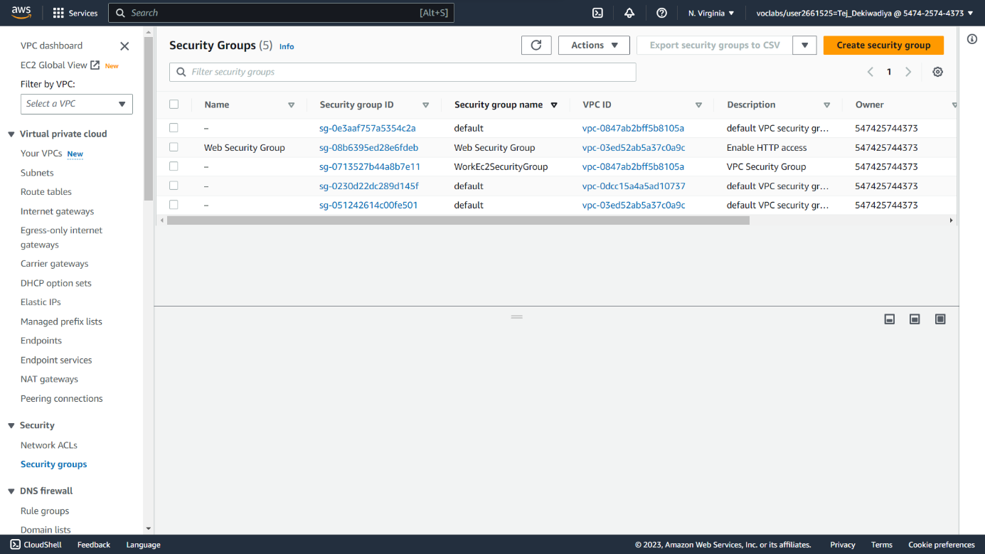**Snapshot :**

**Step 03 :** Choose Create security group and then configure:

* + **Security group name**: DB Security Group
  + **Description**: Permit access from Web Security Group
  + **VPC**: Lab VPC

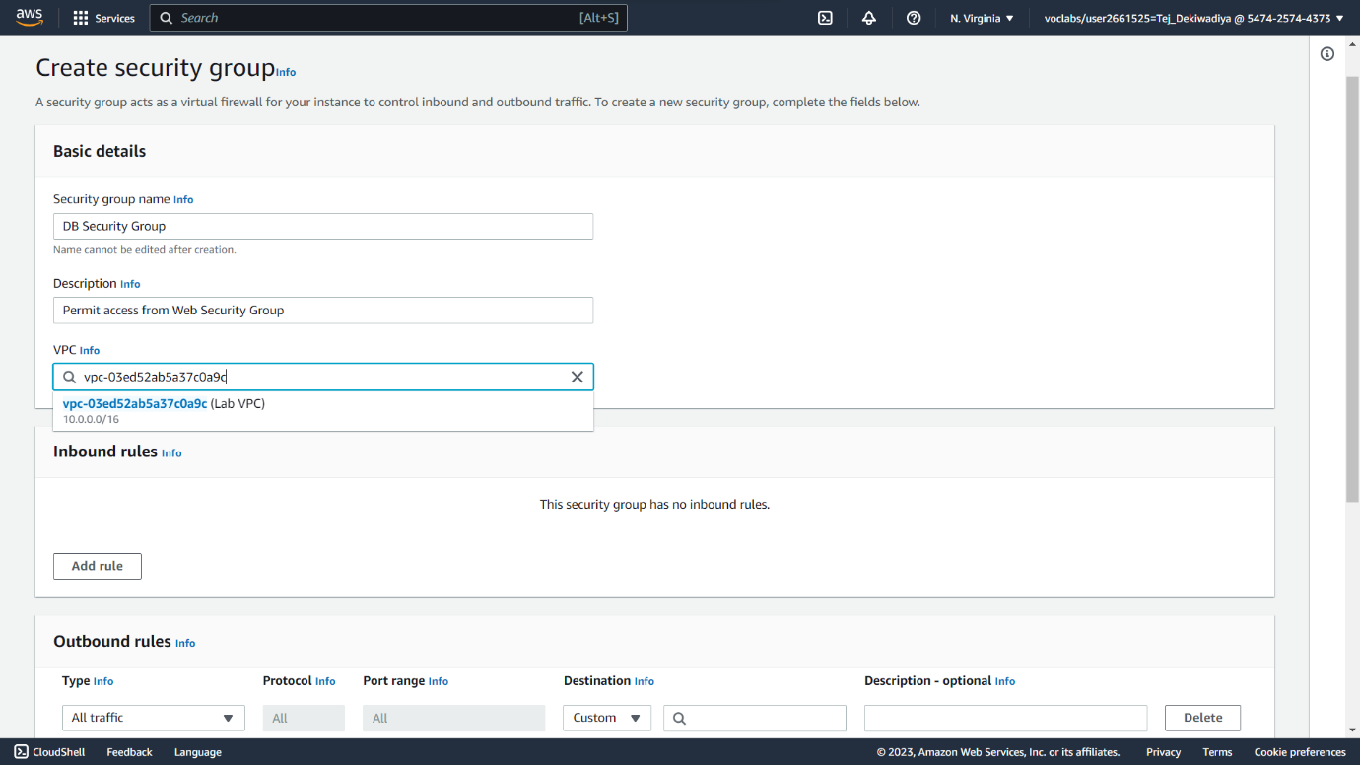**Snapshot :**

**Step 04 :** In the Inbound rules pane, choose Add rule**.**

* + **Type**: MySQL/Aurora (3306)
  + **CIDR, IP, Security Group or Prefix List**: Type **sg** and then select Web Security Group.
  + Choose Create security group

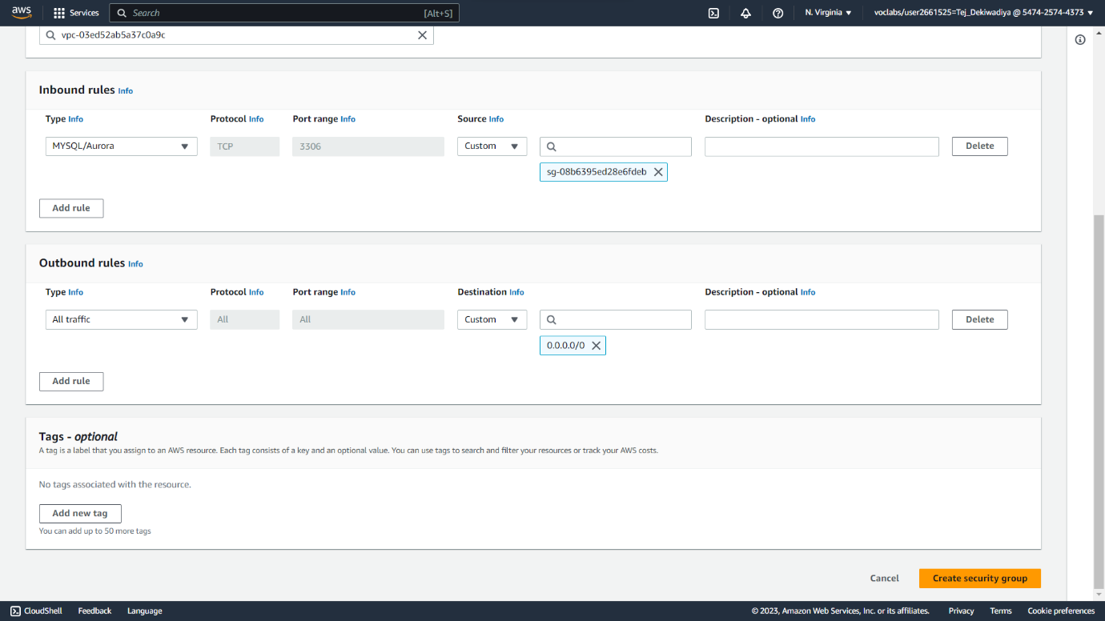**Snapshot :**

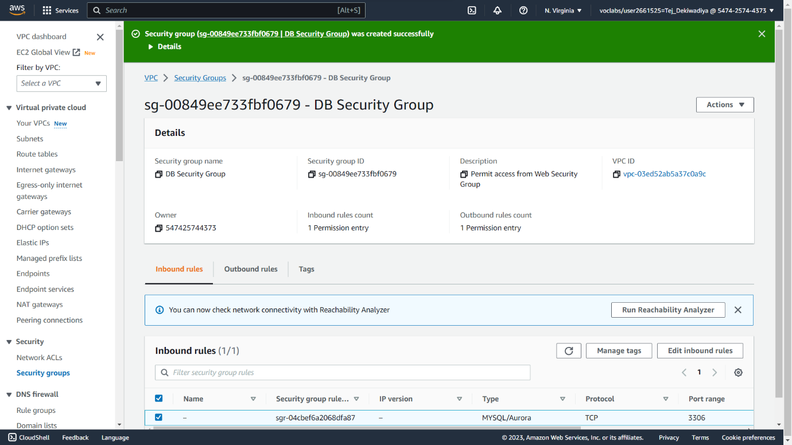

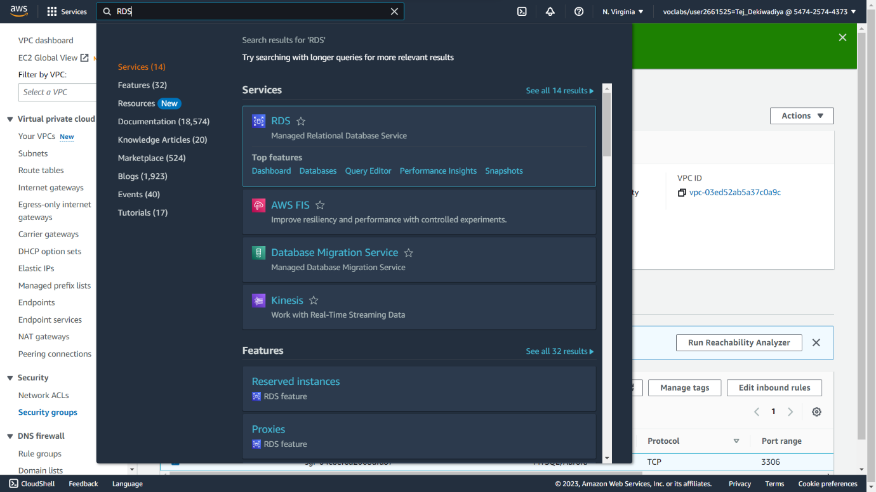**Step 05 :** On the Services menu, choose RDS.

**Snapshot :**

**Step 06 :** In the left navigation pane, choose Subnet groups.

**Snapshot :**

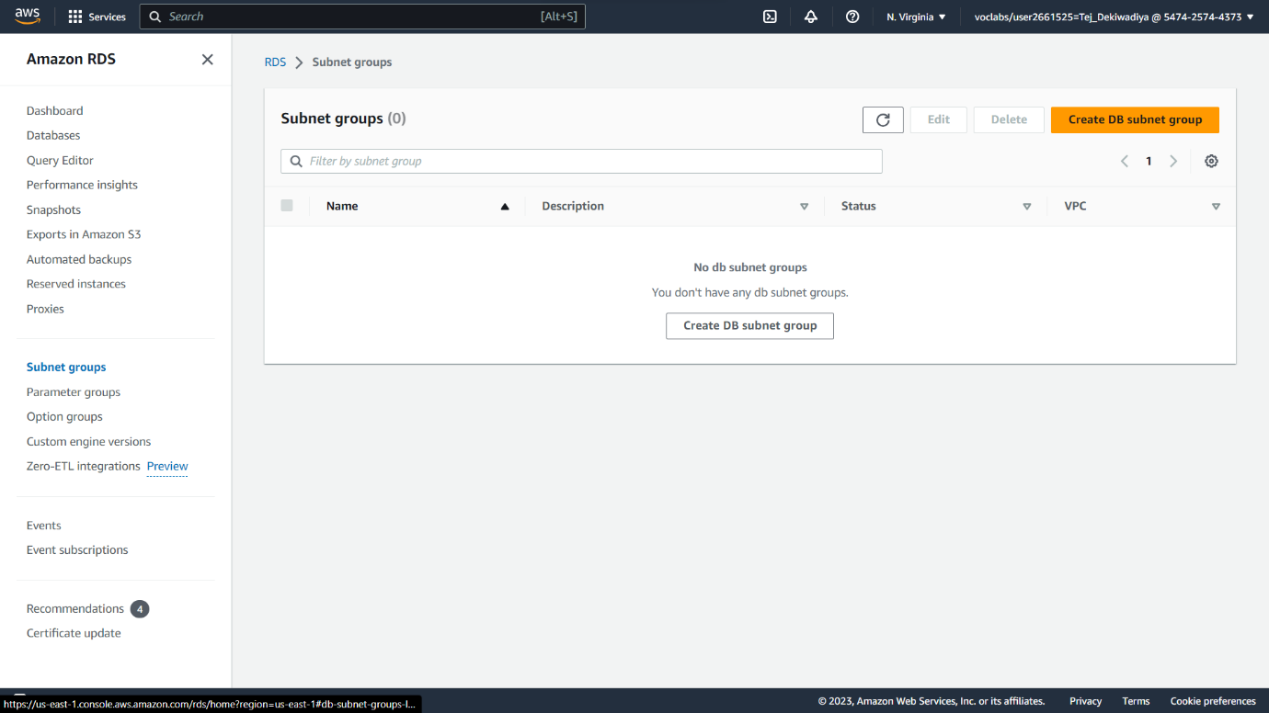

**Step 07 :** Choose Create DB Subnet Group then configure:

* + **Name**: DB-Subnet-Group
  + **Description**: DB Subnet Group
  + **VPC**: Lab VPC

**Snapshot :**

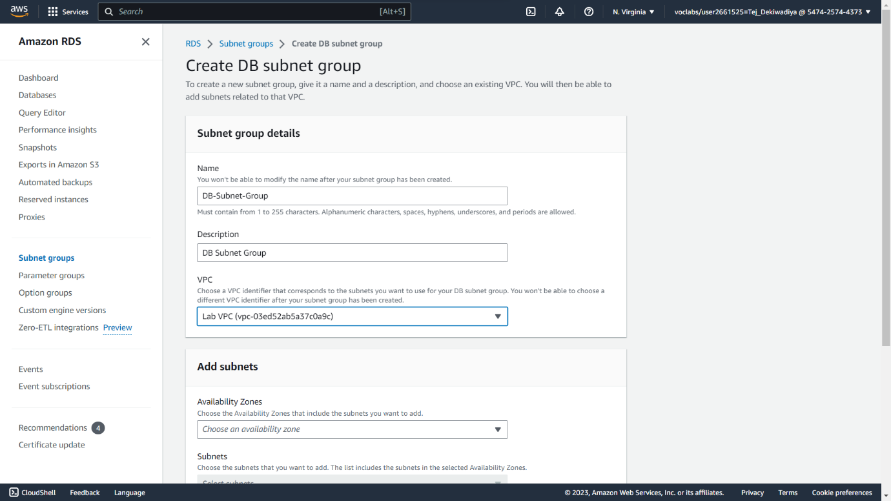

**Step 08 :** Scroll down to the Add Subnets section. Expand the list of values under Availability Zones and select the first two zones: us-east-1a and us-east-1b. Expand the list of values under Subnets and select the subnets associated with the CIDR ranges 10.0.1.0/24 and 10.0.3.0/24 Than Choose Create.

**Snapshot :**

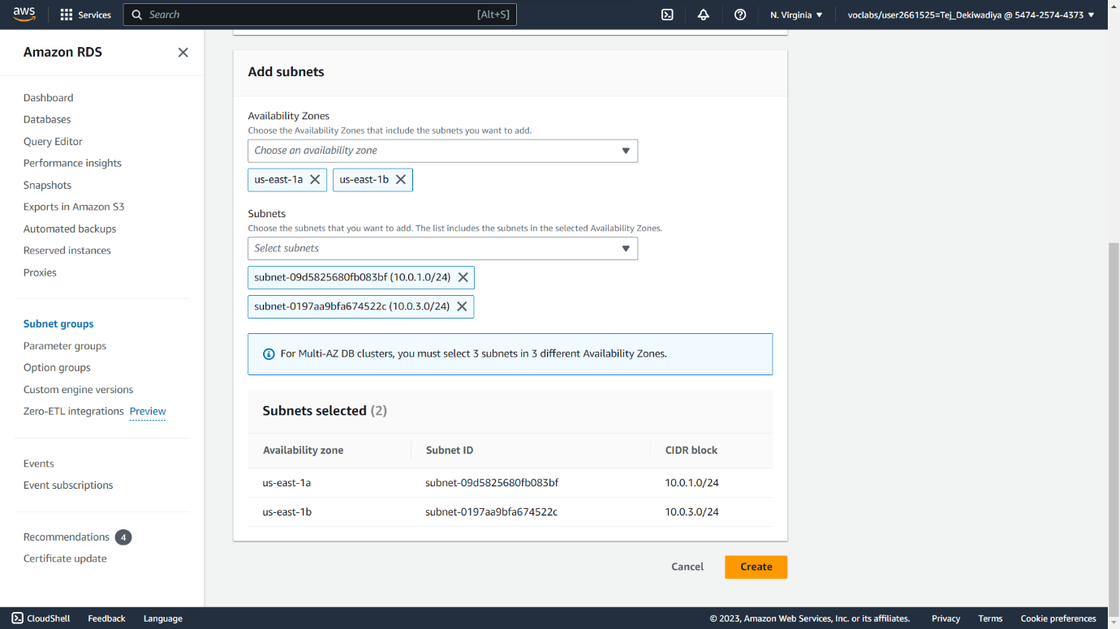

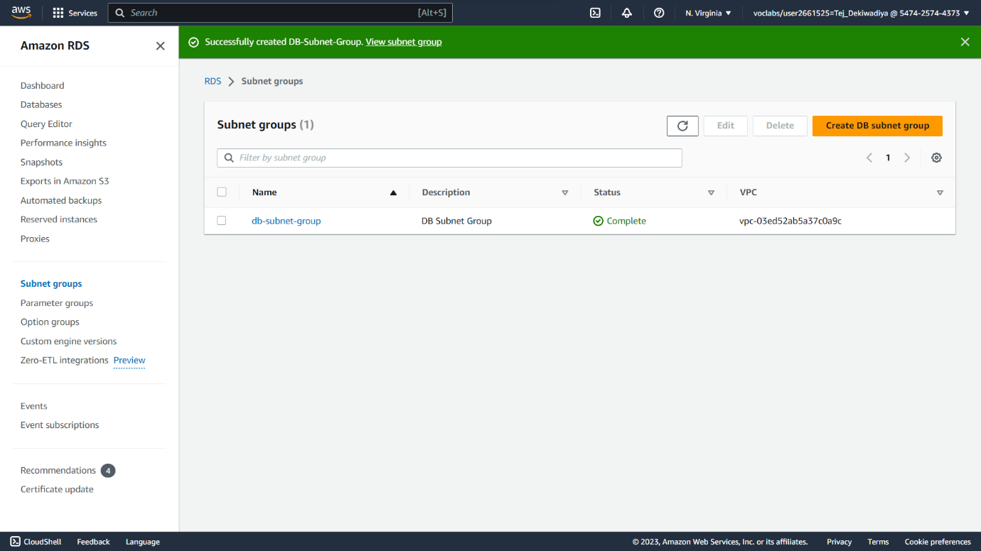

**Step 09 :** In the left navigation pane, choose Databases. Choose Create database.

**Snapshot :**

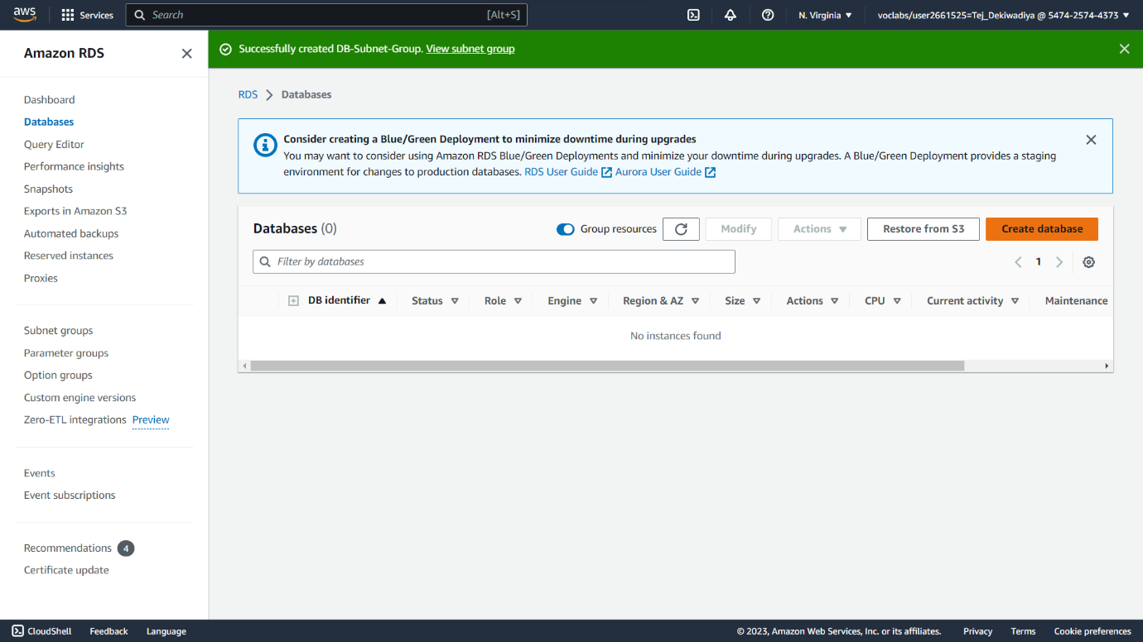

**Step 10 :** Select MySQL under Engine Options.

**Snapshot :**

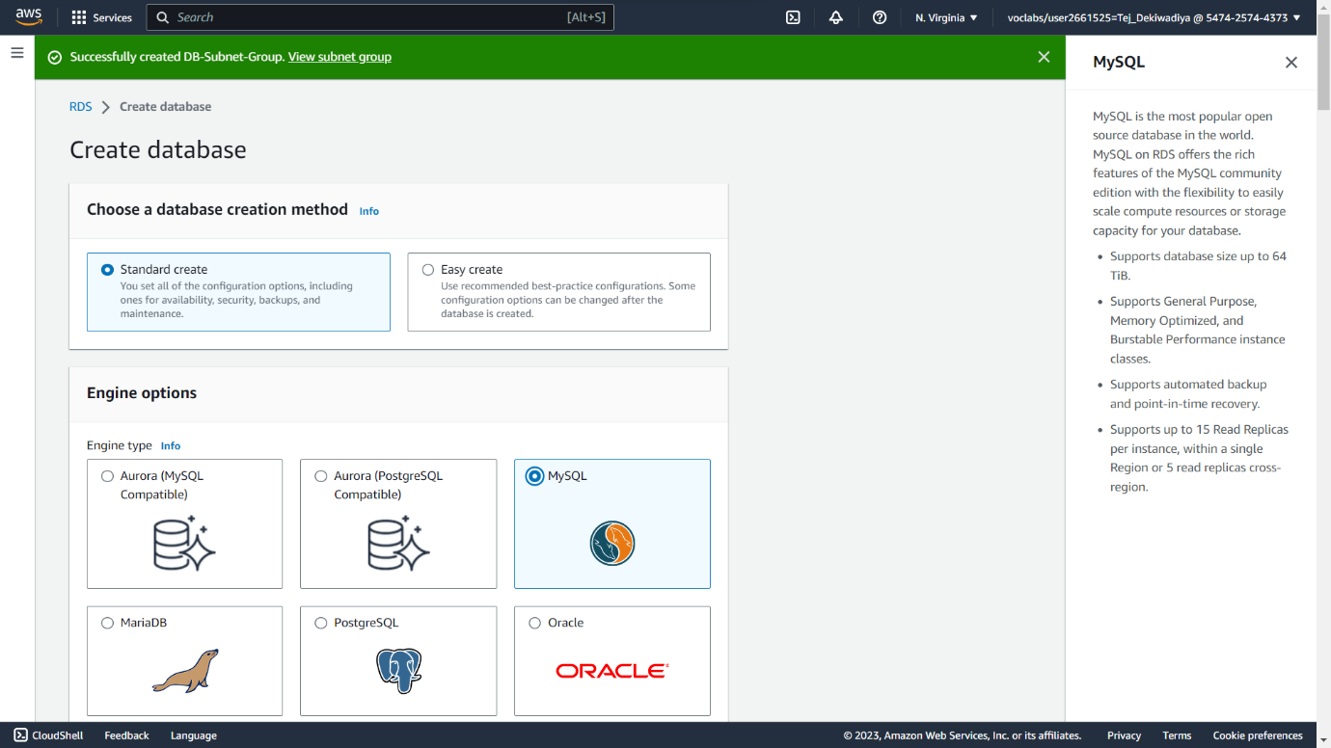

**Step 11 :** Under Templates choose Dev/Test Under Availability and durability choose Multi-AZ DB instance.

**Snapshot :**

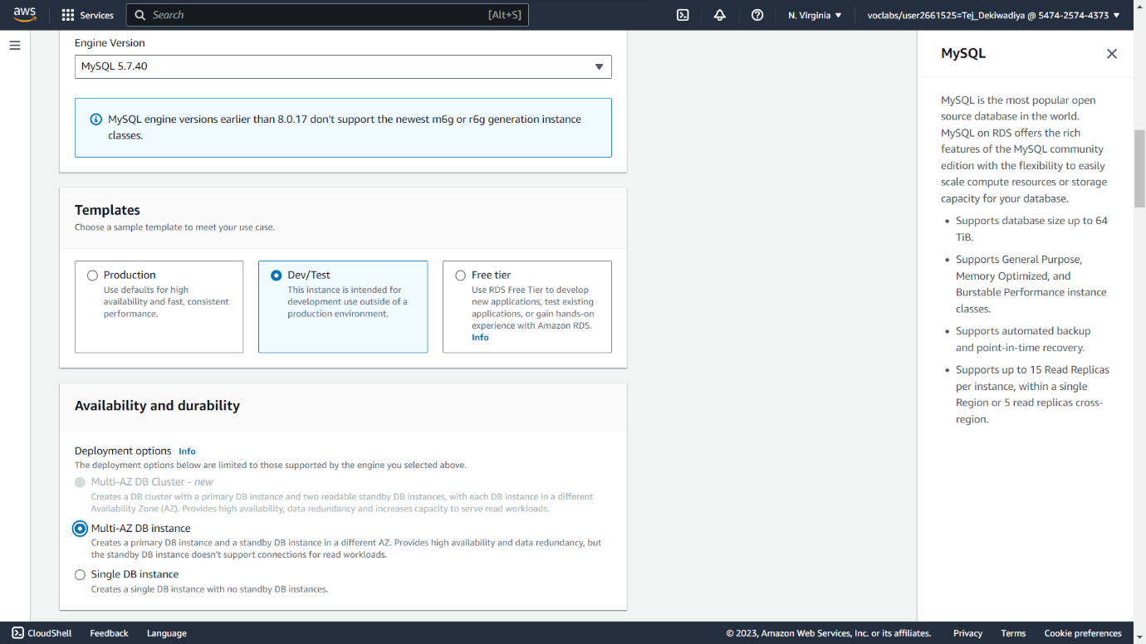

**Step 12 :** Under Settings, configure:

* + **DB instance identifier**: lab-db
  + **Master username**: main
  + **Master password**: lab-password
  + **Confirm password**: lab-password

**Snapshot :**

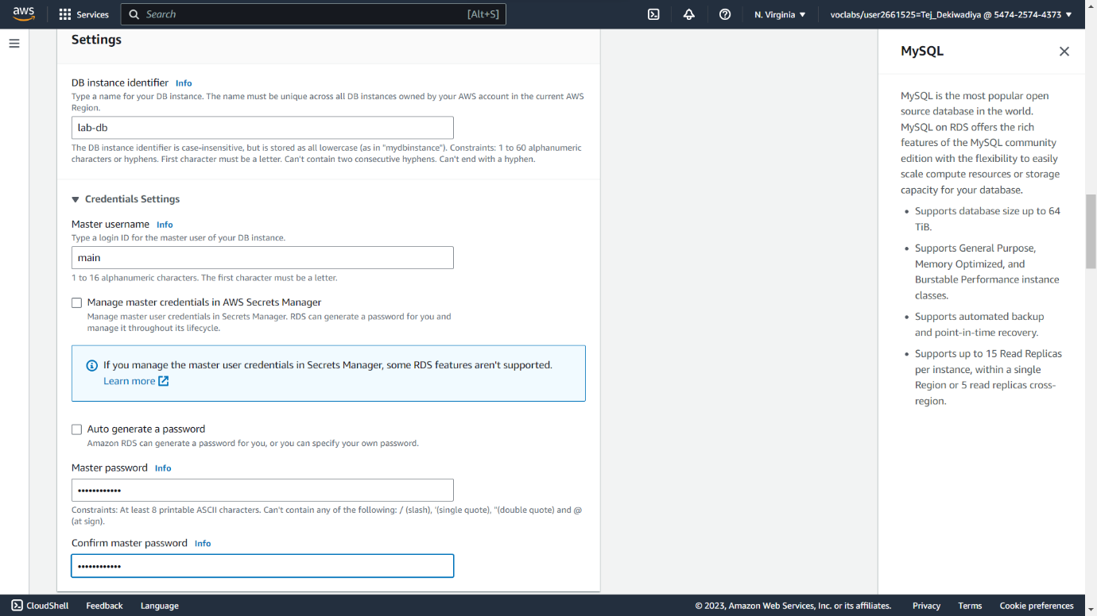

**Step 13 :** Under DB instance class, configure:

* + Select Burstable classes (includes t classes).
  + Select db.t3.micro
* Under Storage, configure:
  + Storage type: General Purpose (SSD)
  + Allocated storage: 20

**Snapshot :**

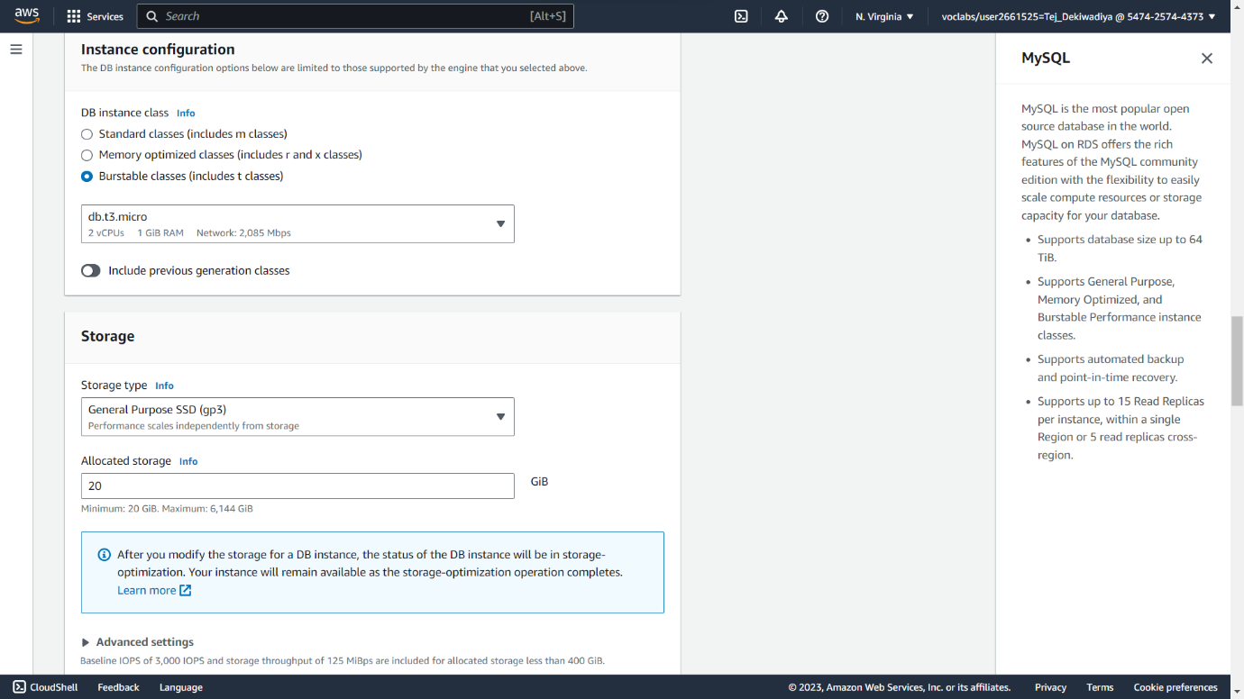

**Step 14 :** Under Connectivity, configure:

* **Virtual Private Cloud (VPC)**: Lab VPC**.**

**Snapshot :**

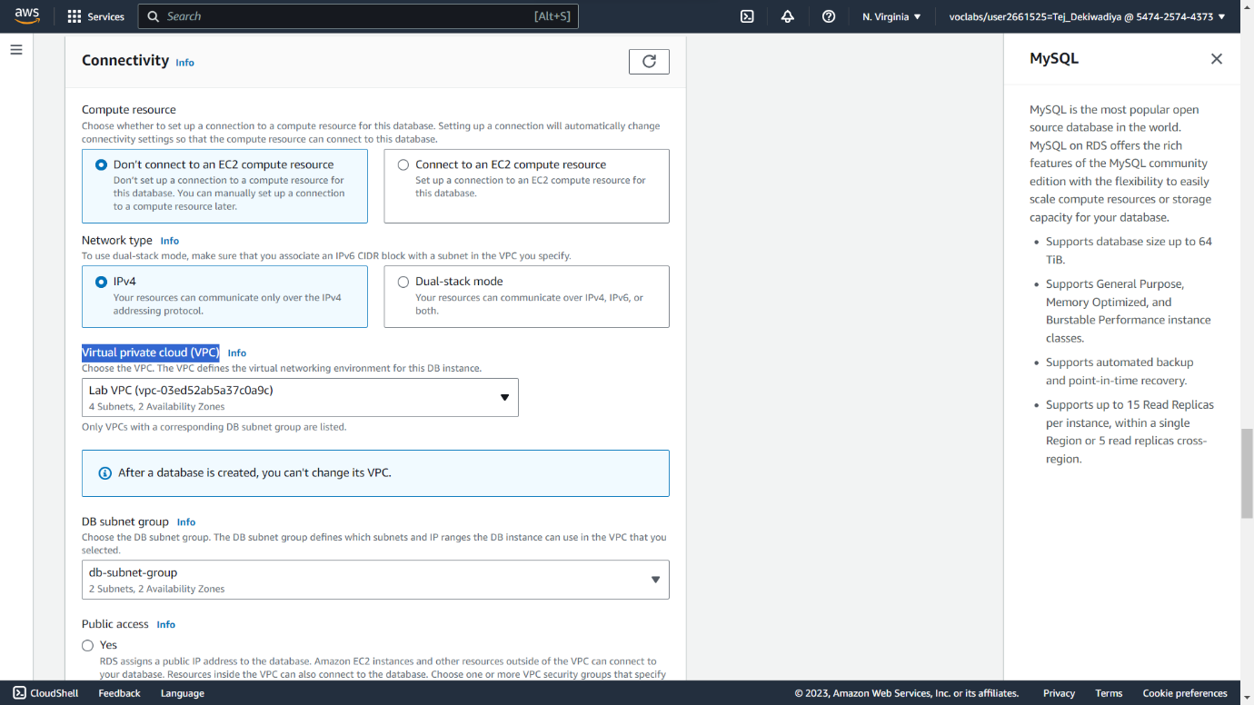

**Step 15 :** Under Existing VPC security groups, from the dropdown list:

* Choose DB Security Group.
* Deselect default.

**Snapshot :**

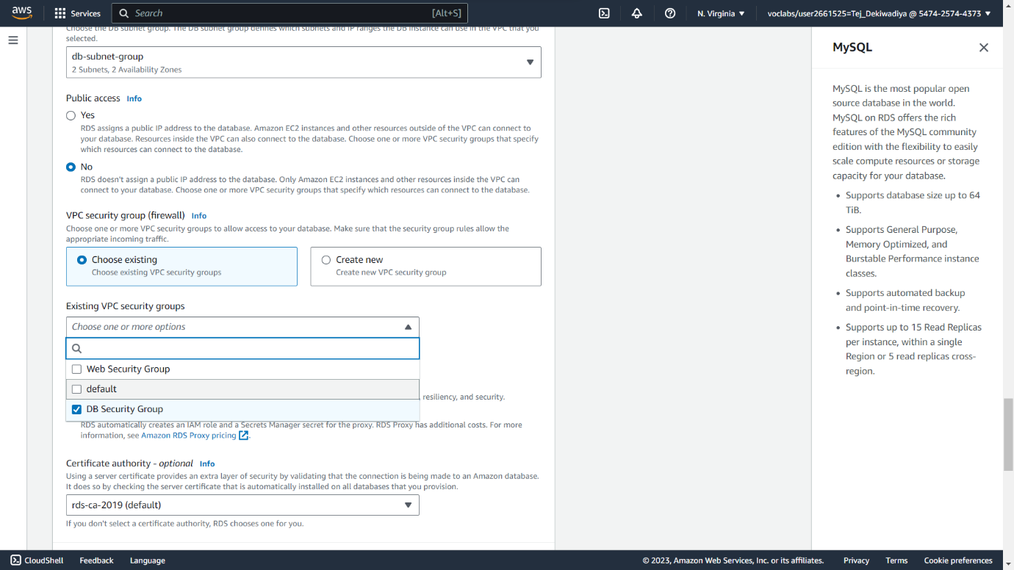

**Step 16 :** Expand Additional configuration, then configure:

* Initial database name: lab
* Uncheck Enable automatic backups.
* Uncheck Enable encryption
* Uncheck Enable Enhanced monitoring**.** Than Choose Create database

**Snapshot :**

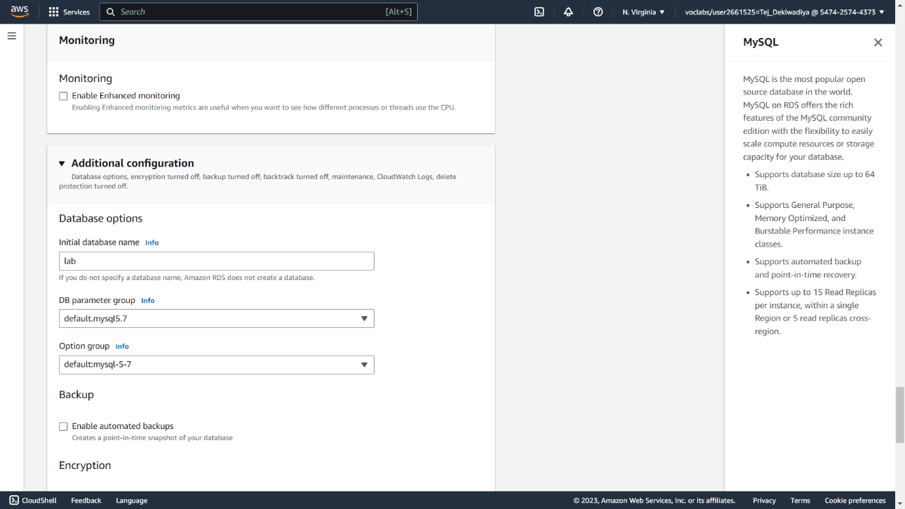

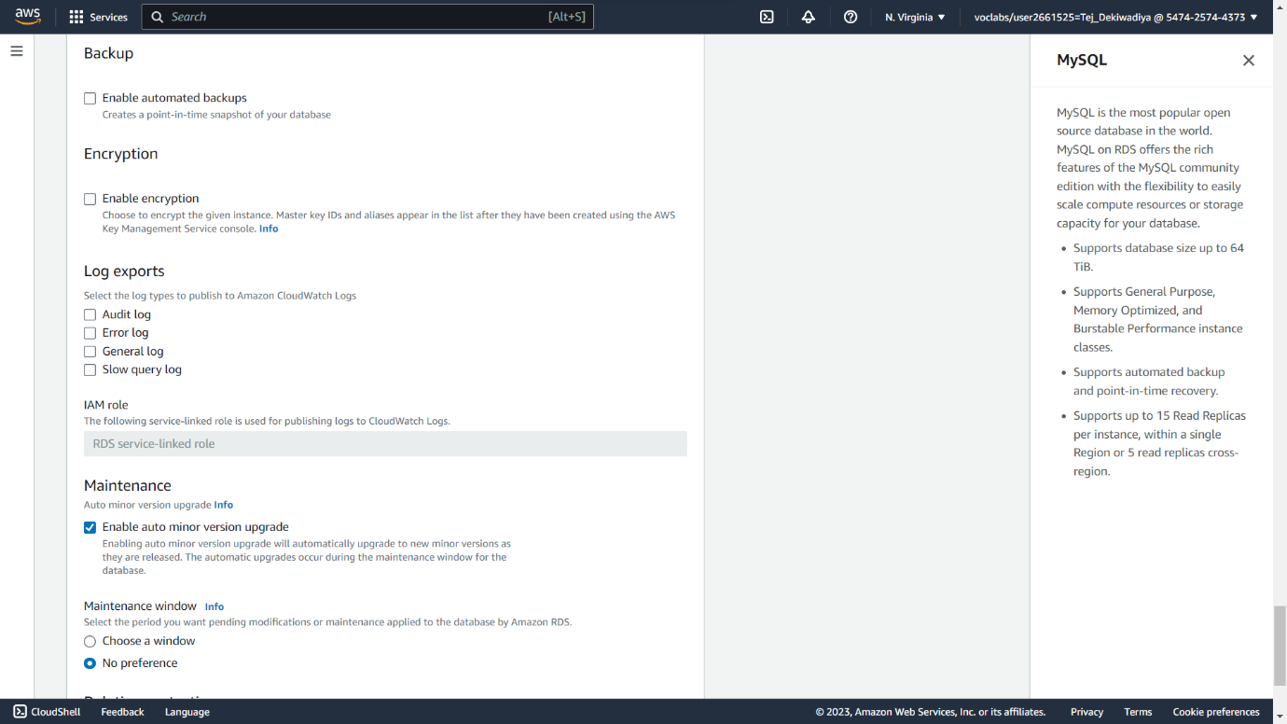

**Step 17 :** Choose lab-db (choose the link itself)**.**

**Snapshot :**

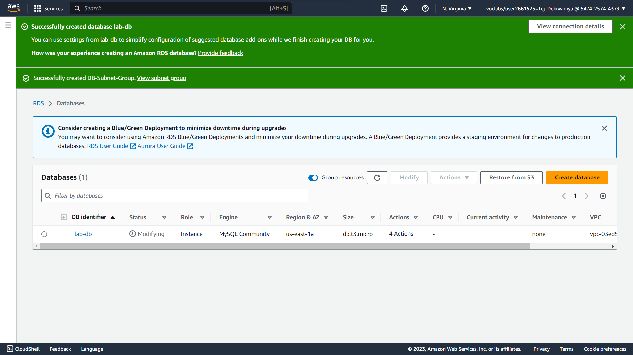

**Step 18 :** Wait until Info changes to Modifying or Available.

**Snapshot :**

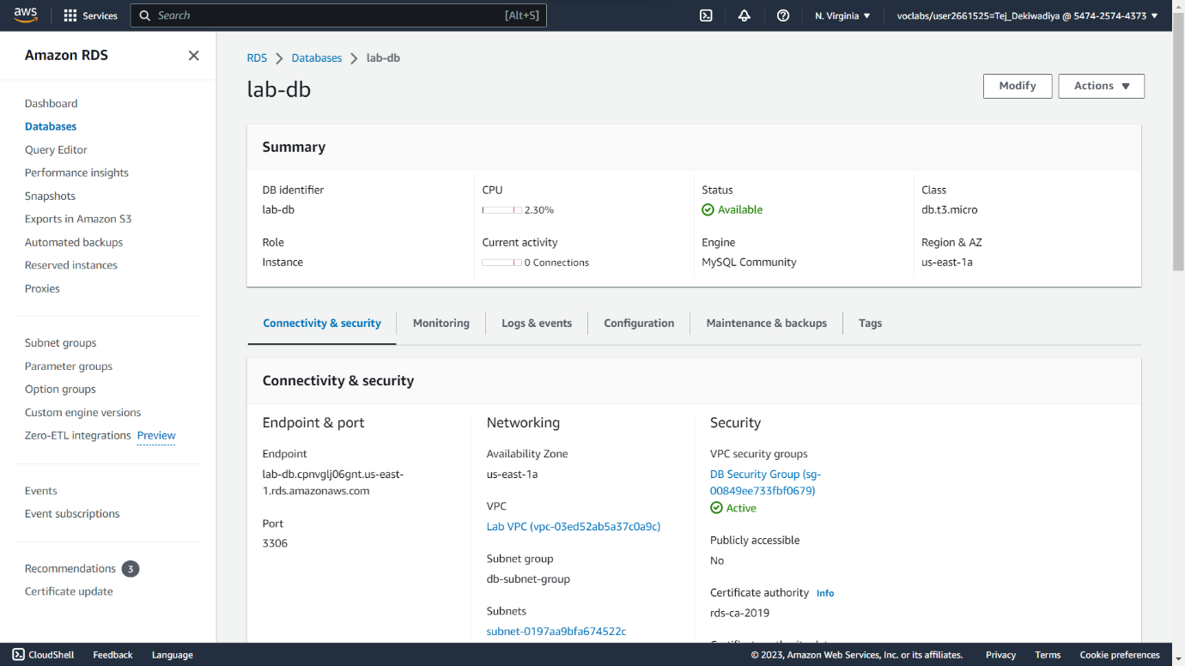

**Step 19 :** Scroll down to the Connectivity & security section and copy the Endpoint field**.**

**Snapshot :**

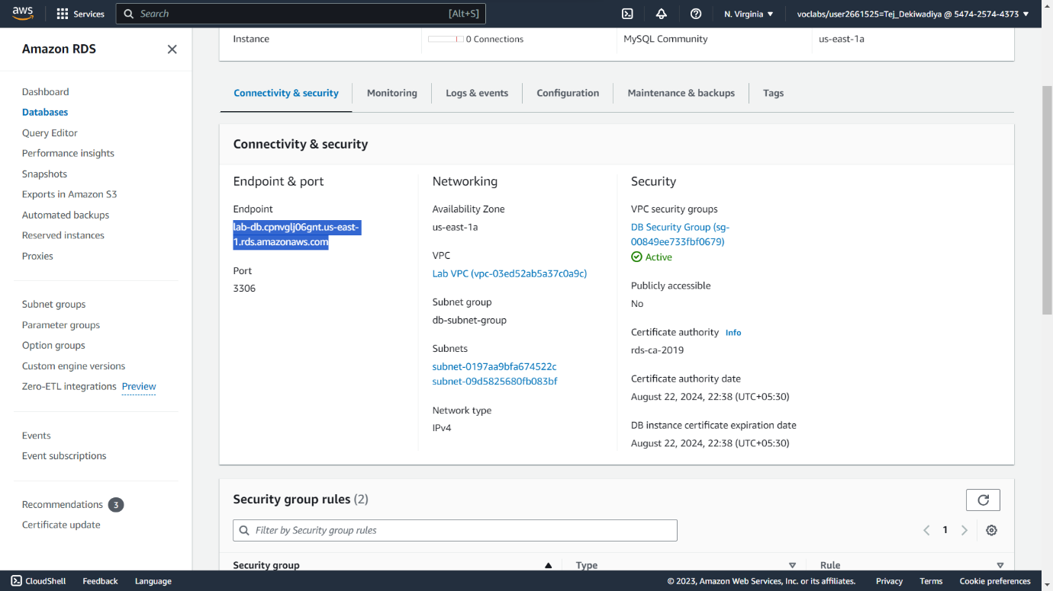

**Step 20 :** To copy the WebServer IP address, choose on the Details drop down menu above these instructions, and then choose Show**.** and Open a new web browser tab, paste the WebServer IP address and press Enter.

**Snapshot :**

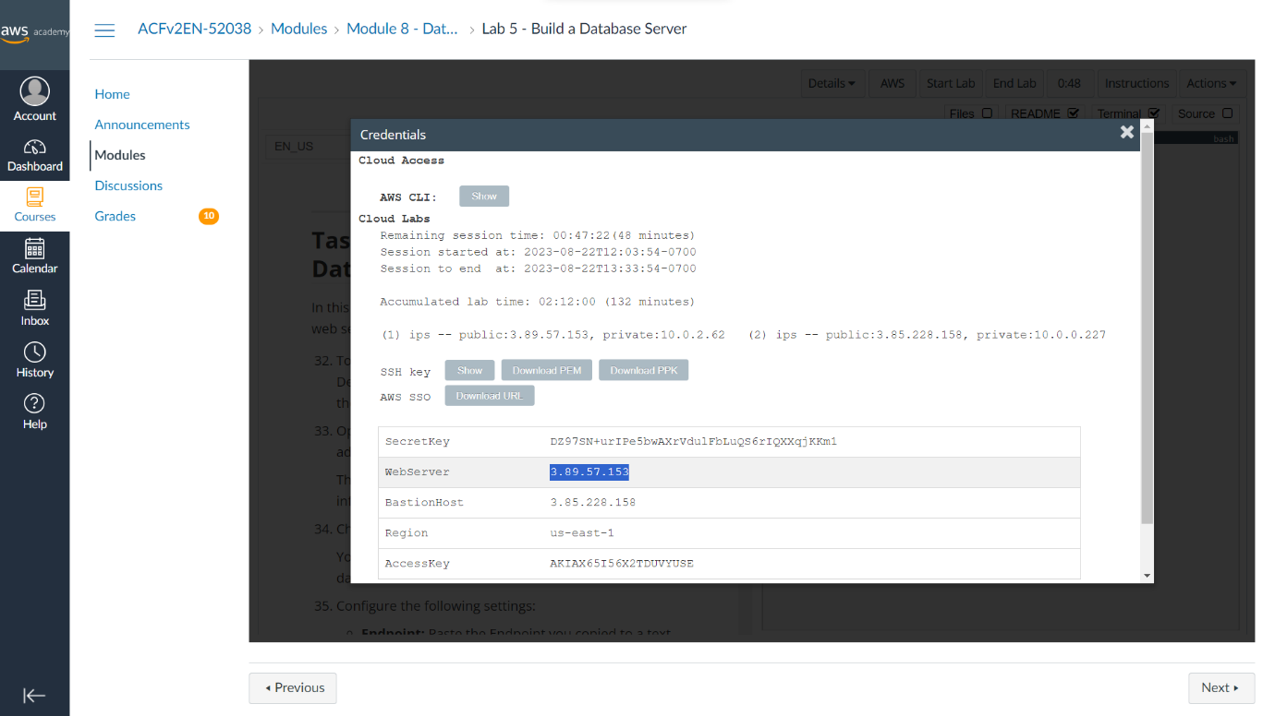



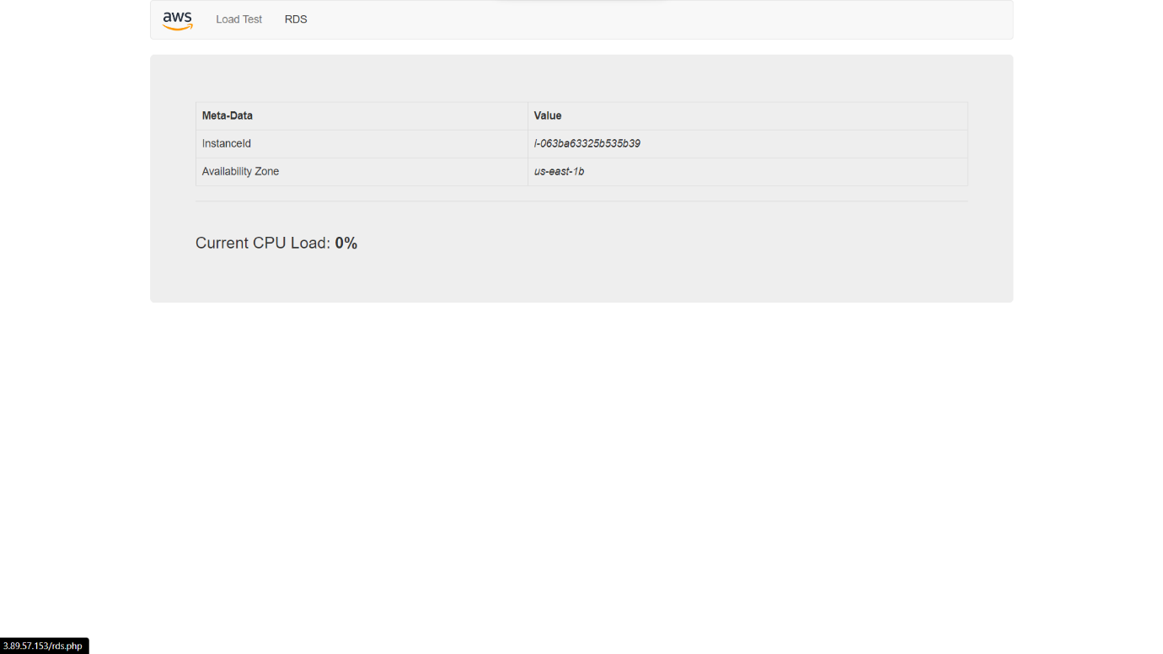

**Step 21 :** Choose the RDS link at the top of the page then Configure the following settings:

* Endpoint: Paste the Endpoint you copied to a text editor earlier
* Database: lab
* Username: main
* Password: lab-password
* Choose Submit

**Snapshot :**

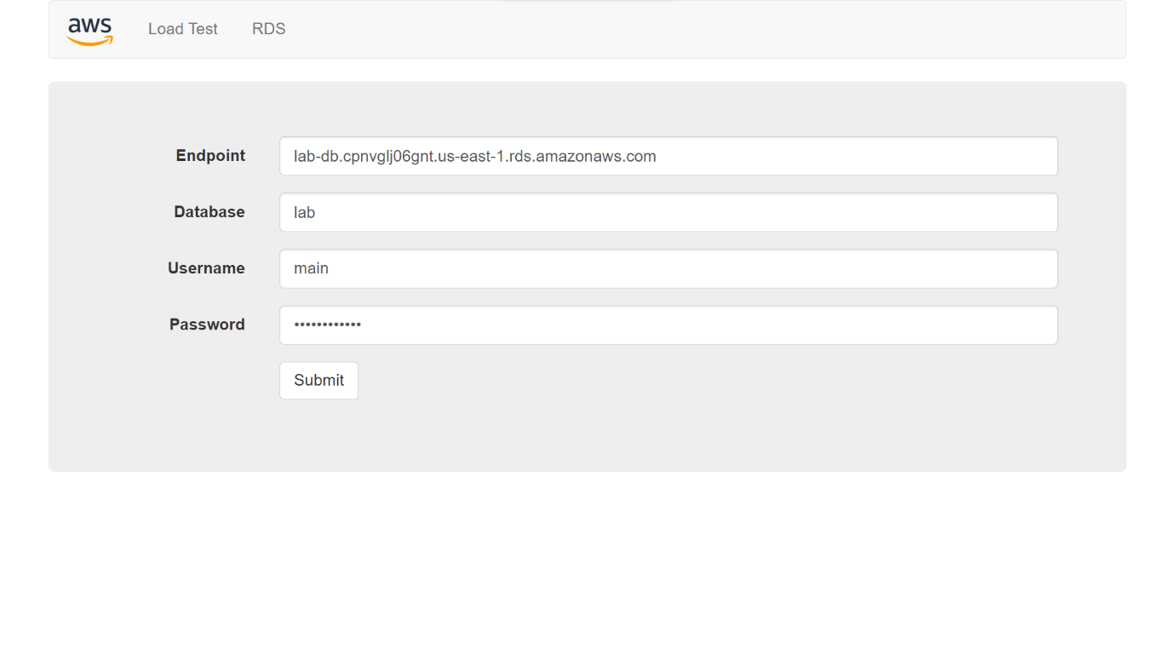

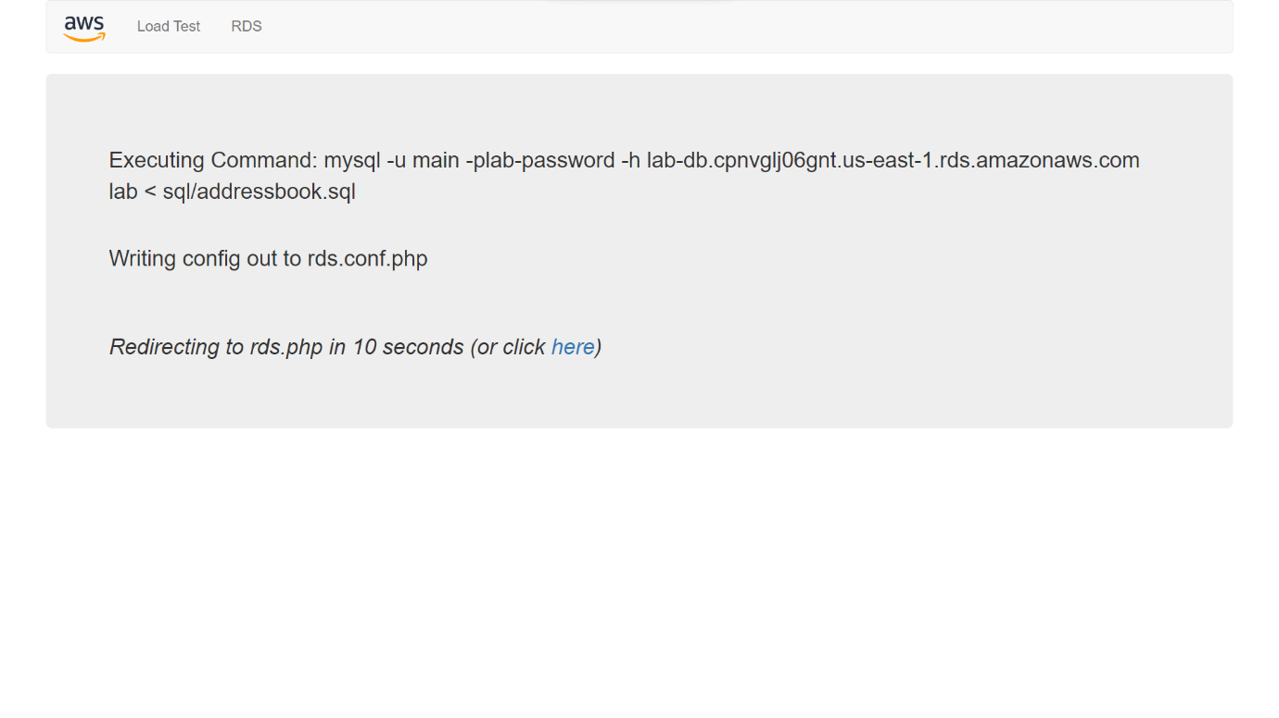

**Step 22 :** Test the web application by adding, editing and removing contacts**.**

**Snapshot :**

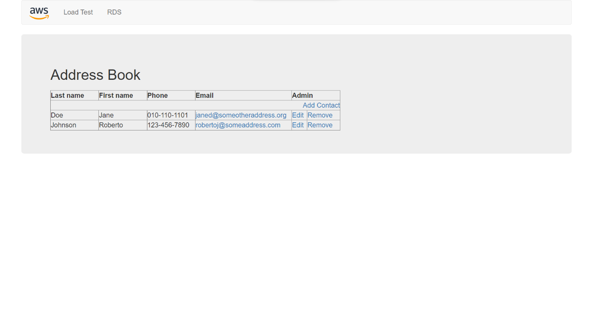

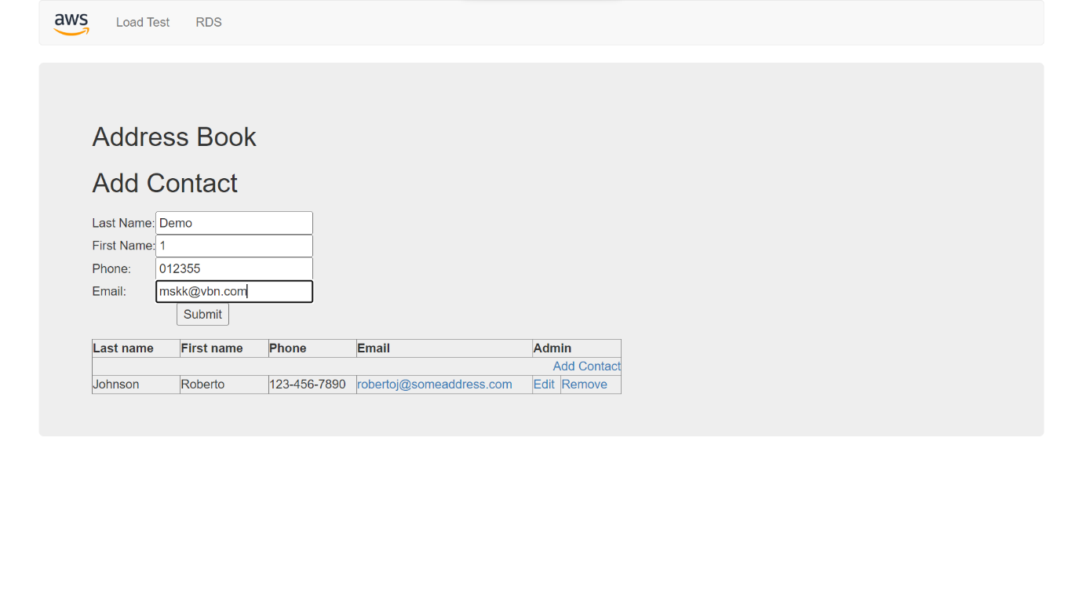

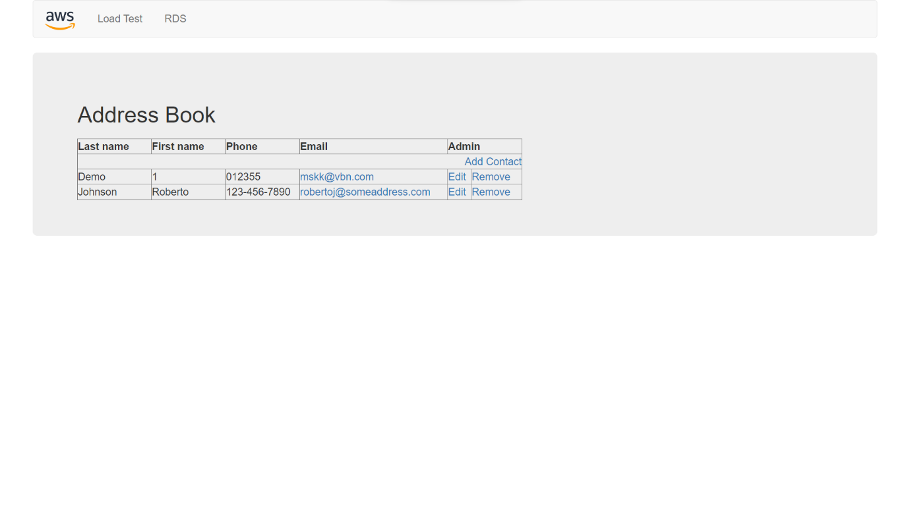

**Practical 09 : Containerization with Docker**

**Step 01 :** Create Instances in EC2

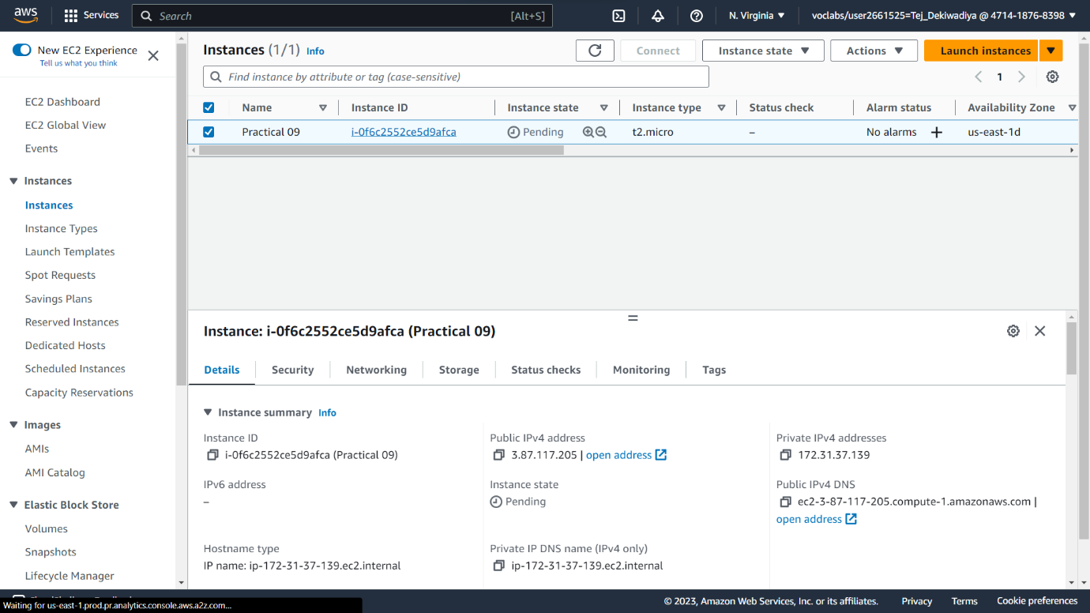**Snapshot :**

**Step 02 :** Click On Connect Button

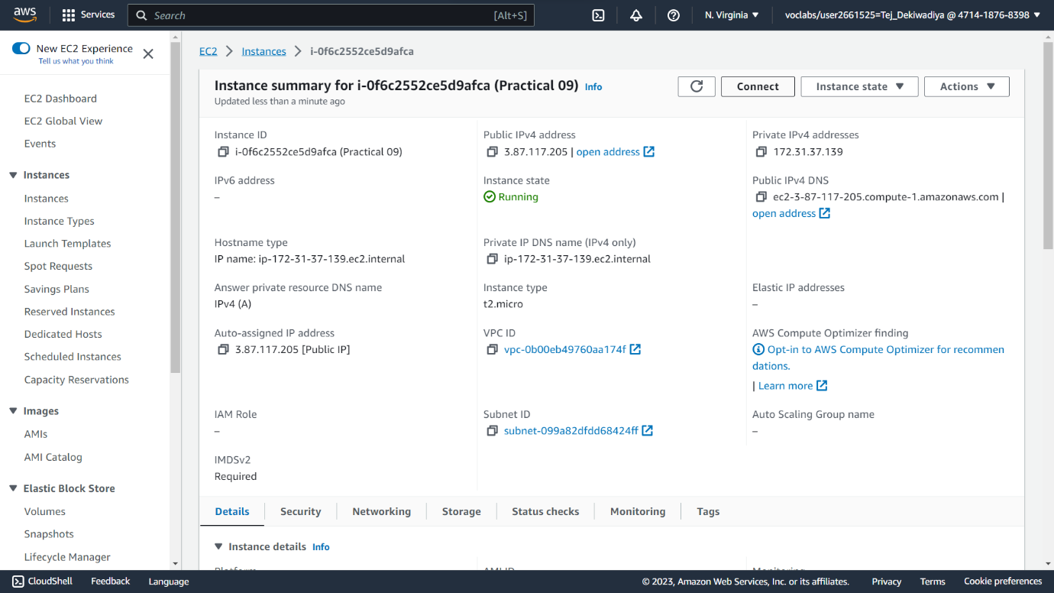**Snapshot :**

**Step 03 :** After Click On Connect button page rendering on connect to instance page than Connect to terminal

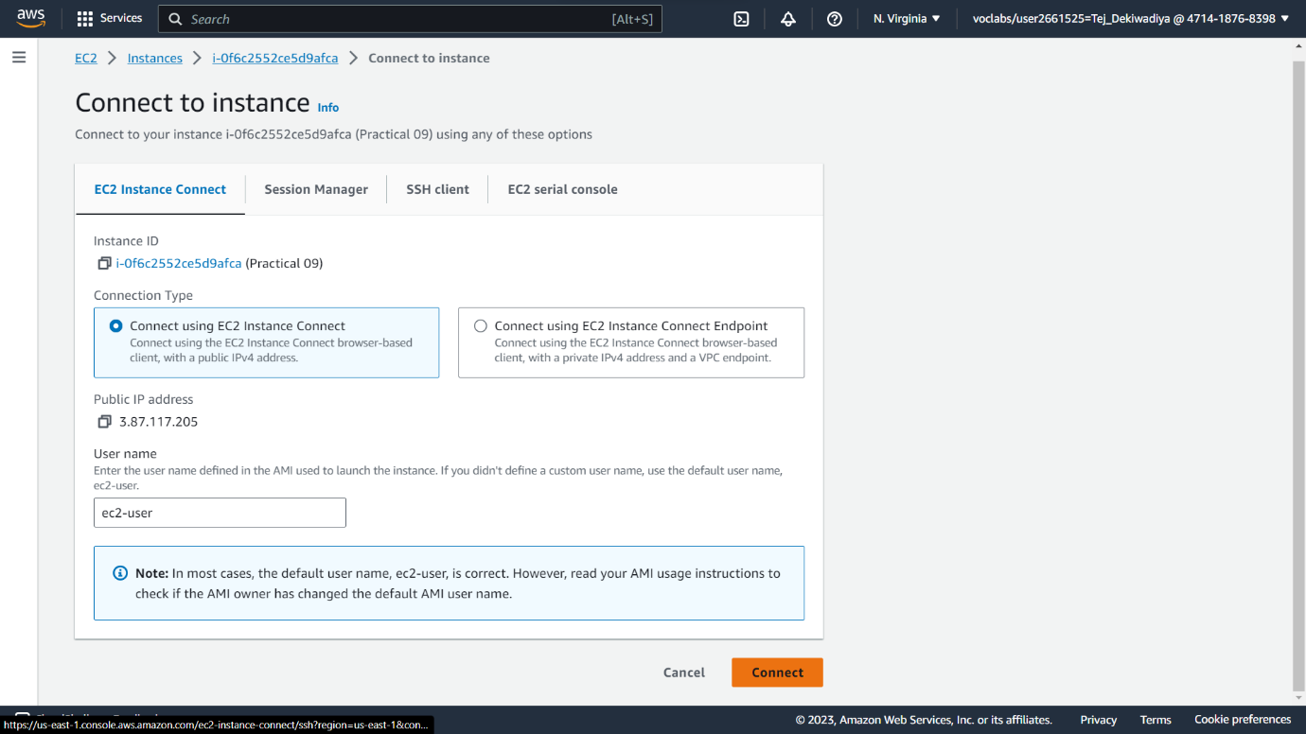**Snapshot :**

**Step 04 :** run **sudo su** and **sudo yum update** command

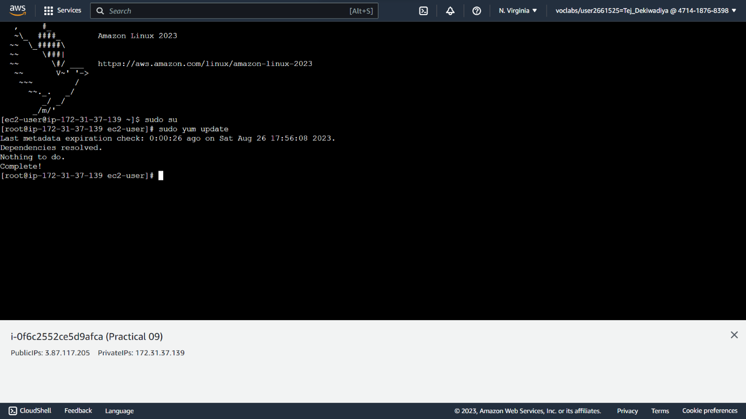**Snapshot :**

**Step 05 :** after run previous command then write **sudo yum install docker**

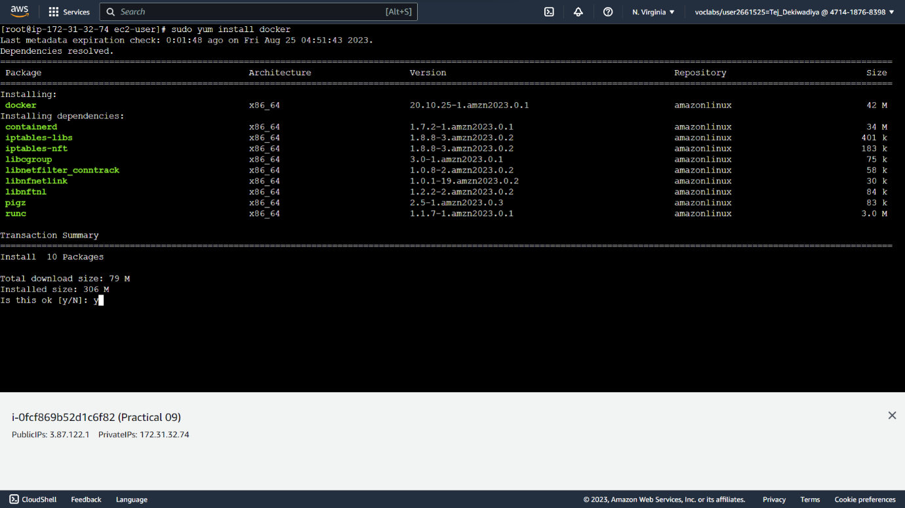**Snapshot :**

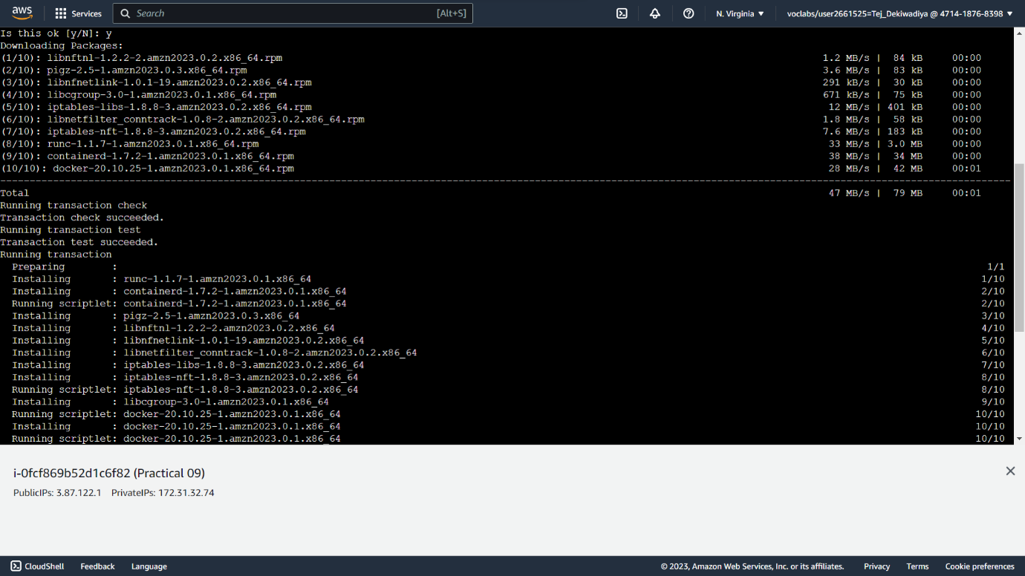

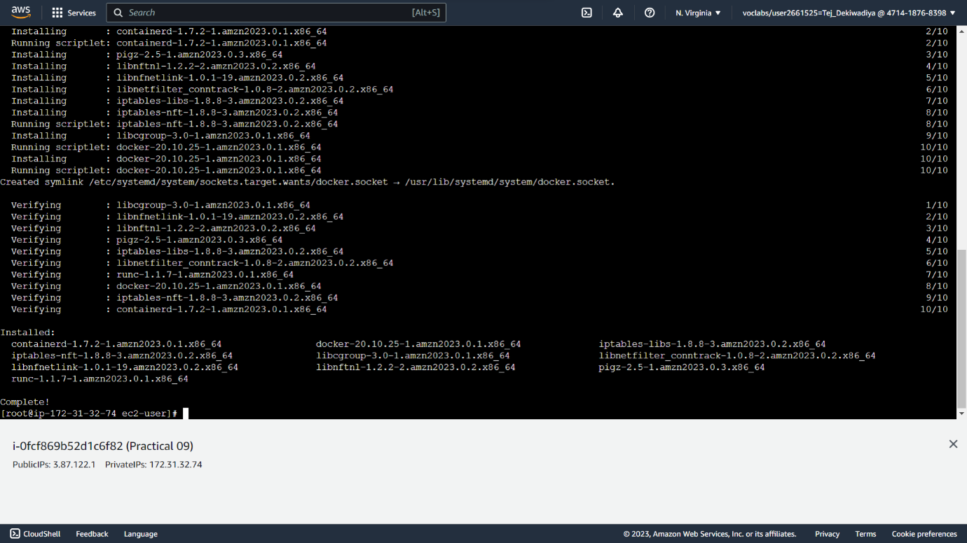

**Step 06 :** run **sudo service docker start** command

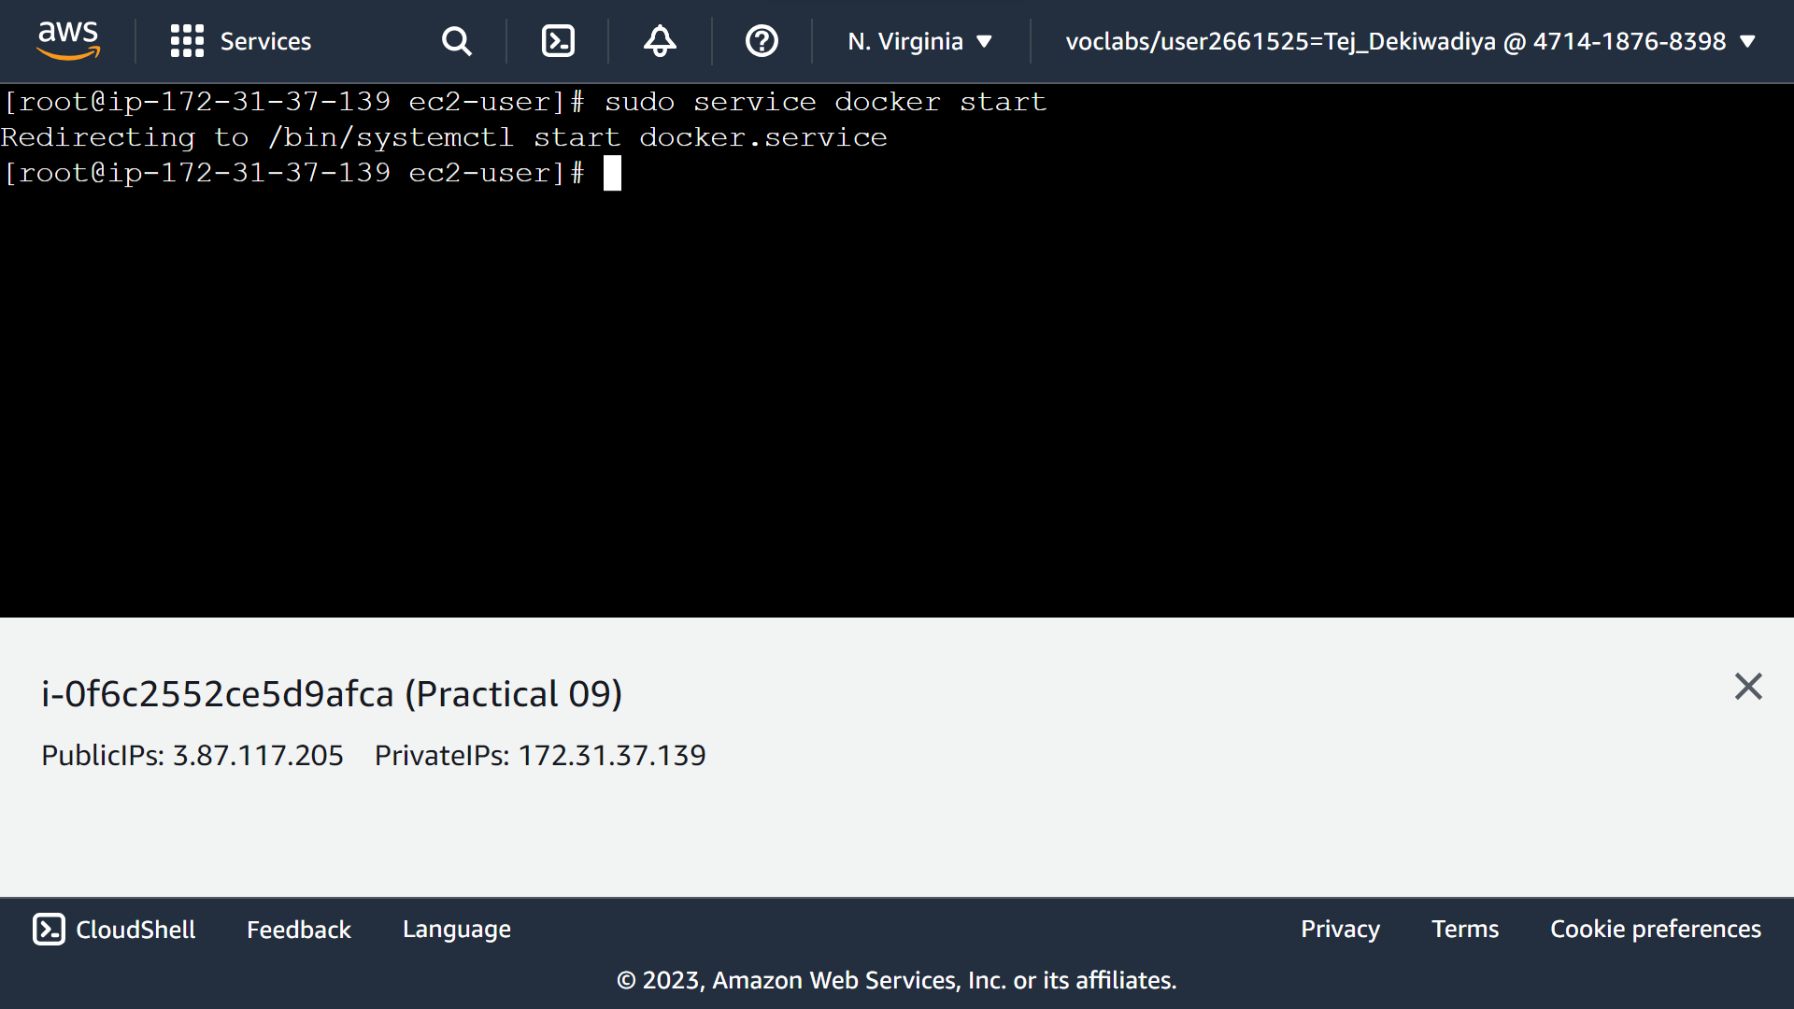**Snapshot :**

**Step 07 :** run **sudo service docker status**

**Snapshot :**

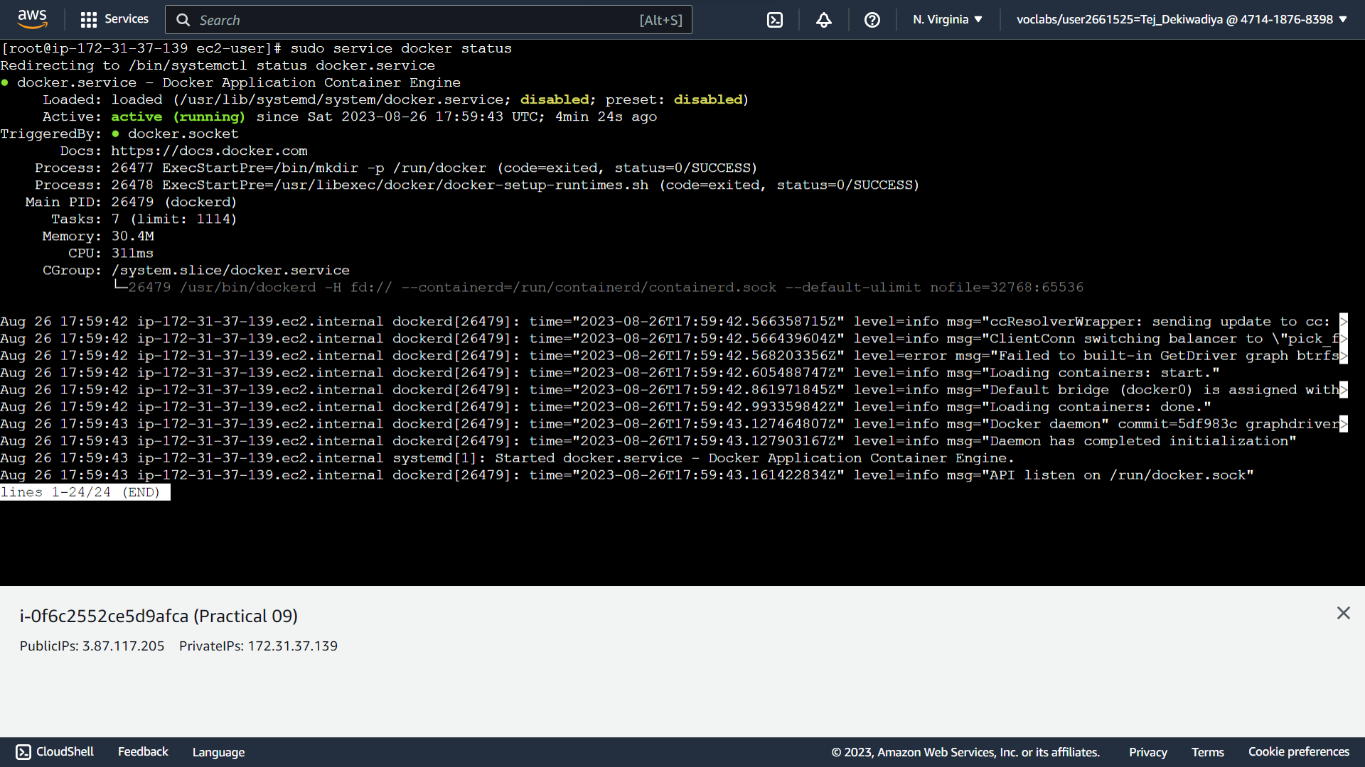

**Step 08 :** after install and start docker service check version using **docker version** command

**Snapshot :**

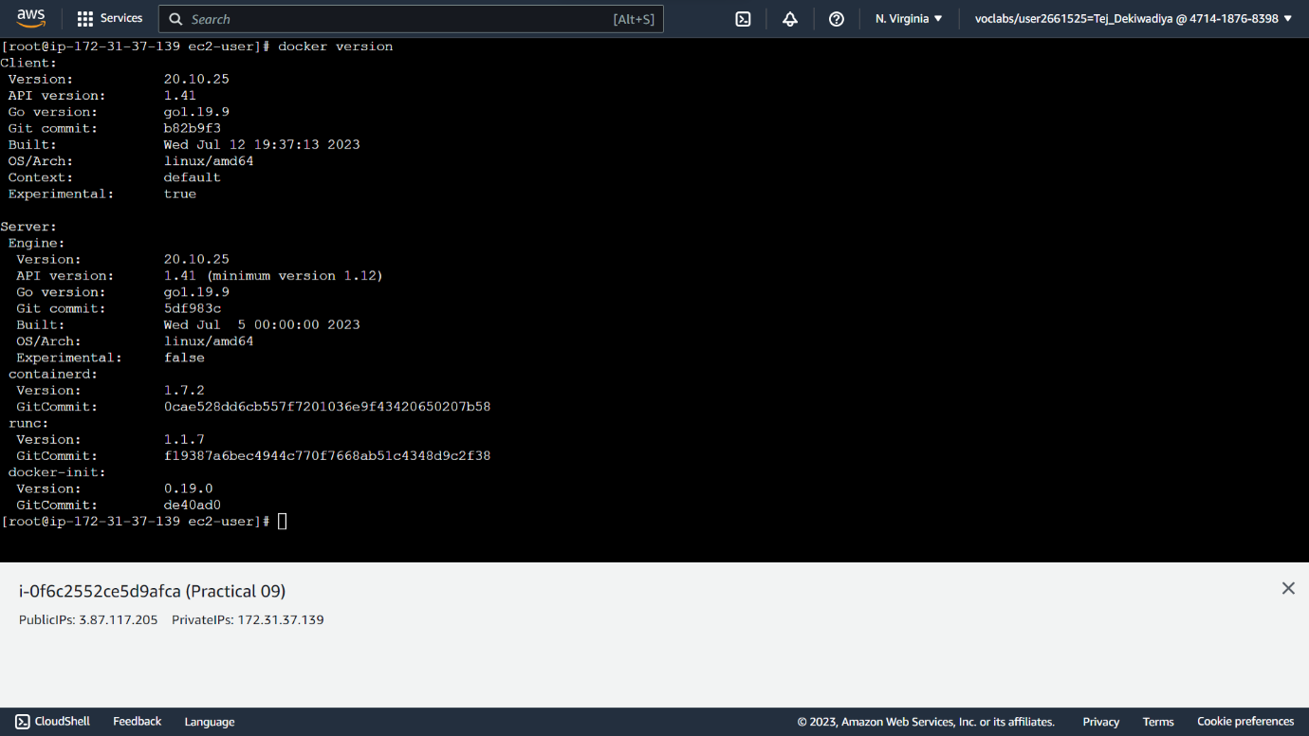

**Step 09 :** run **docker search nginx**

**Snapshot :**

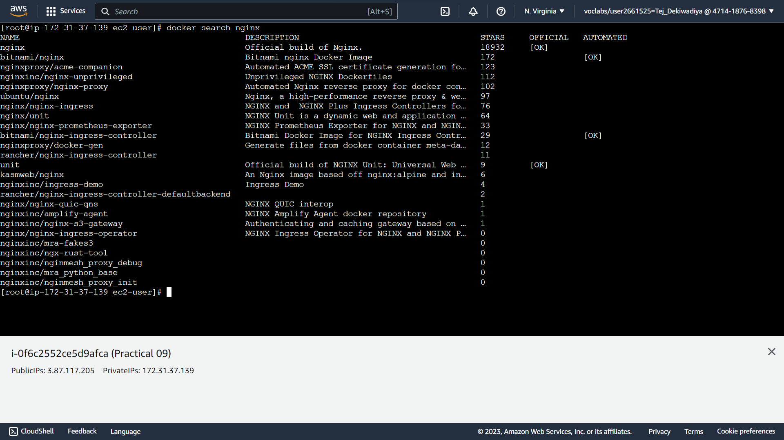

**Step 10 :** run **docker pull nginx**

**Snapshot :**

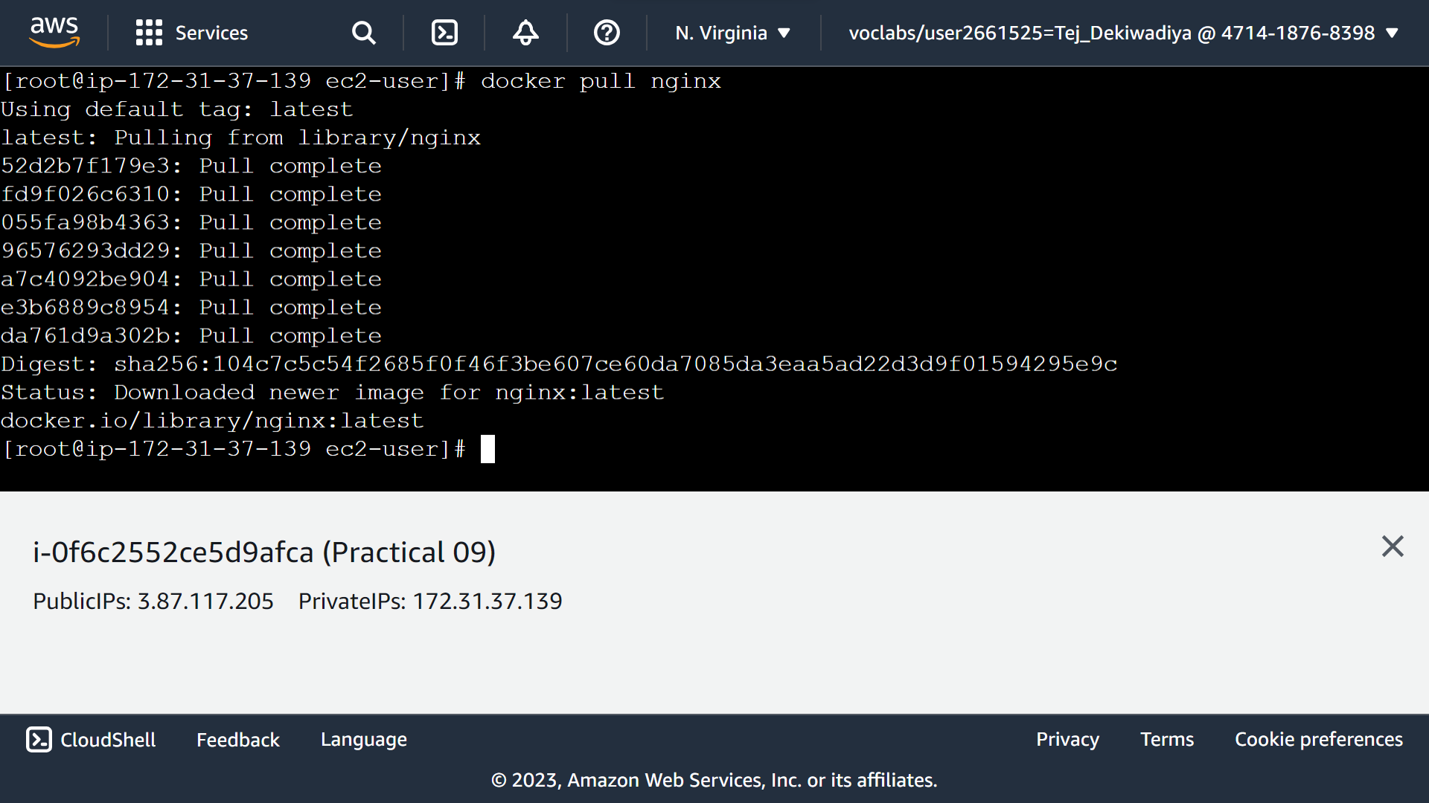

**Step 11:** Run **docker run -d -p 80:80 nginx**

**Snapshot :**

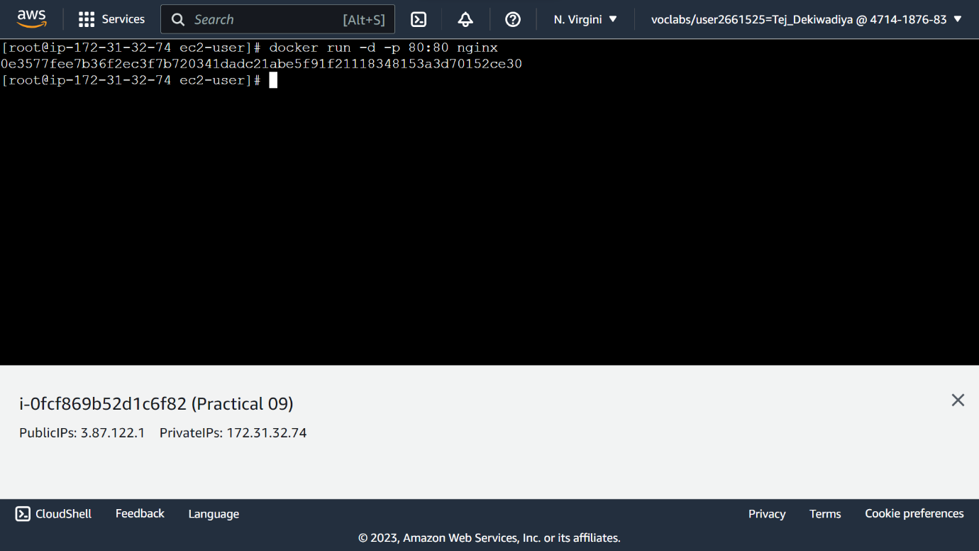

**Step 12 :** Copy Public IP Address In Connect to instance section

**Snapshot :**

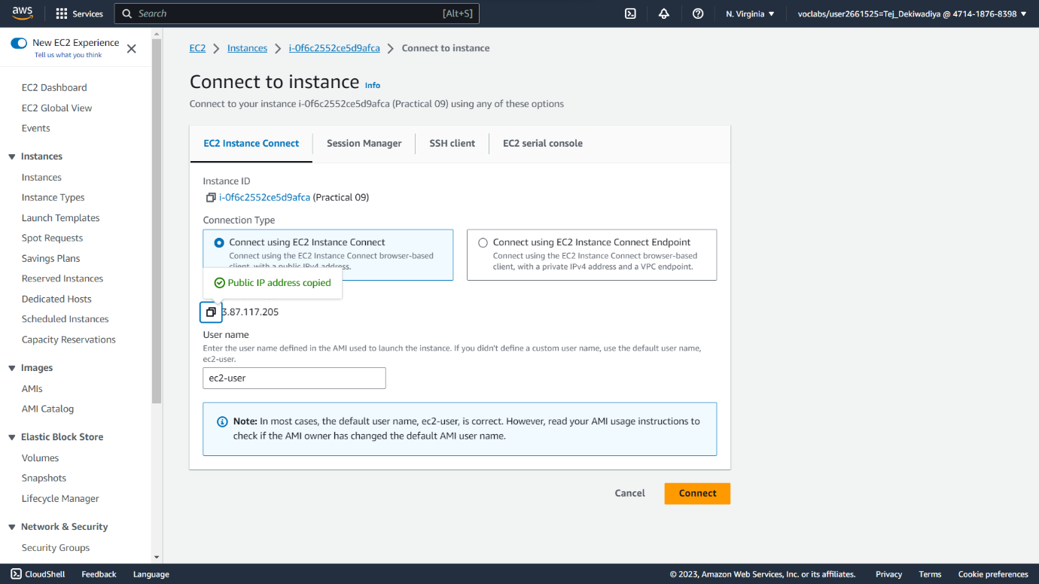

**Step 13 :** You can see server has been deployed

**Snapshot :**

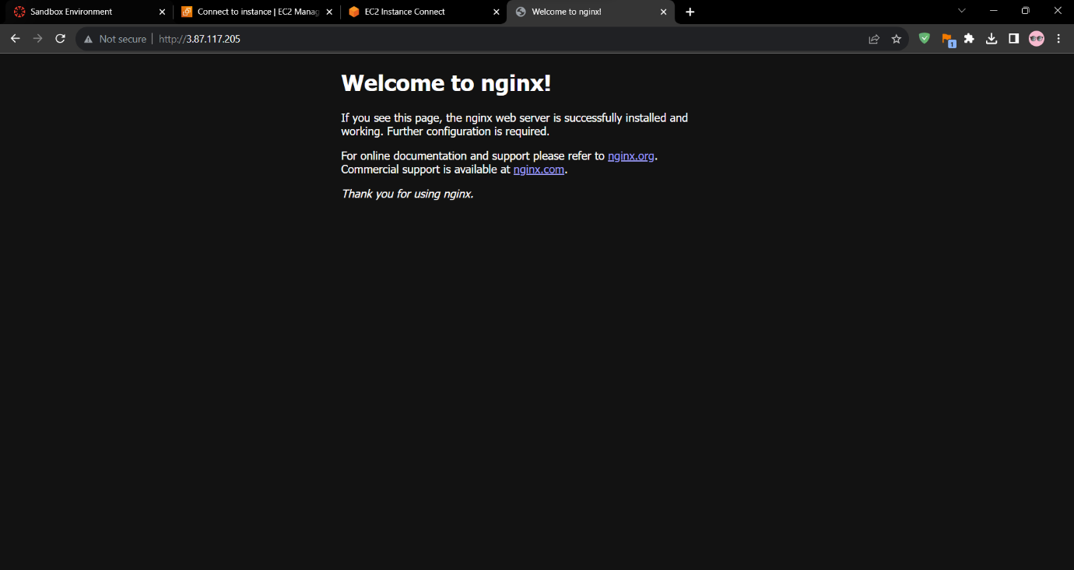

**Step 14 :** then run **docker ps**

**Snapshot :**

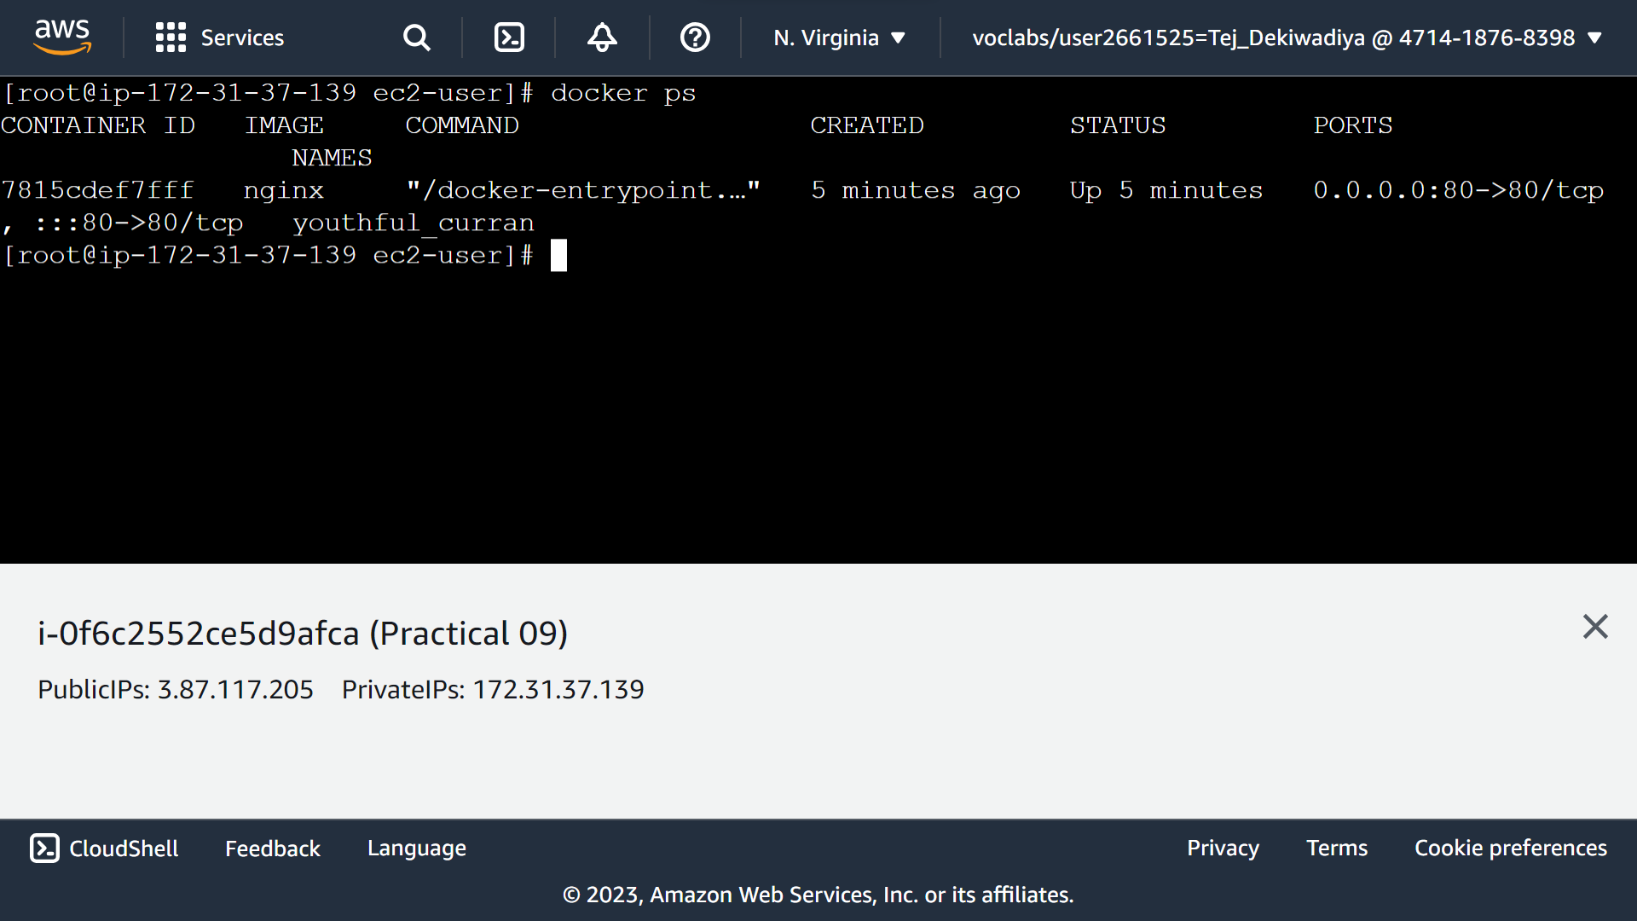

**Step 15 :** then run **docker network ps**

**Snapshot :**

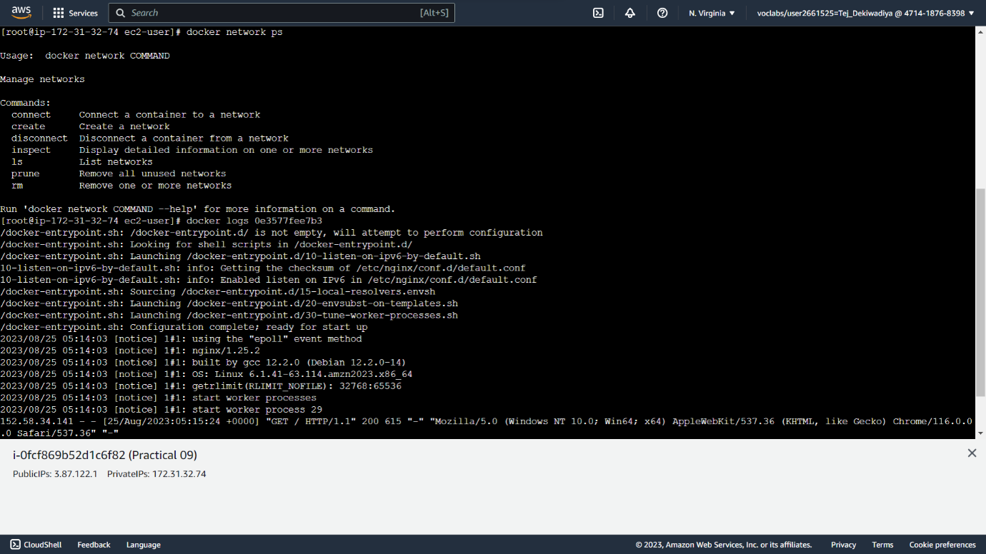

**Step 16 :** run **docker stop <Container ID>** to stop docker service

**Snapshot :**

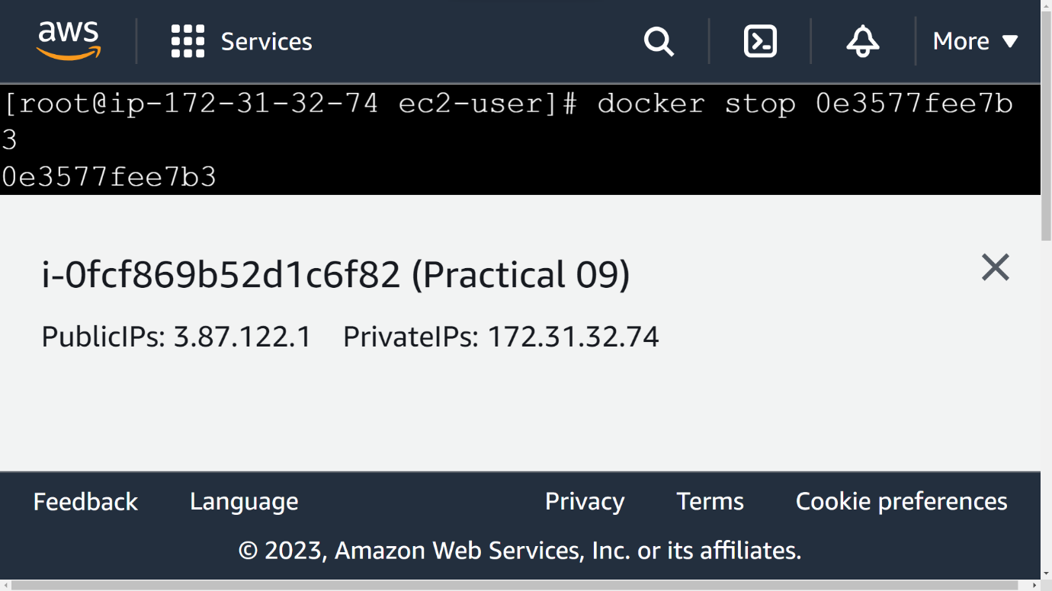

**Step 17 :** Refresh Public IP Tab and you can see no response from server

**Snapshot :**

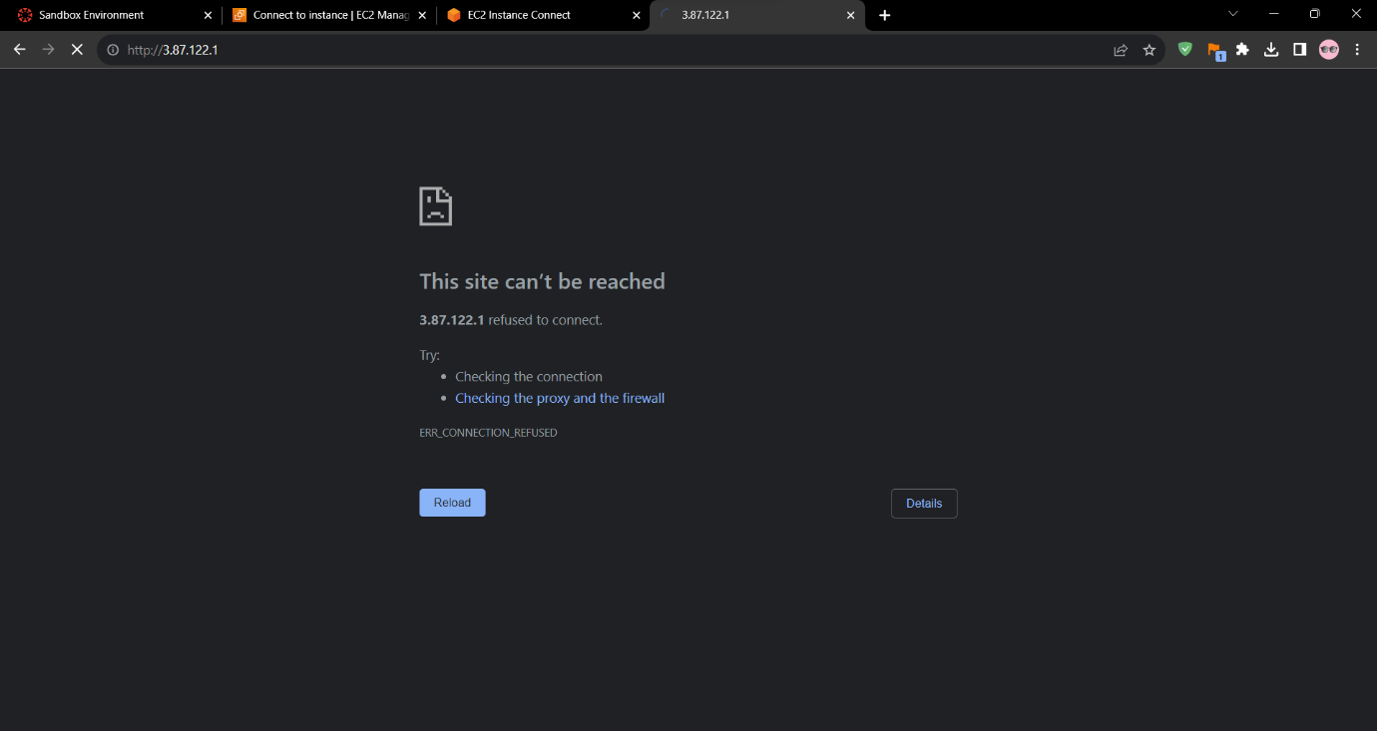

**Step 18 :** than run **docker push nginx, docker ps**

**Snapshot :**

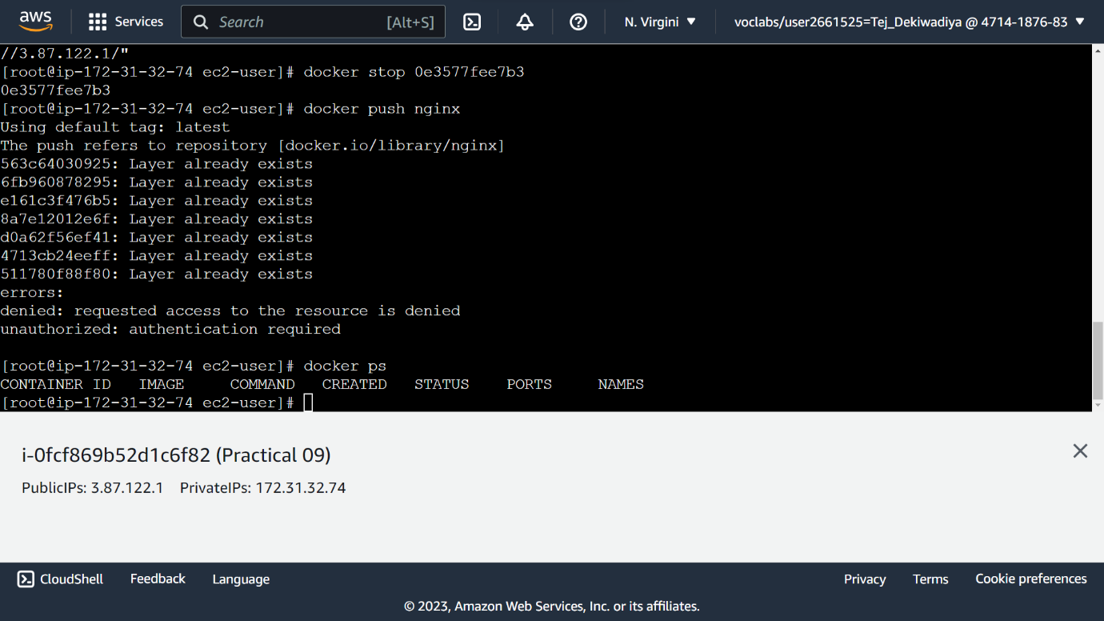

**Practical 10 : Deploy Docker Technology**

**Step 01 :** Create an Instance in EC2

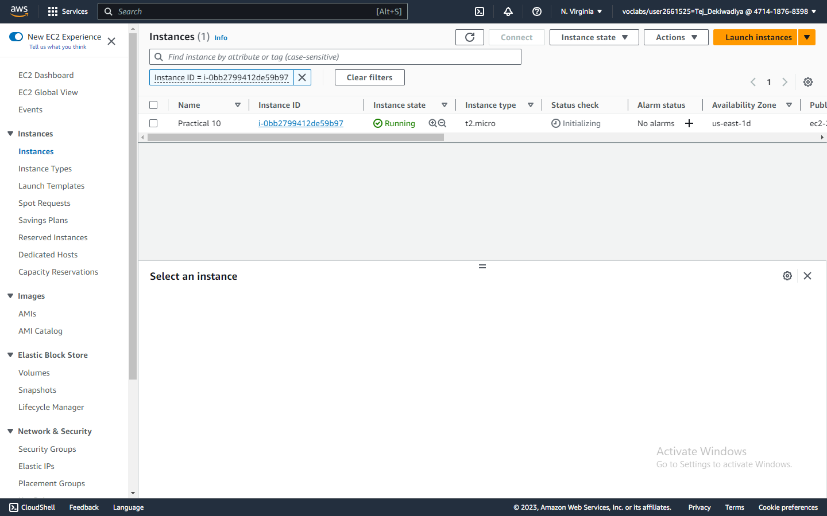**Snapshot :**

**Step 02 :** Click on instance ID and click Connect

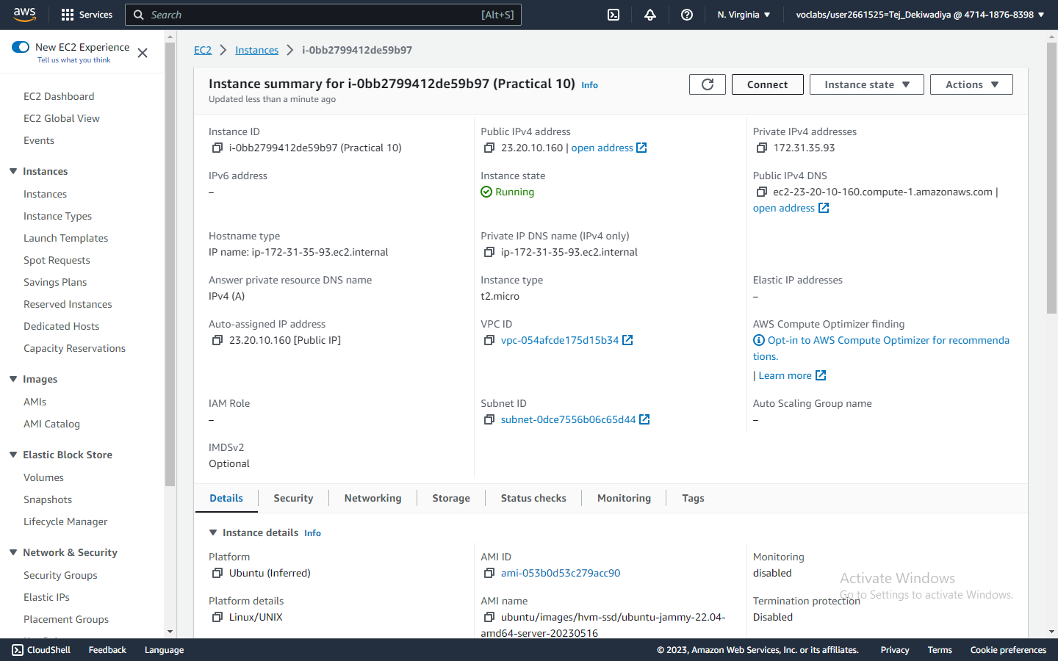**Snapshot :**

**Step 03 :** Connect the Instance

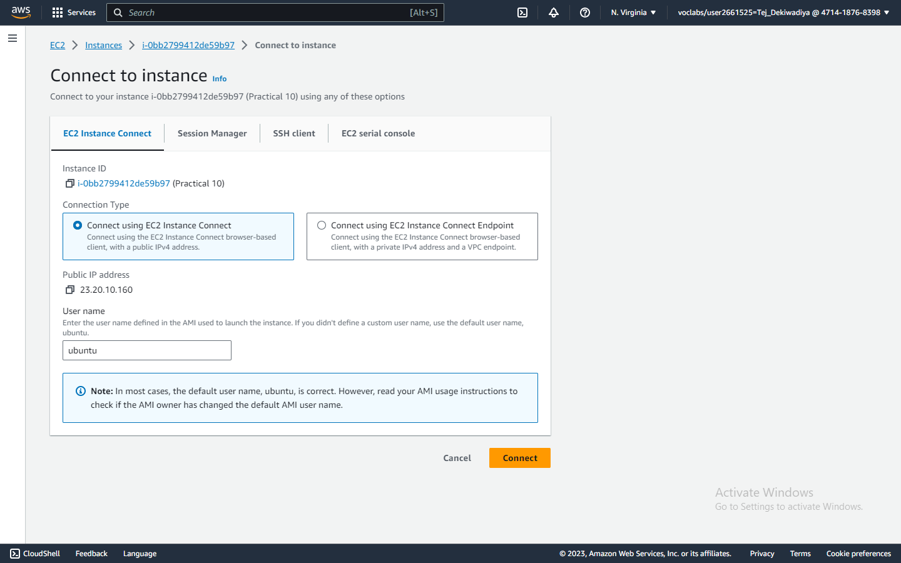**Snapshot :**

**Step 04 :** Run command - sudo apt-get update

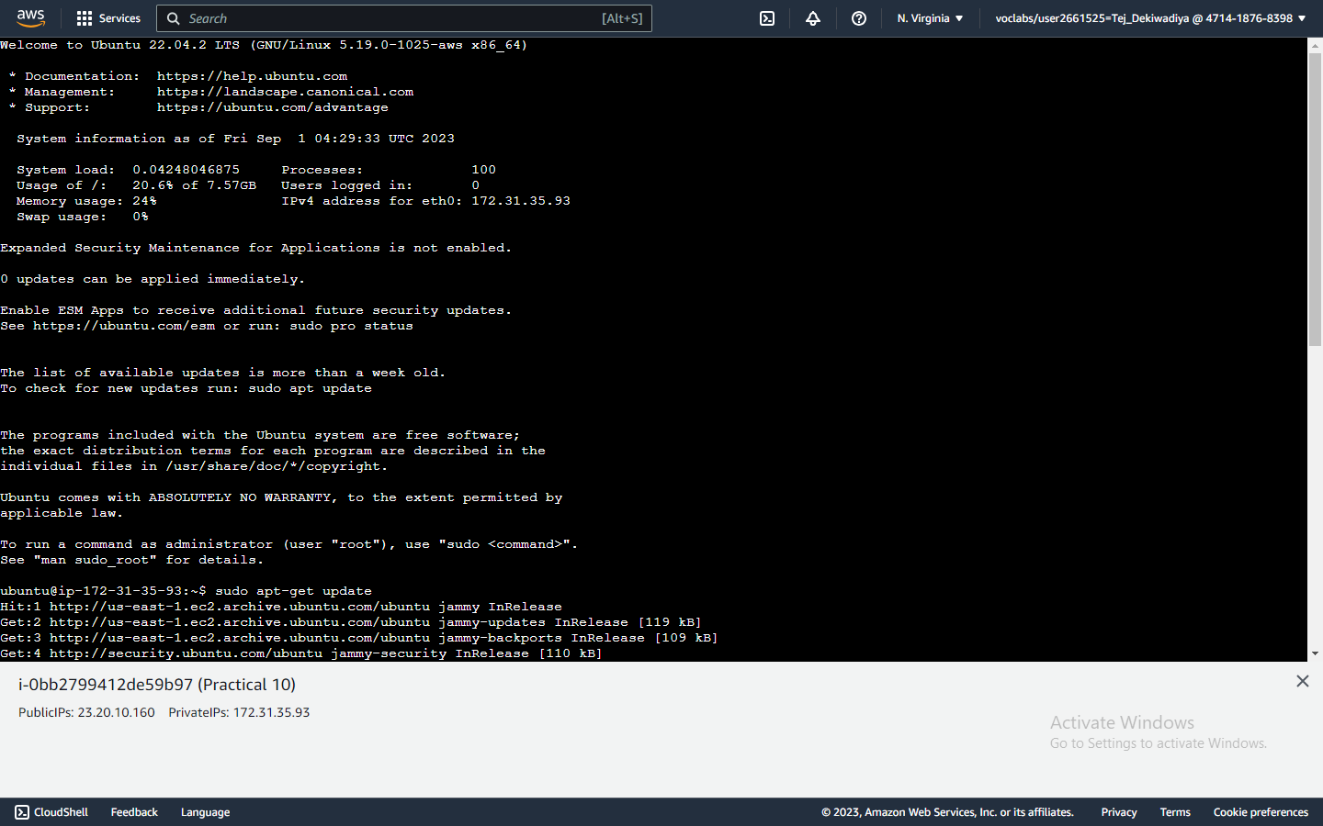**Snapshot :**

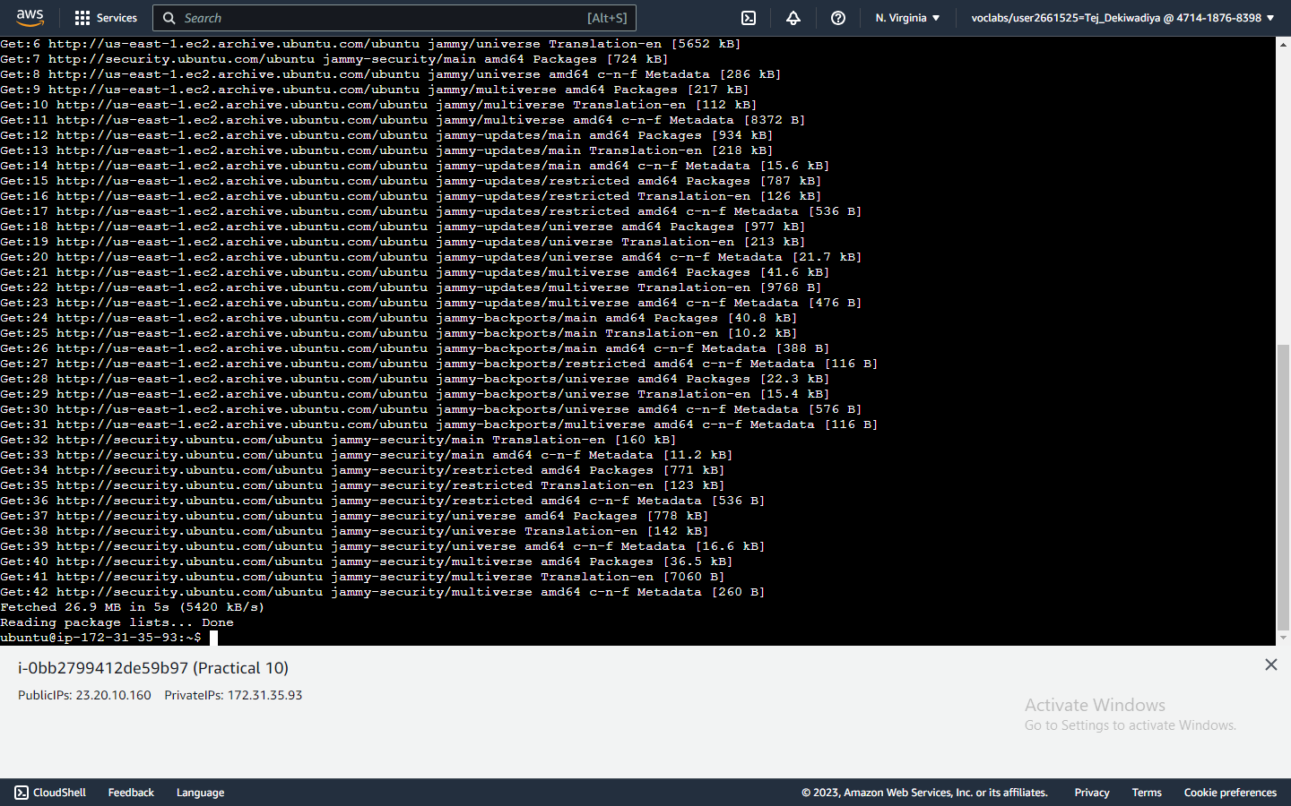

**Step 05:** Run -sudo apt-get install docker.io

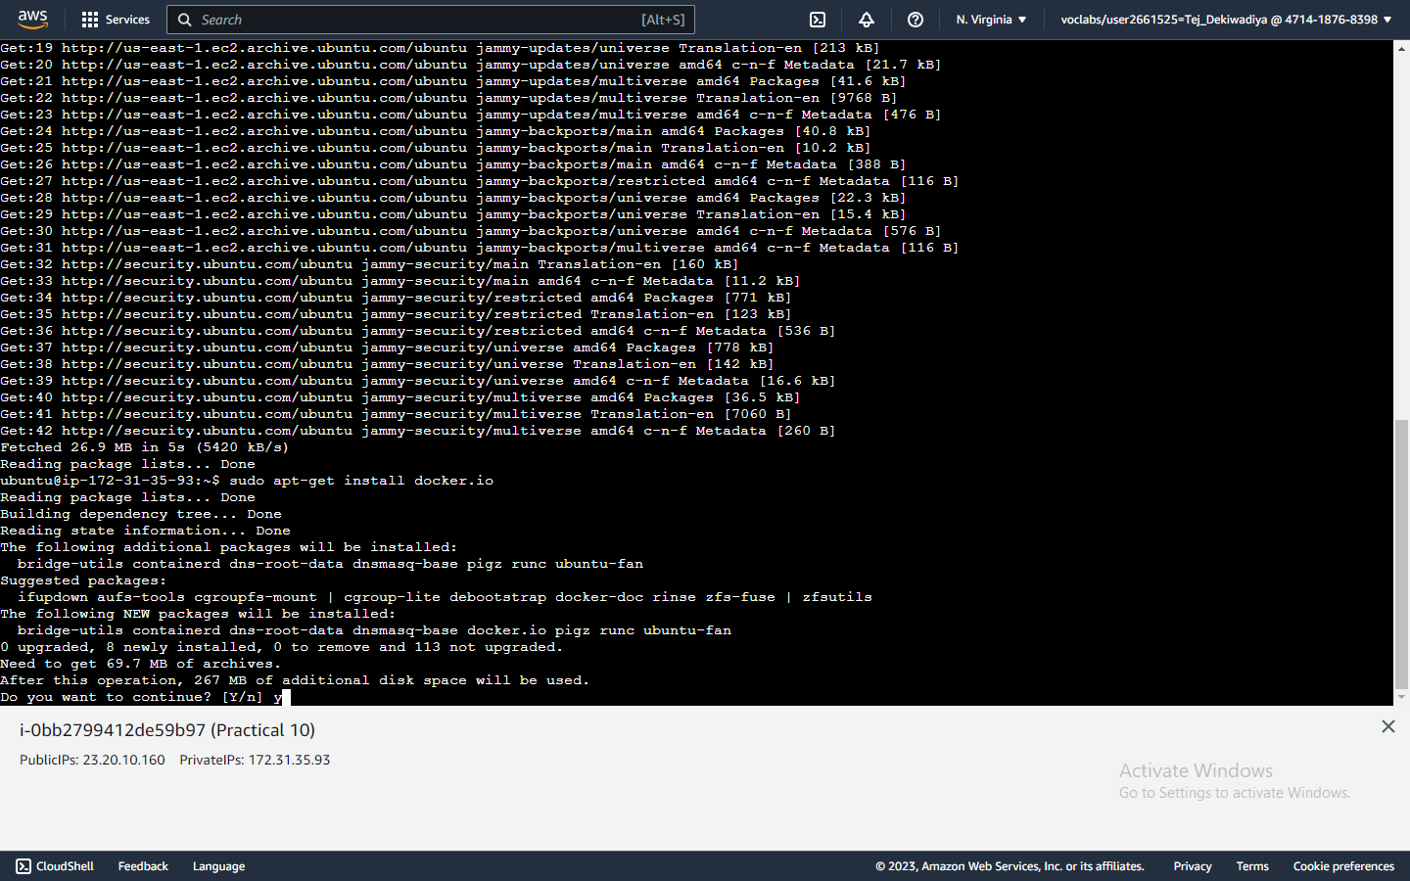**Snapshot :**

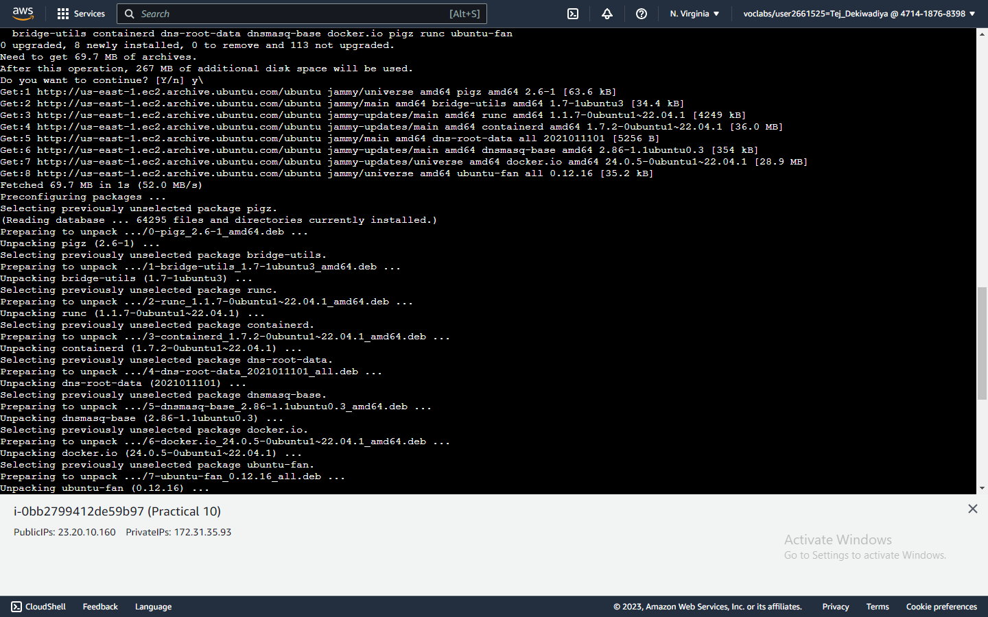

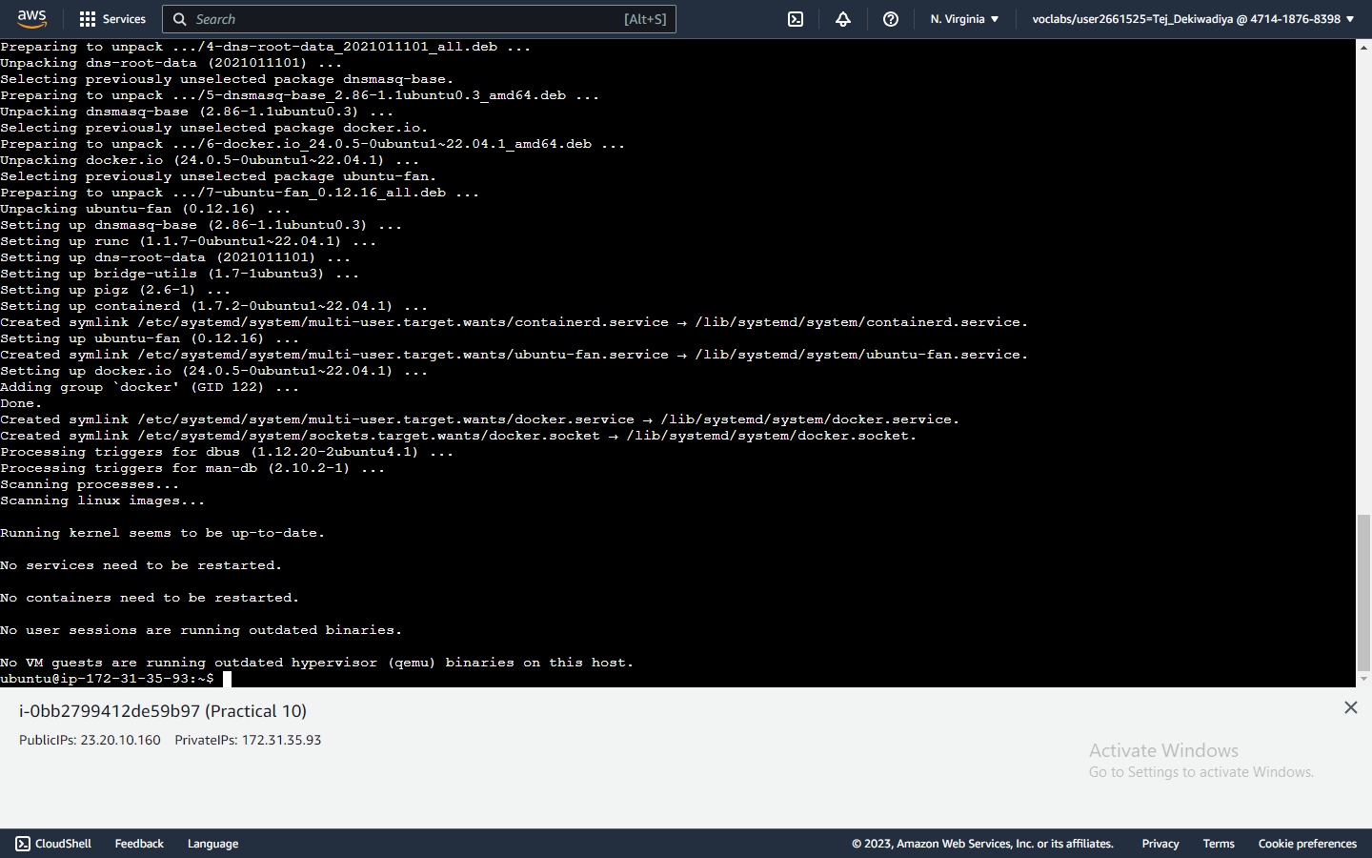

**Step 06 :** Run command - sudo docker version.

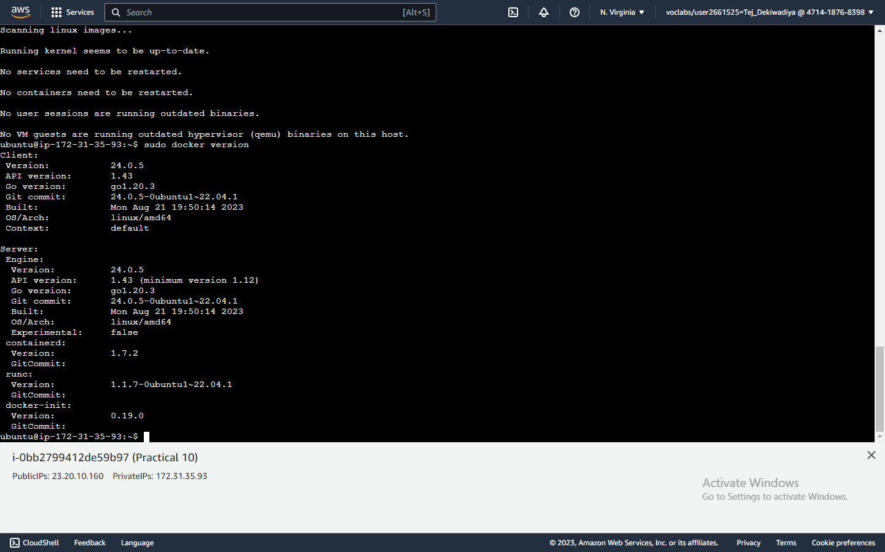**Snapshot :**

**Step 07 :** Run command - sudo apt install docker-compose

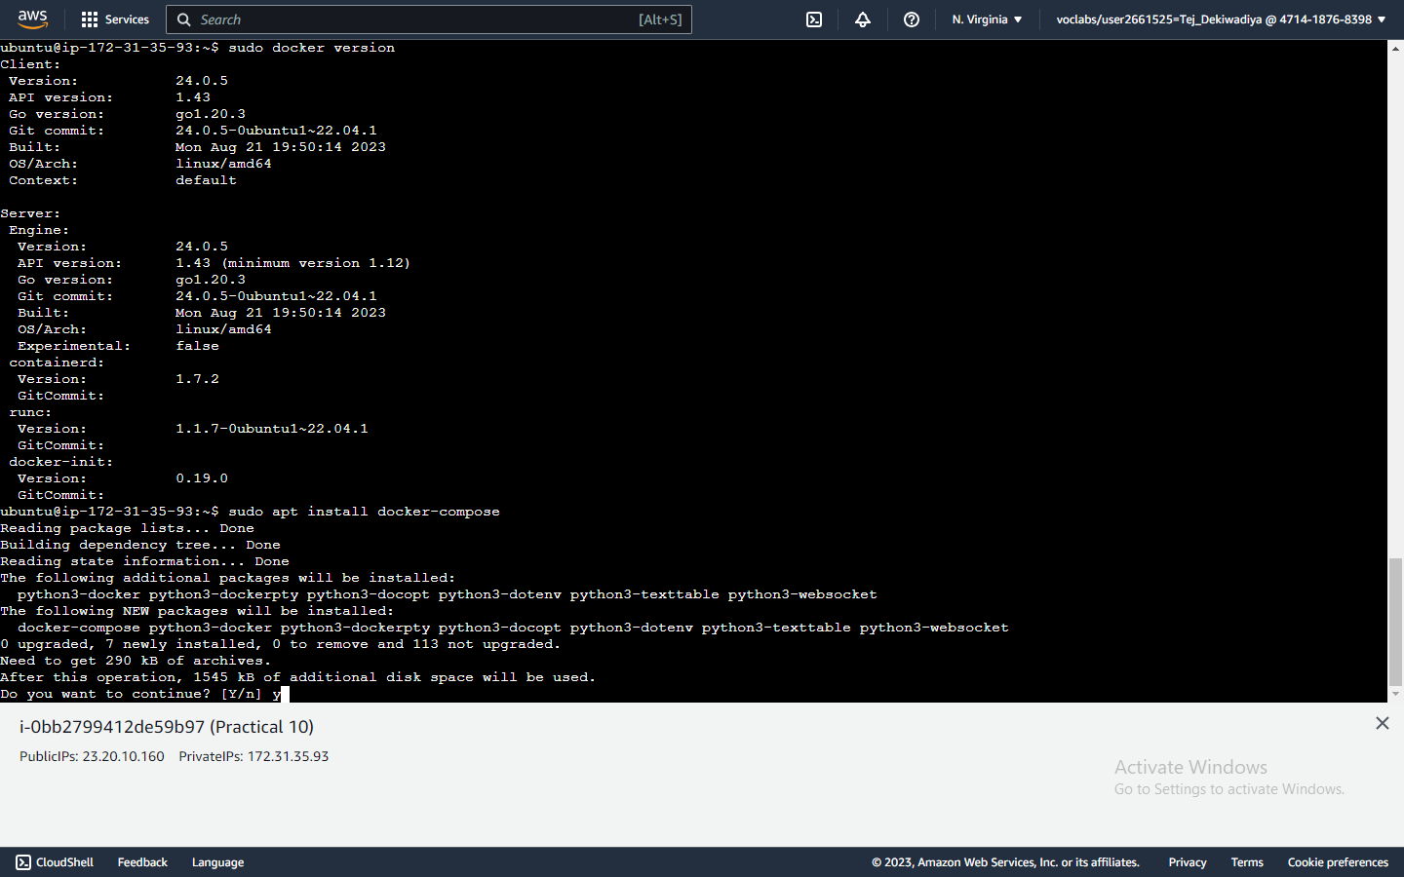**Snapshot :**

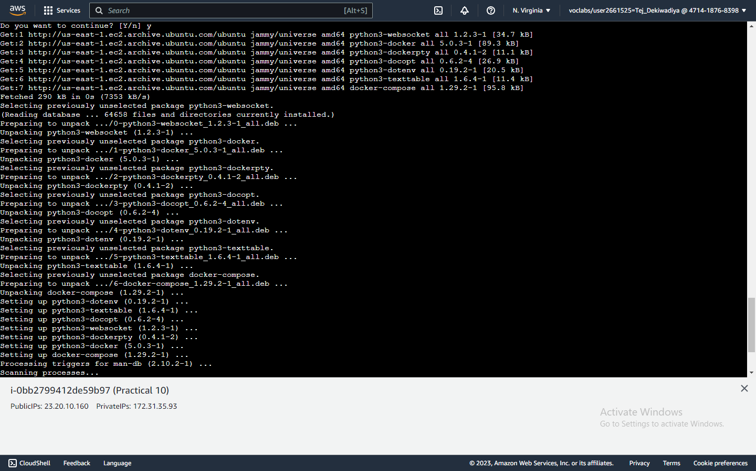

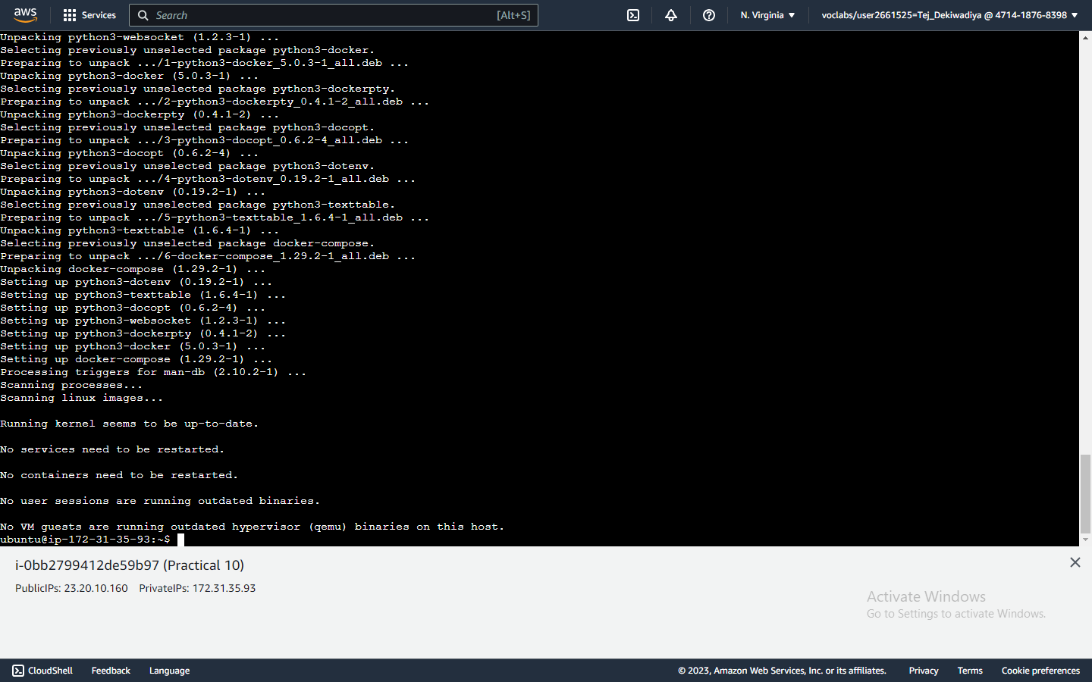

**Step 08 :** Run command – sudo docker-compose –version.

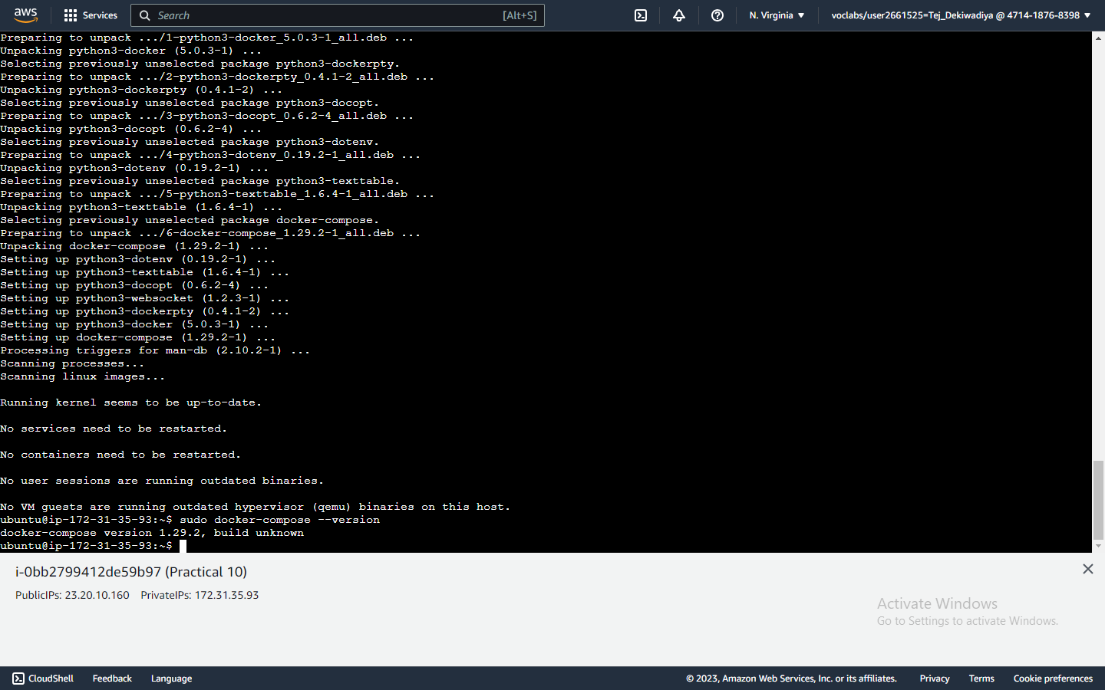**Snapshot :**

**Step 09 :** Run command – mkdir WordPress

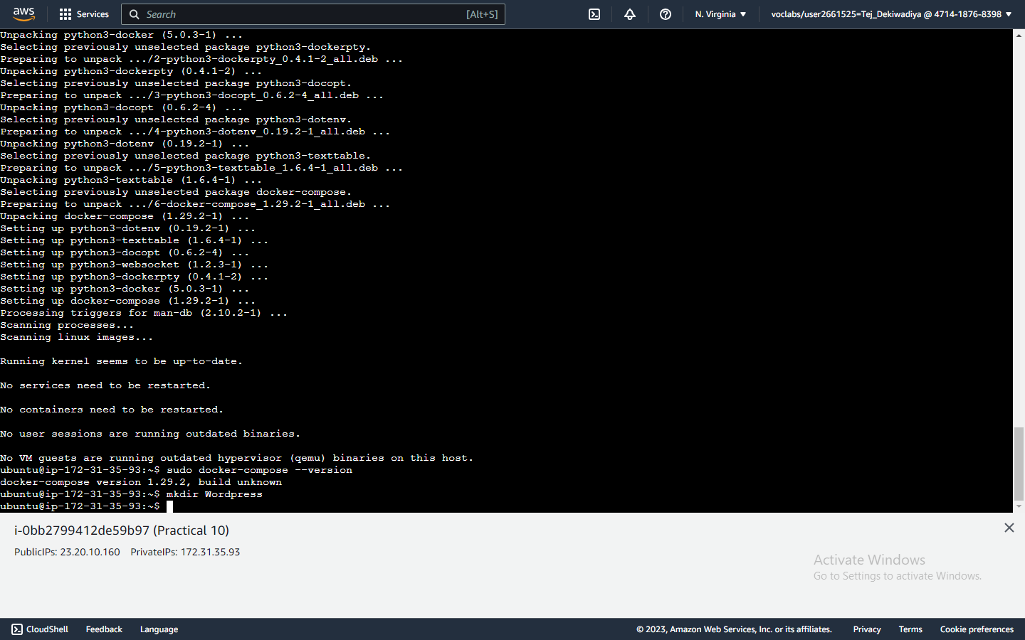**Snapshot :**

**Step 10 :** Run command – cd WordPress

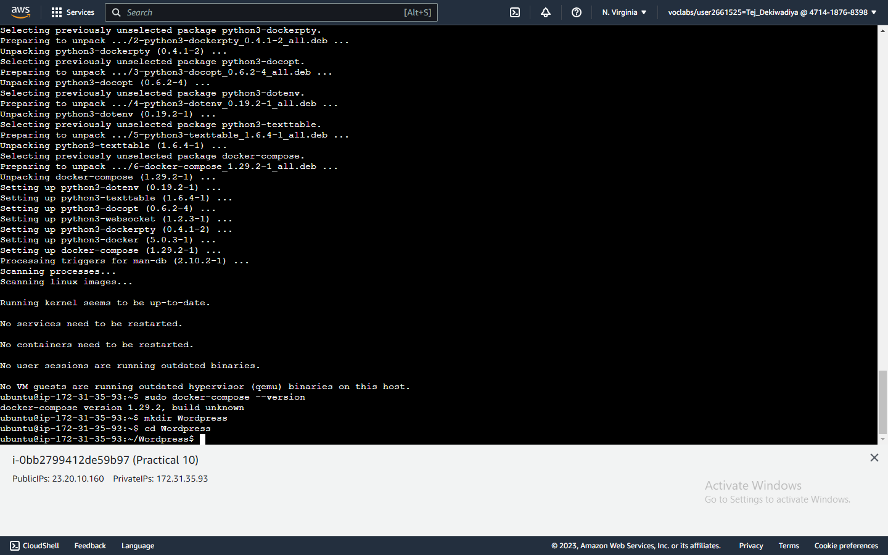**Snapshot :**

**Step 11 :** Run command – nano docker-compose.yml to create a new yml file

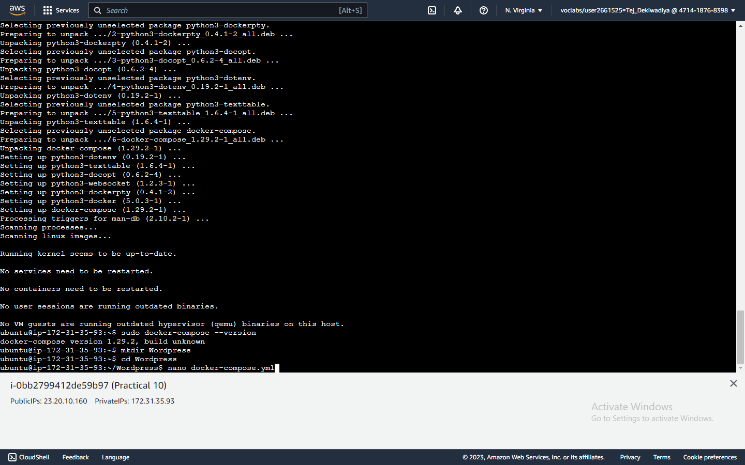**Snapshot :**

**Step 12 :** Inside file write down code that redirects to Wordpress Website

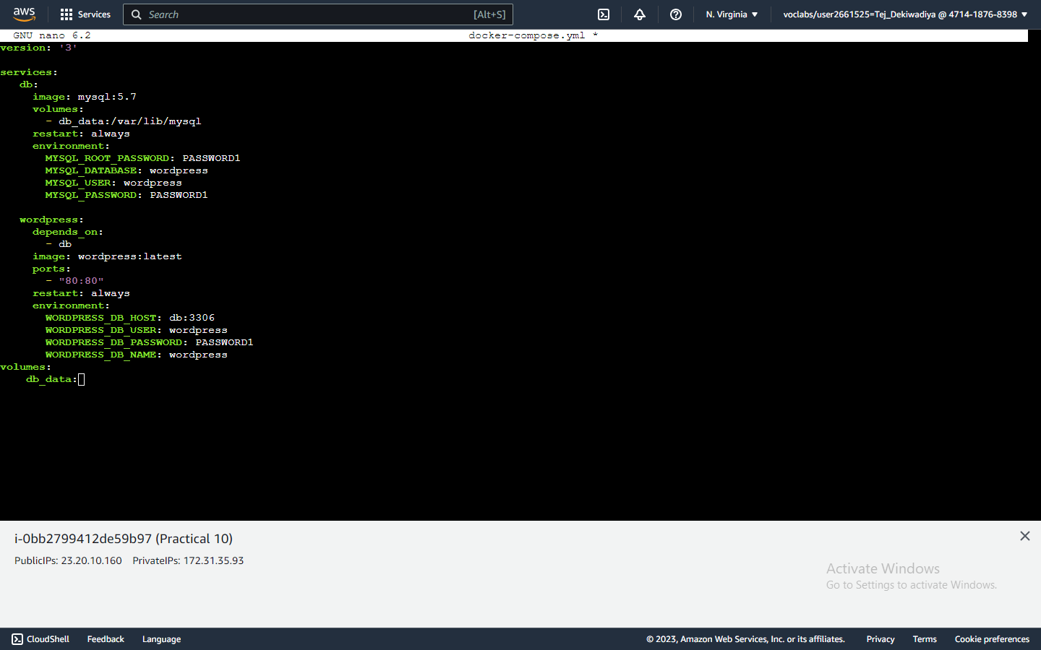**Snapshot :**

**Step 13 :** Run command – sudo docker-compose up -d.

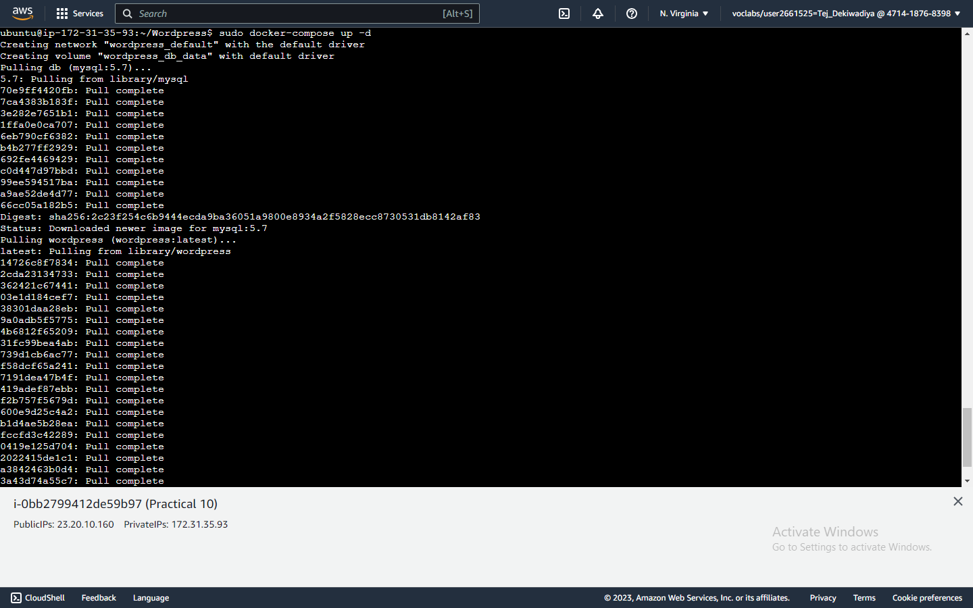**Snapshot :**

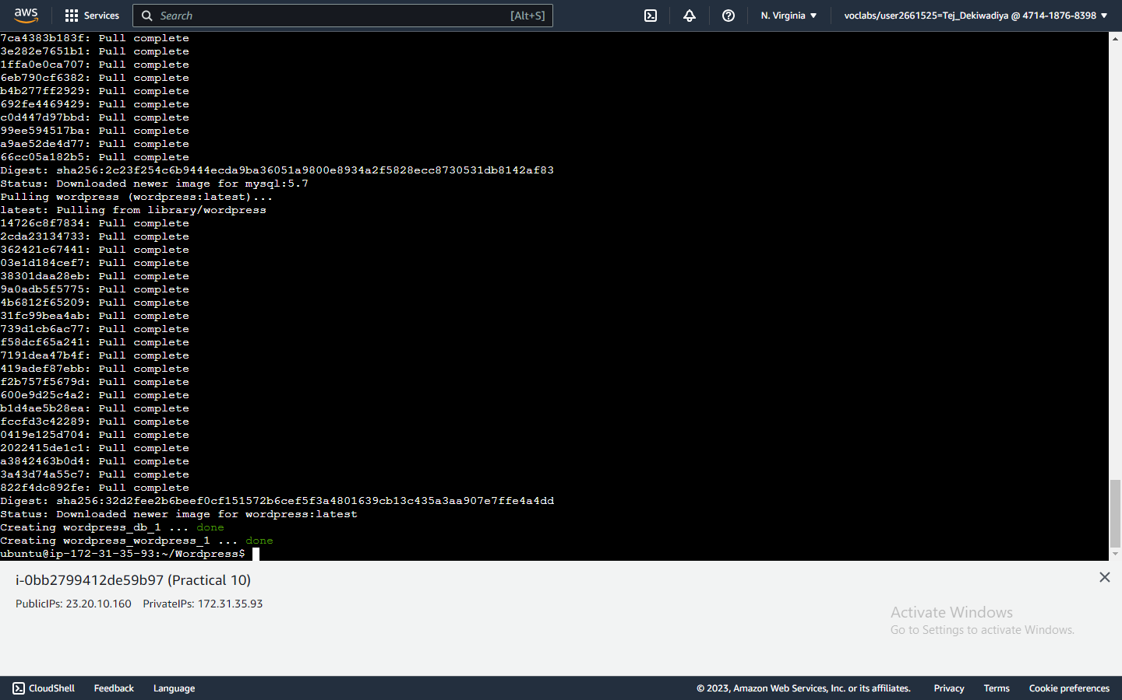

**Step 14 :** Copy the public IP address.

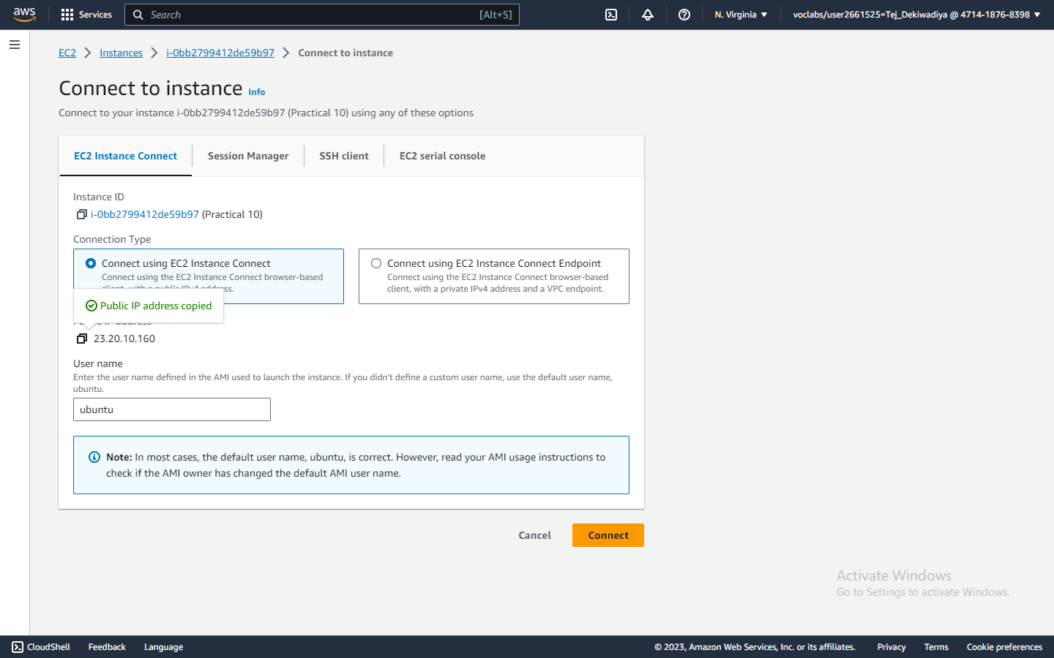**Snapshot :**

**Step 15 :** Paste the public IP address in a new tab. And click on continue.

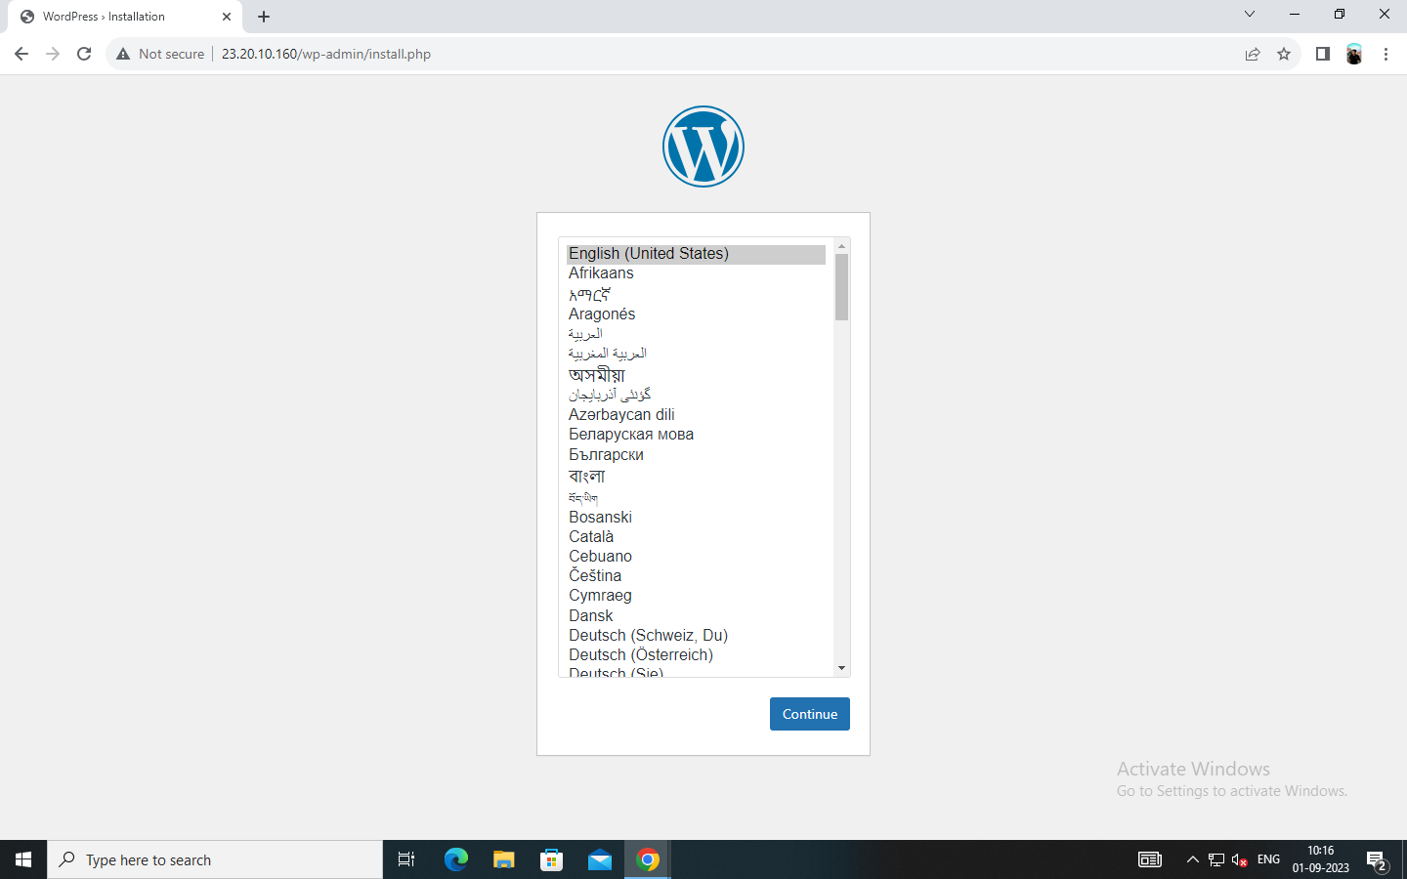**Snapshot :**

**Step 16 :** Fill the details to create an a account in WordPress. And click on ‘Install WordPress’.

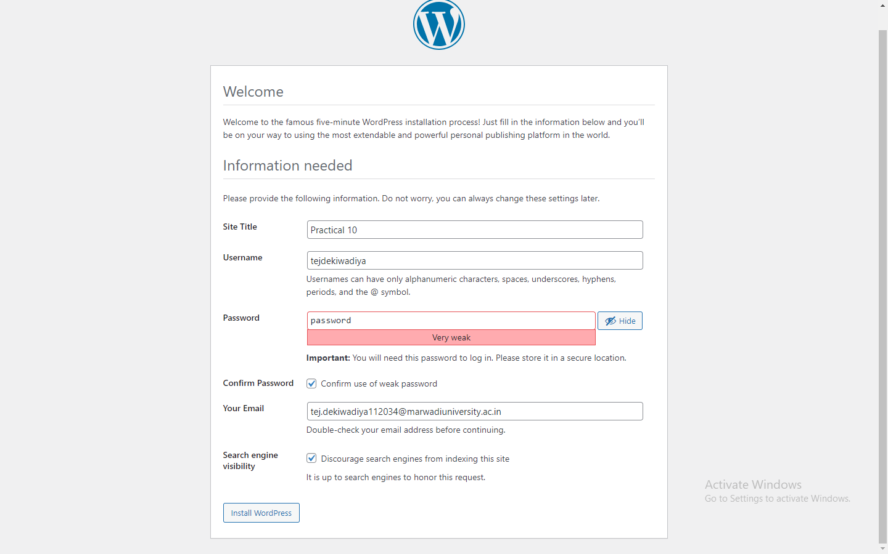**Snapshot :**

**Step 17 :** Log In to WordPress.

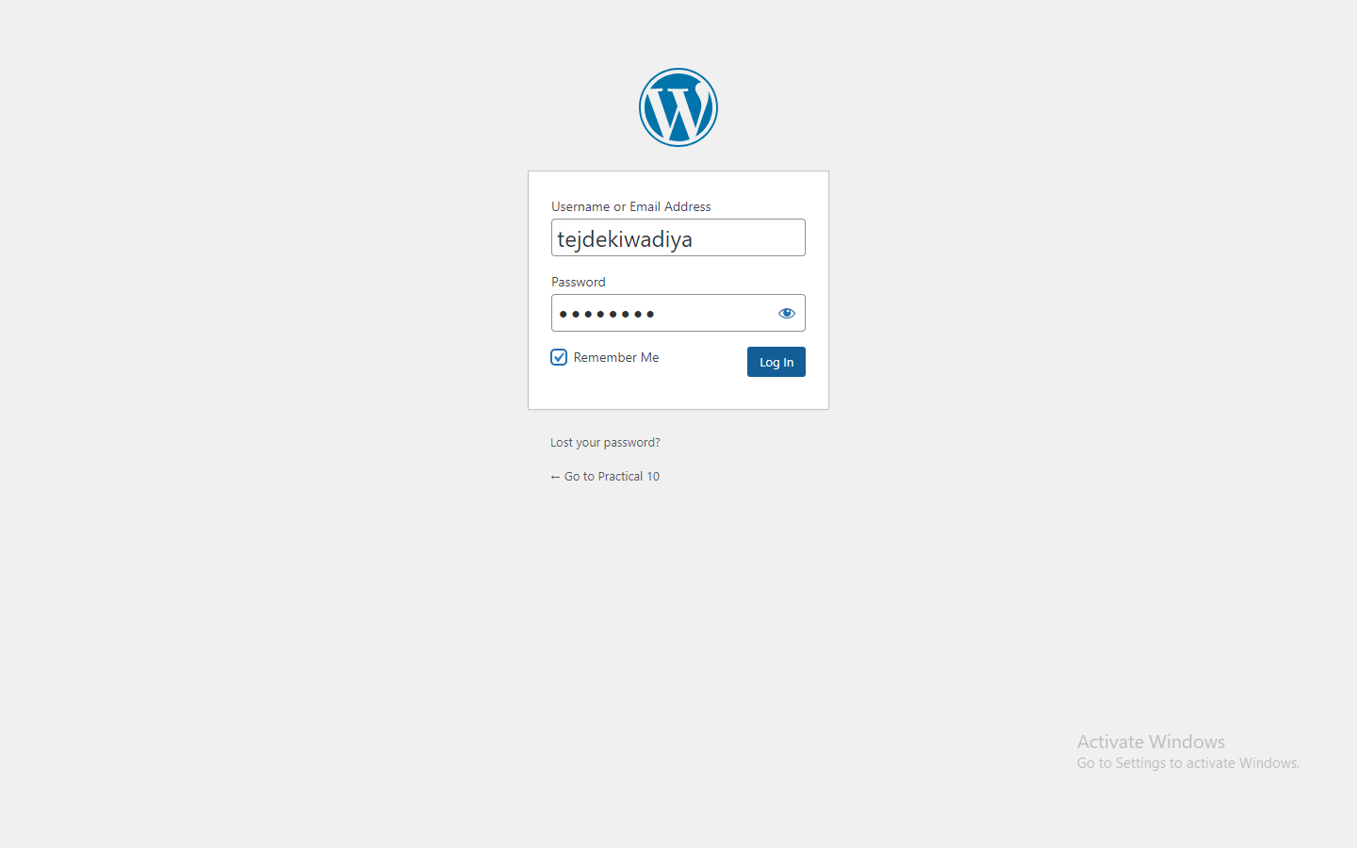**Snapshot :**

**Step 18 :** Now go to Appearance >> Themes.

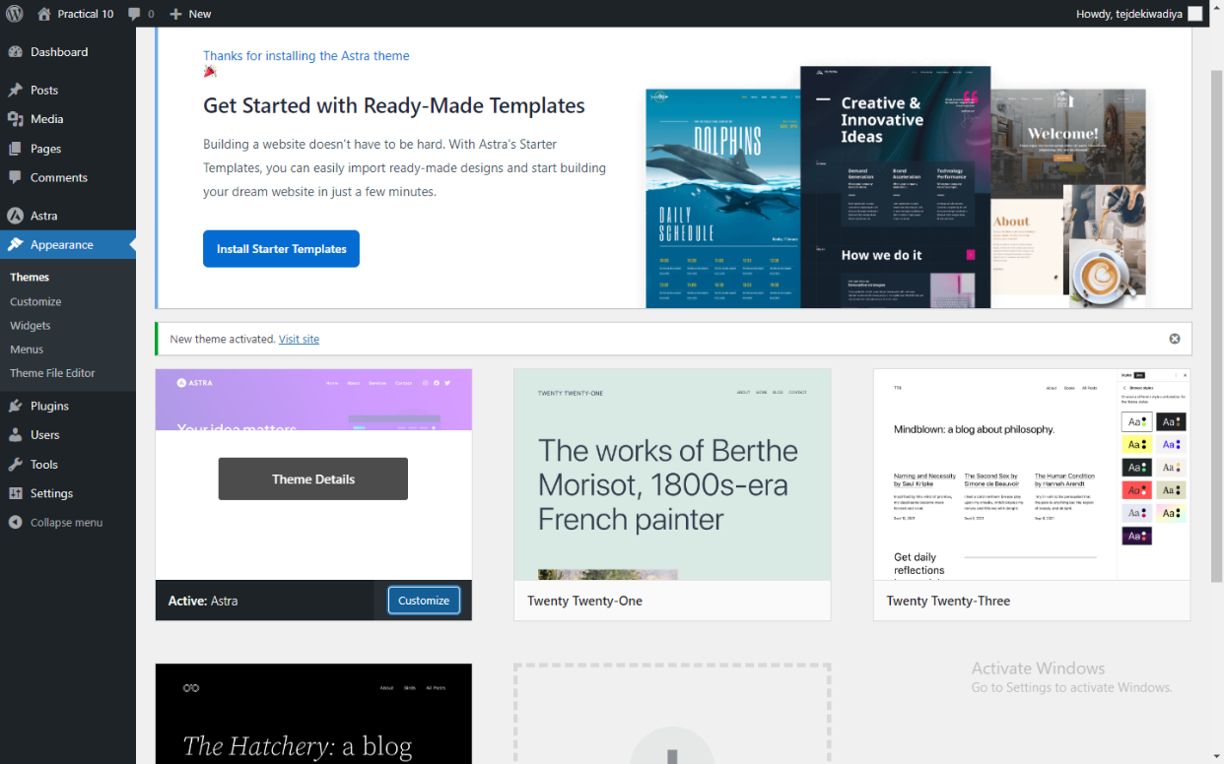**Snapshot :**

**Step 19 :** Edit Template and Publish it.

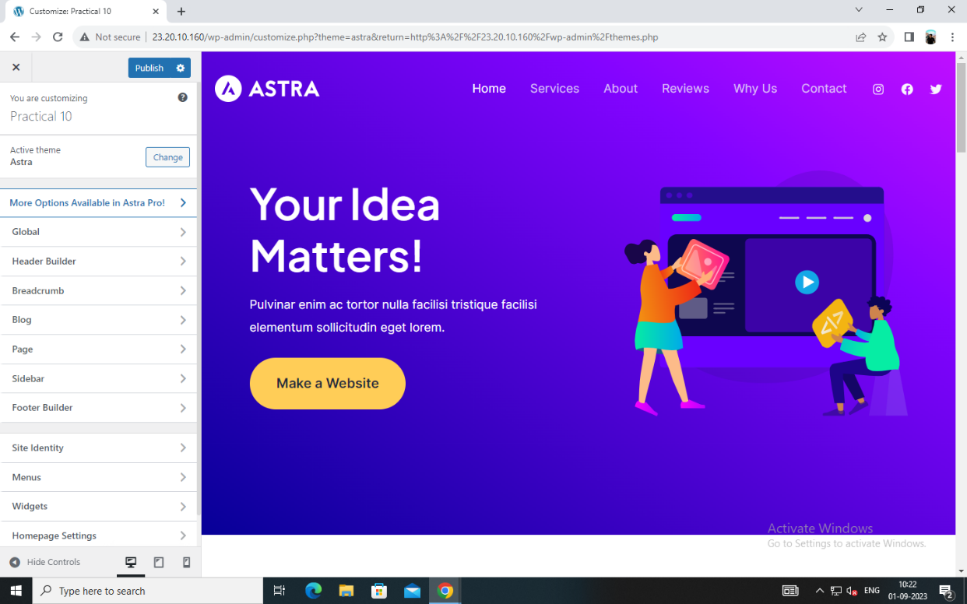**Snapshot :**

**Step 20 :** Go to to settings and copy Site Address(URL)

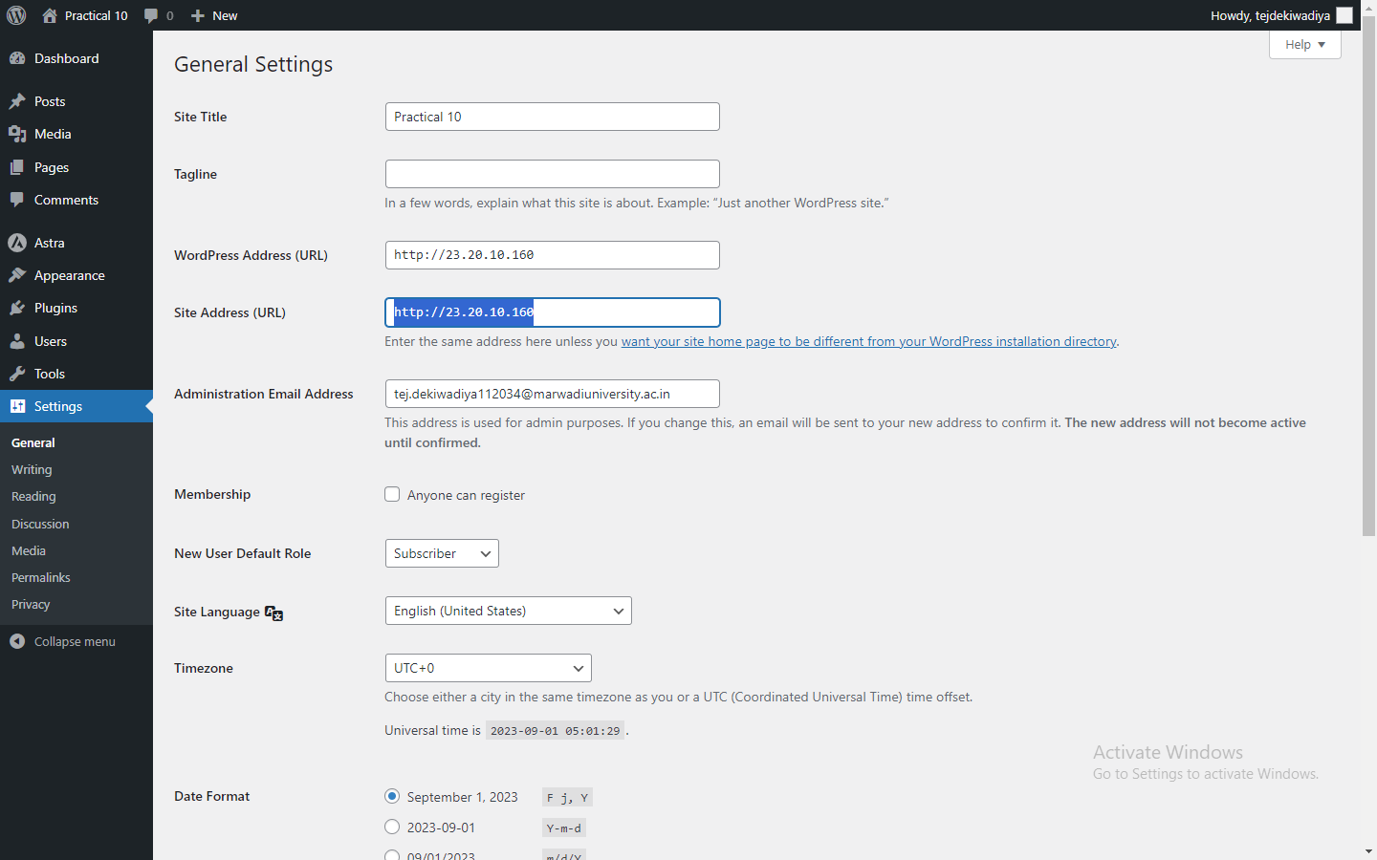**Snapshot :**

**Step 21 :** Paste the Site Address (URL) in a new tab.

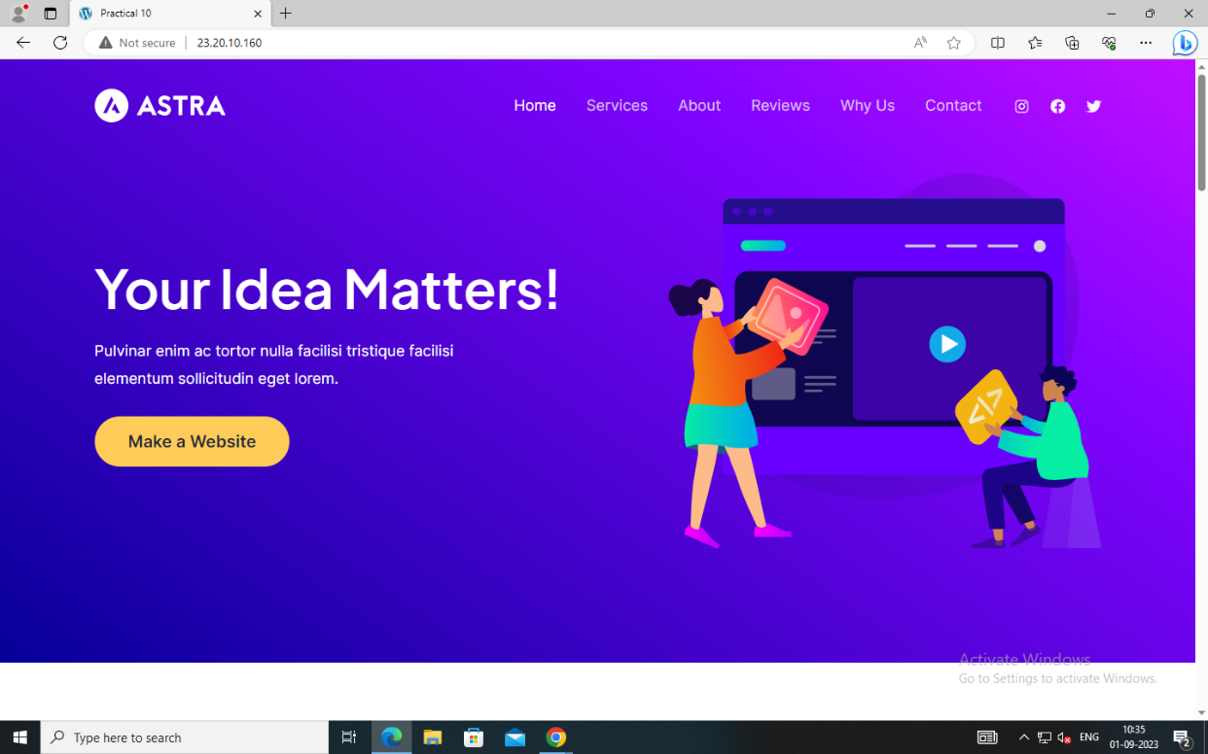**Snapshot :**

**Practical 11 : Study on Hadoop Framework**

**Step 01 :** Create an Instance in EC2. Go to Instance ID.

**Snapshot :**

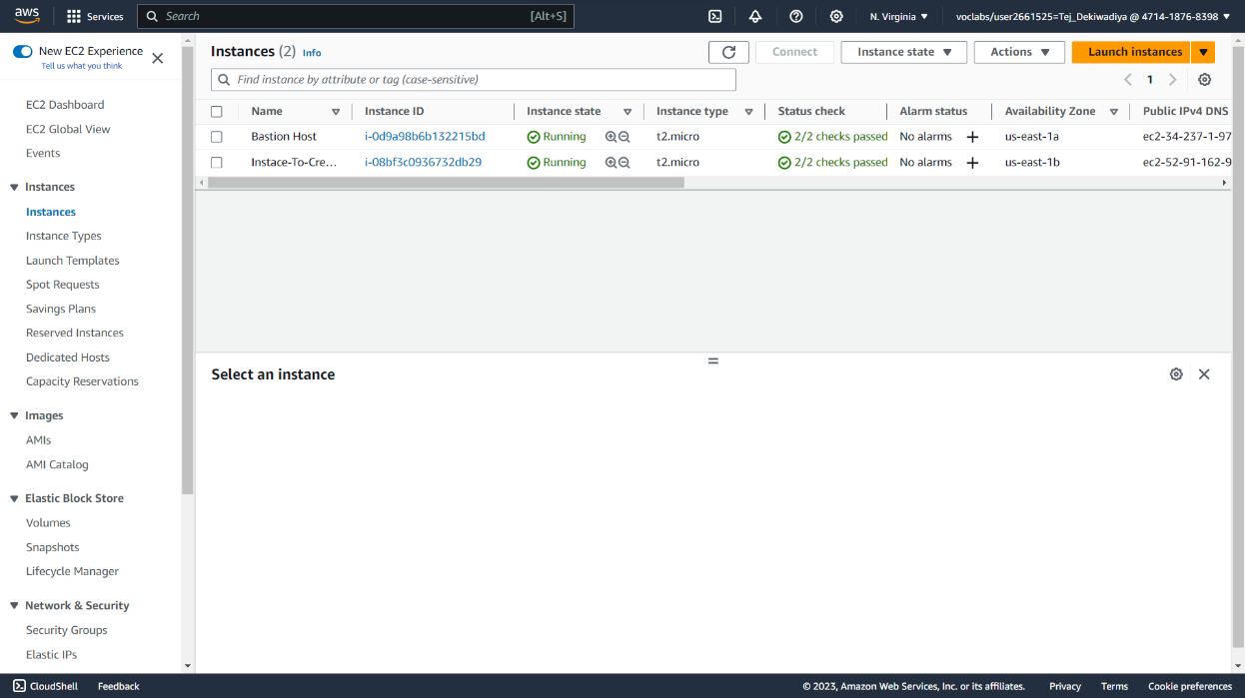

**Step 02 :** Click on Connect.

**Snapshot :**

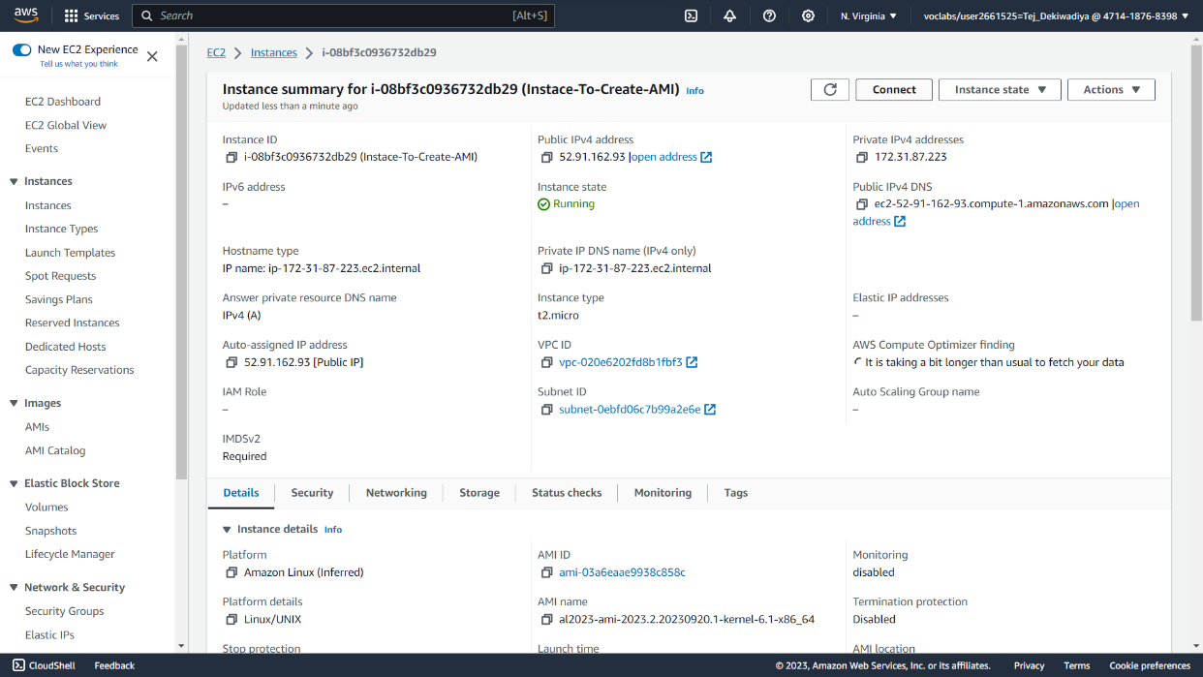

**Step 03 :** Click on Connect.

**Snapshot :**

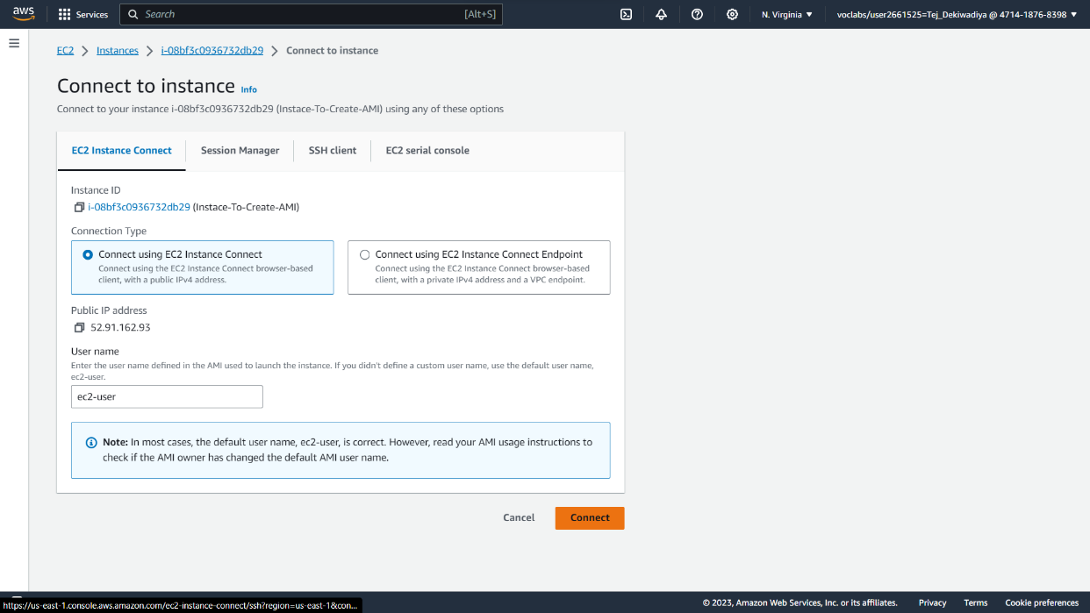

**Step 04 :** An Instance in EC2 is created.

**Snapshot :**

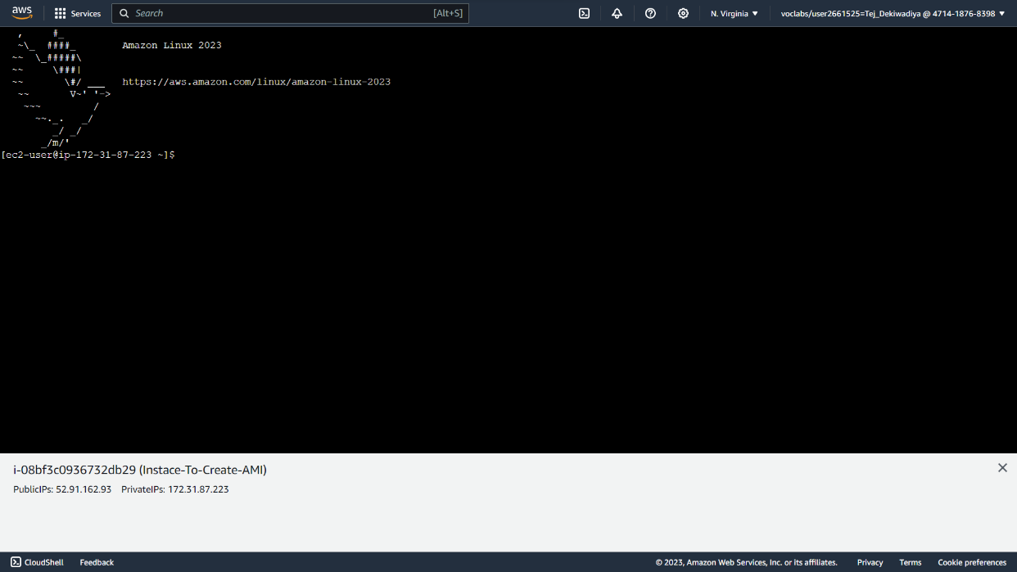

**Step 05 :**Run command ‘sudo su -’.

**Snapshot :**

**Step 06 :** Run command ‘yum update -y’.

**Snapshot :**

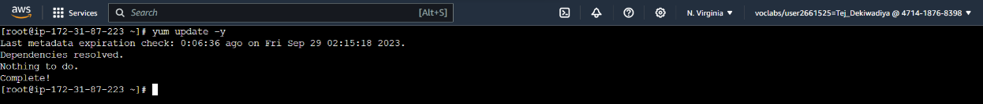

**Step 07 :** Run command ‘yum install nginx -y’.

**Snapshot :**

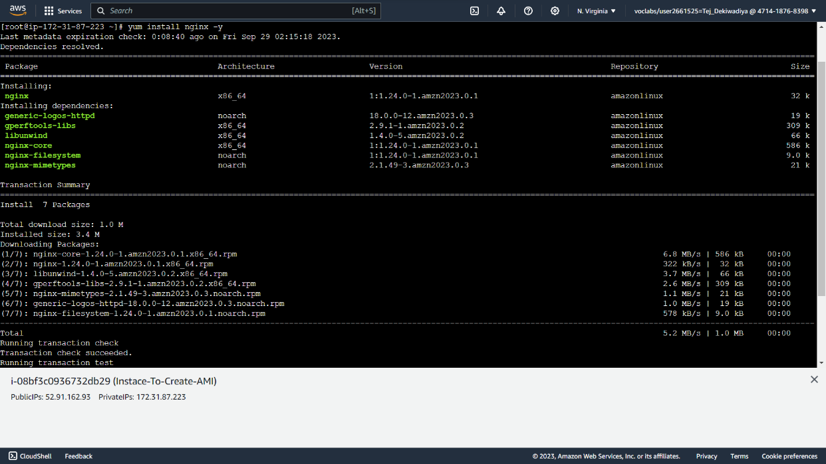

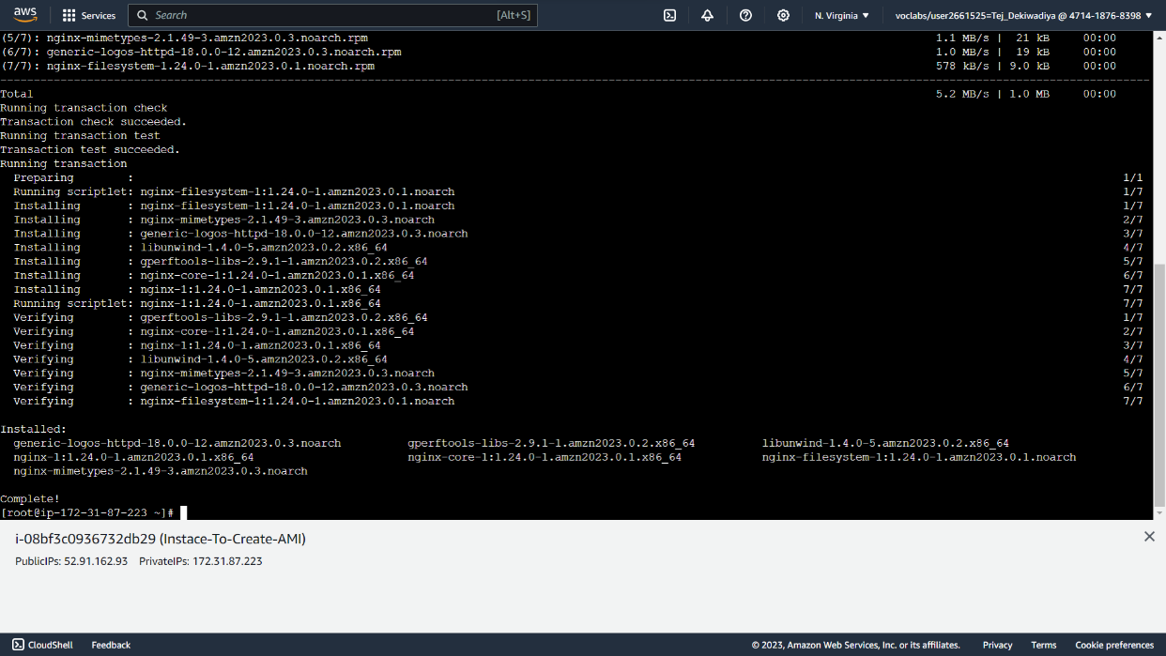

**Step 08 :** Run command ‘sudo service nginx start’.

**Snapshot :**



**Step 09 :** Run command ‘systemctl start nginx.service’.

**Snapshot :**

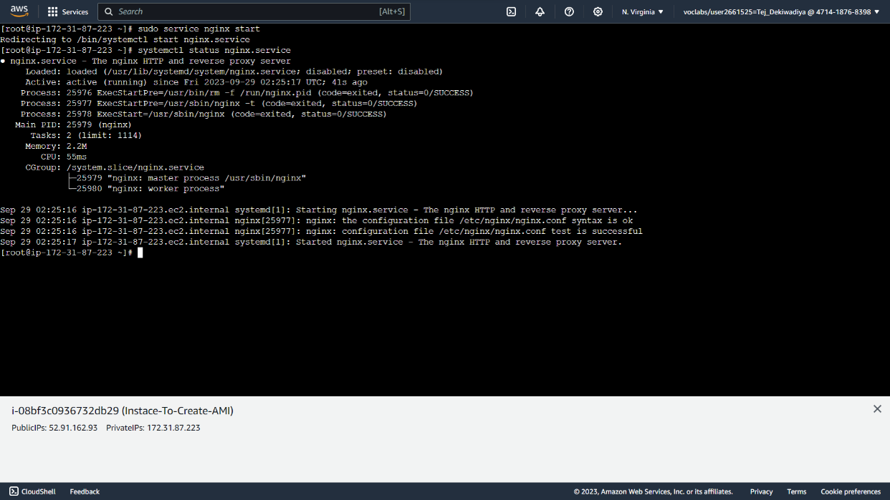

**Step 10 :** Go to Instances >> Actions >> Image and Templates >> Create image.

**Snapshot :**

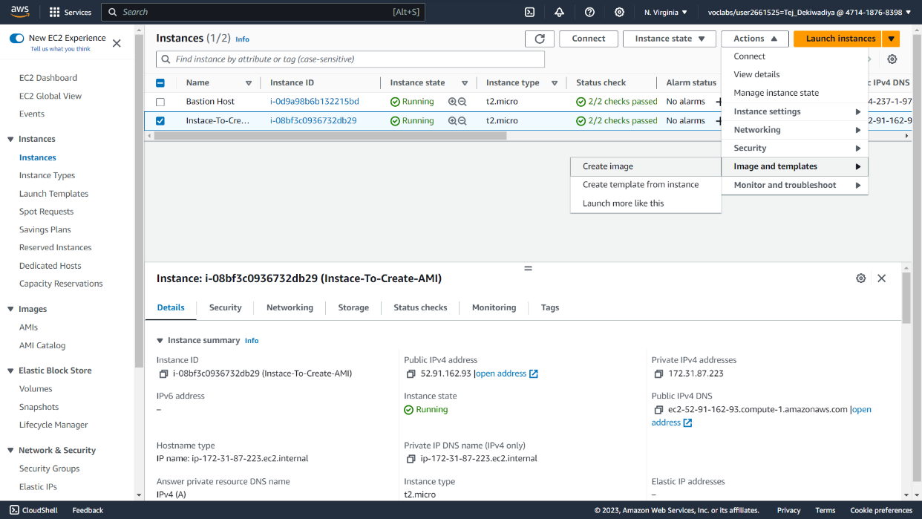

**Step 11 :** Create image.

**Snapshot :**

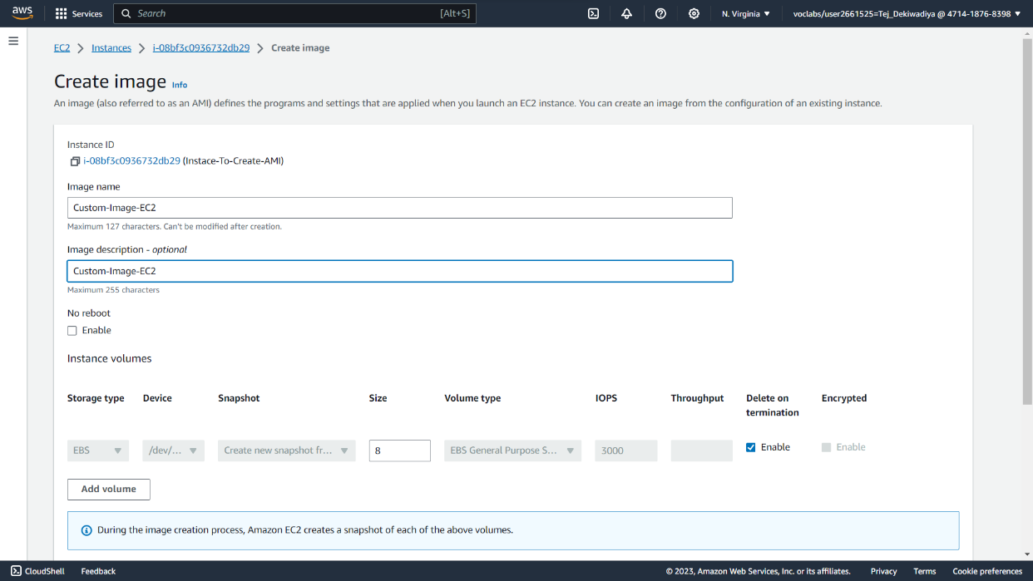

**Step 12 :** Select ‘Tag image and snapshots together.’ And click on Create image.

**Snapshot :**

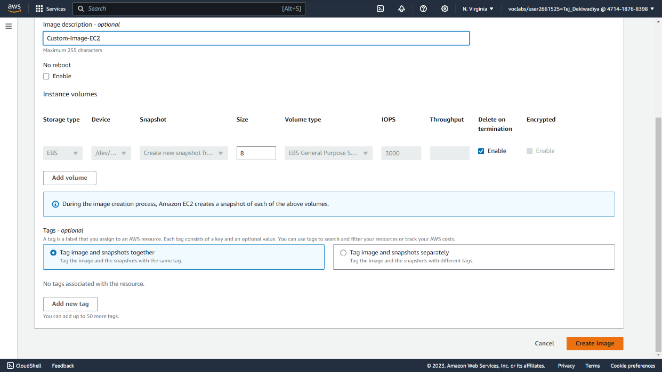

**Step 13 :** AMI created.

**Snapshot :**

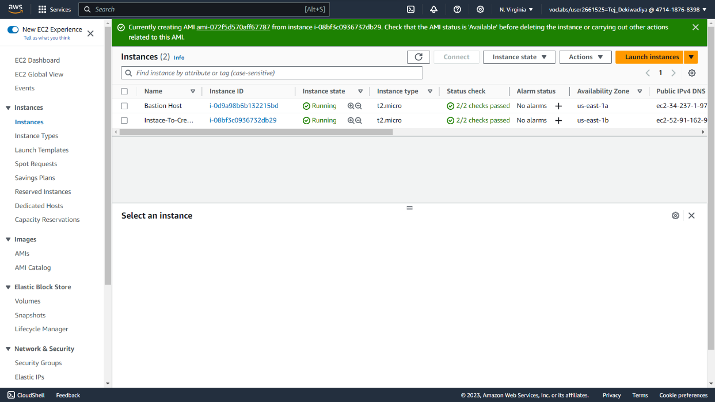

**Step 14 :** Go to Images >> AMIs >> AMI ID

**Snapshot :**

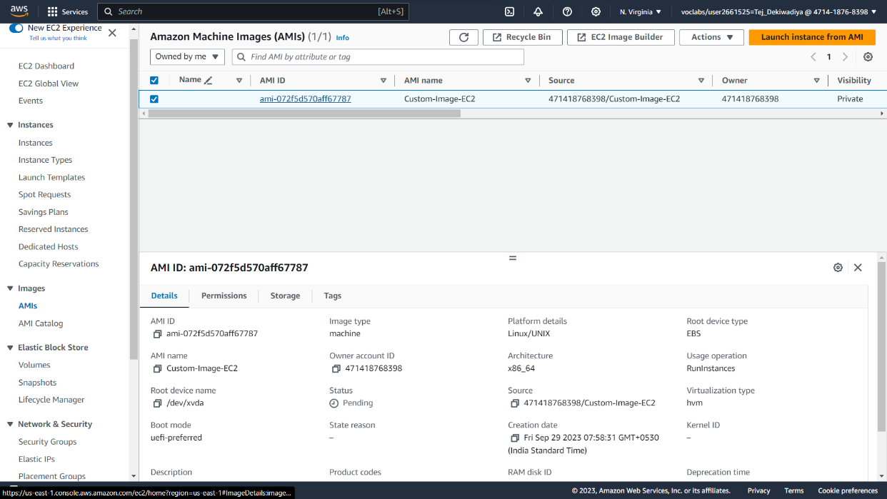

**Step 15 :** Launch instance from AMI. Create 3 Instances.

**Snapshot :**

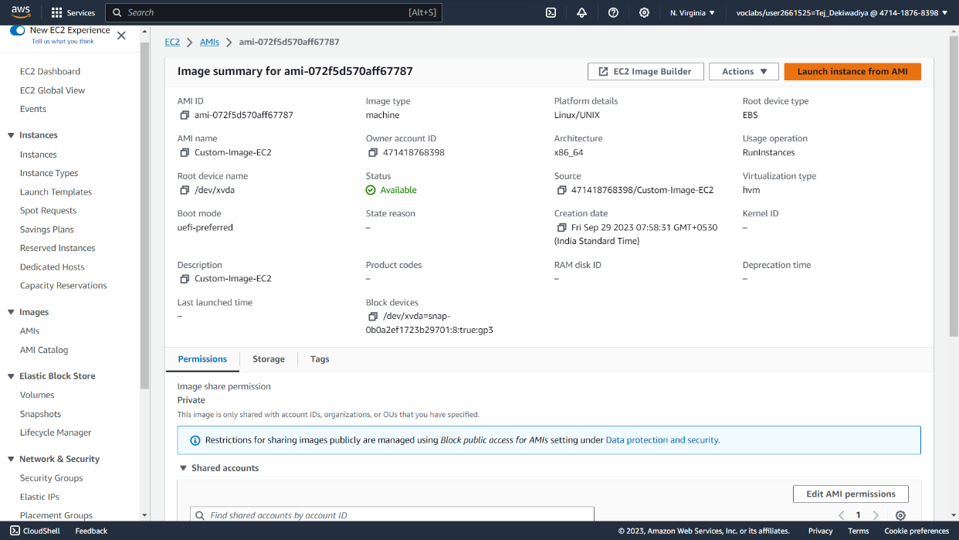

**Step 16 :** Instances created.

**Snapshot :**

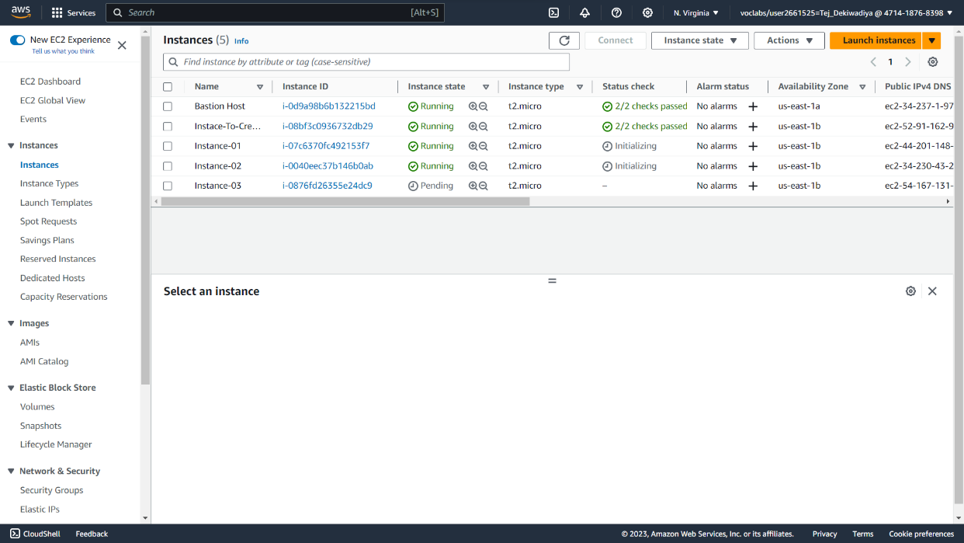

**Step 17 :** Connect Instance 1.

**Snapshot :**

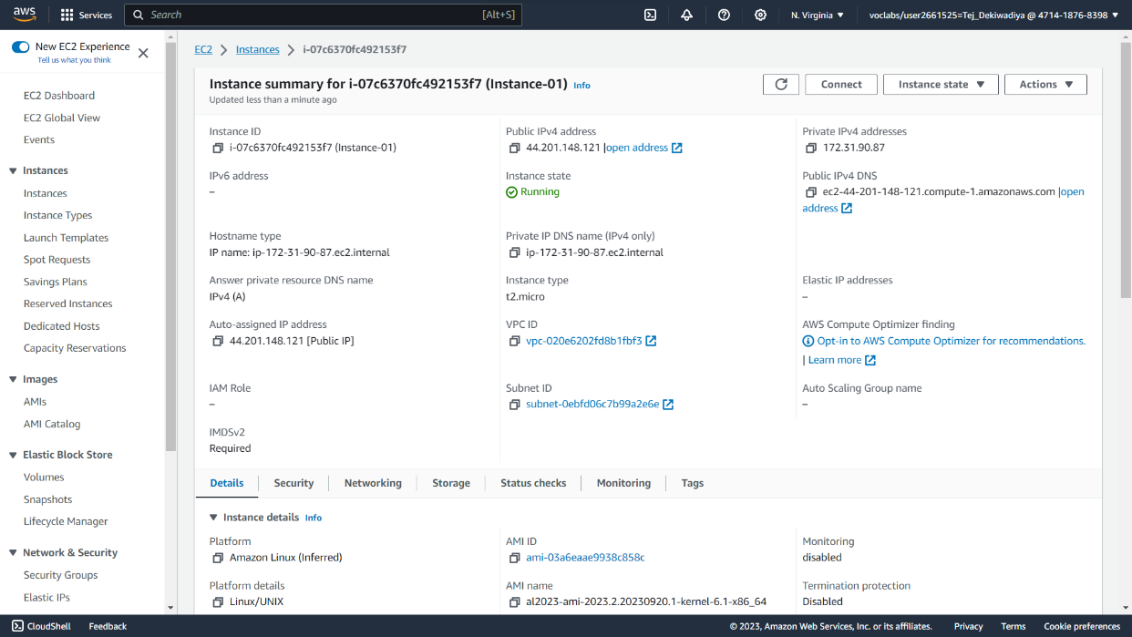

**Step 18 :** Connect.

**Snapshot :**

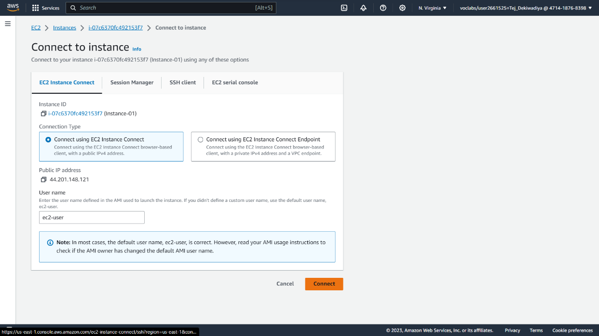

**Step 19 :** Copy IPv4 address.

**Snapshot :**

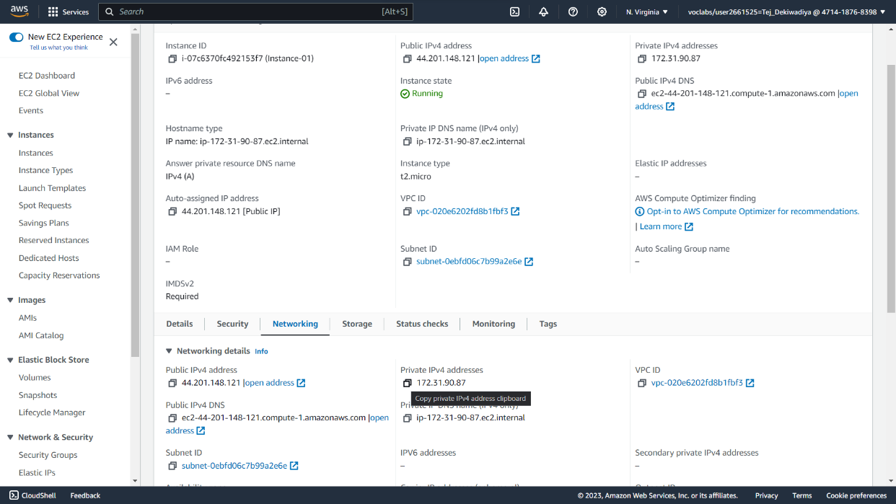

**Step 20 :** Run ping command Instance 1

**Snapshot :**

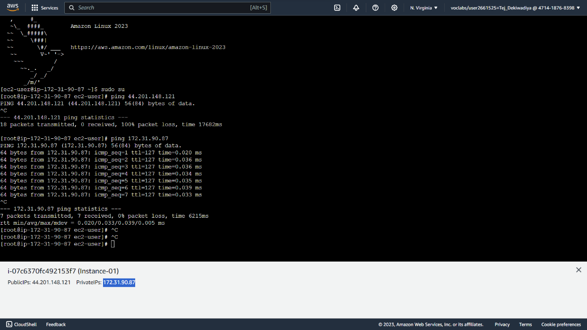

**Step 21 :** Run ping command in Instance 2

**Snapshot :**

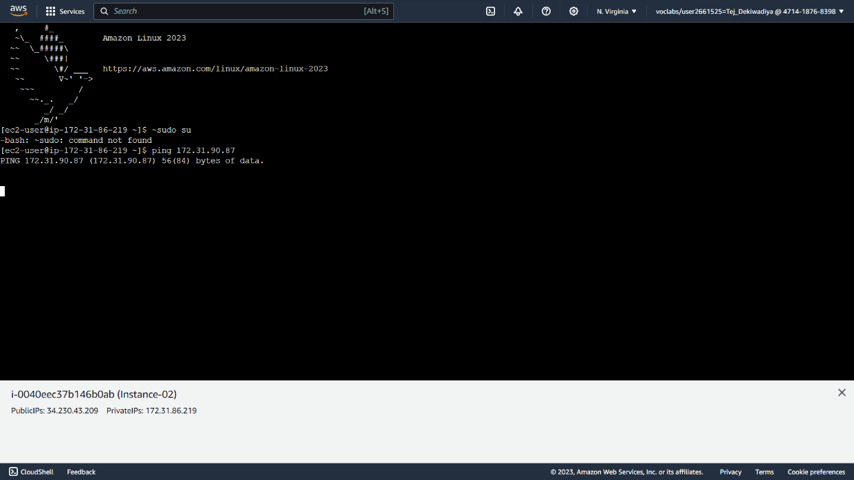

**Practical 12 : Using Auto Scaling with AWS Lambda and Lifecycle Hooks**

**Step 01 :** Search Lambda in service section

**Snapshot :**

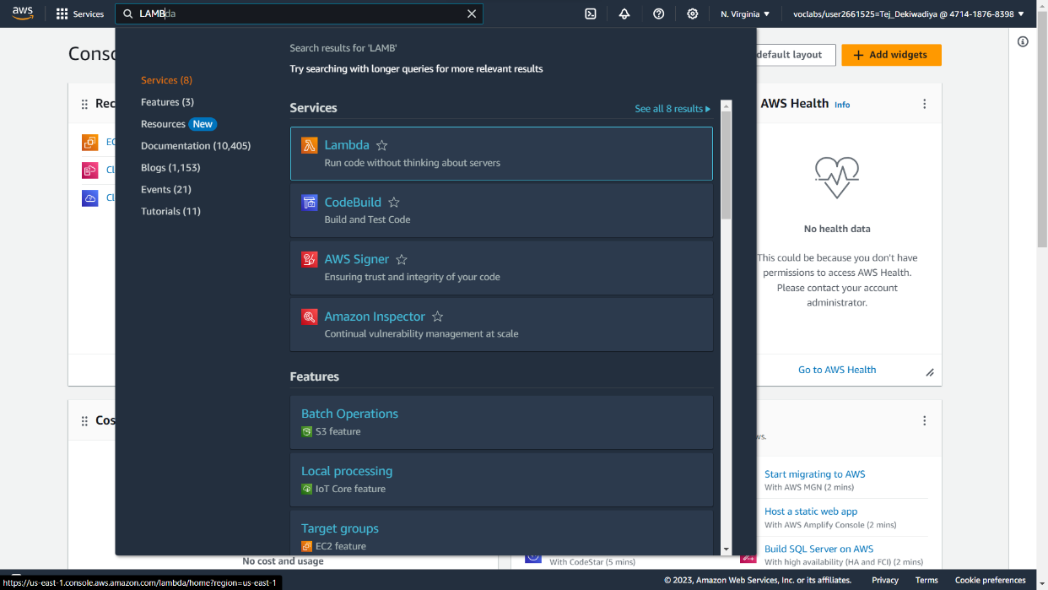

**Step 02 :** Click on create function

**Snapshot :**

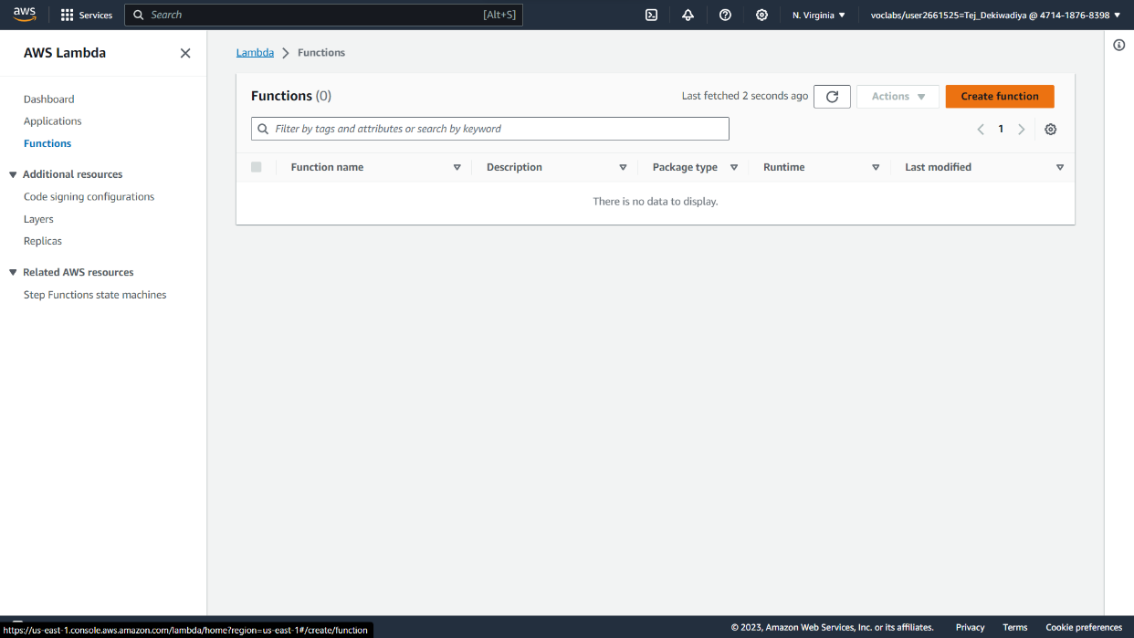

**Step 03 :** Create a function using Lambda service

**Snapshot :**

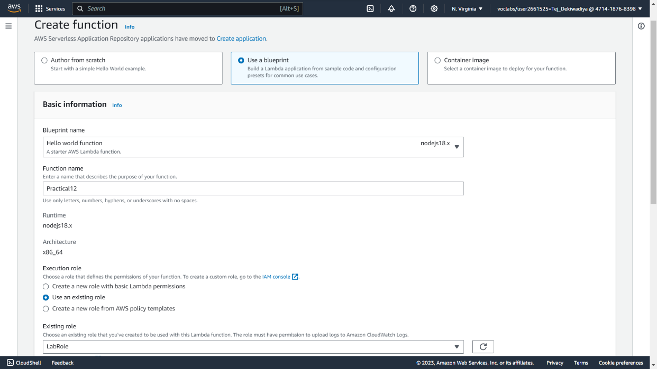

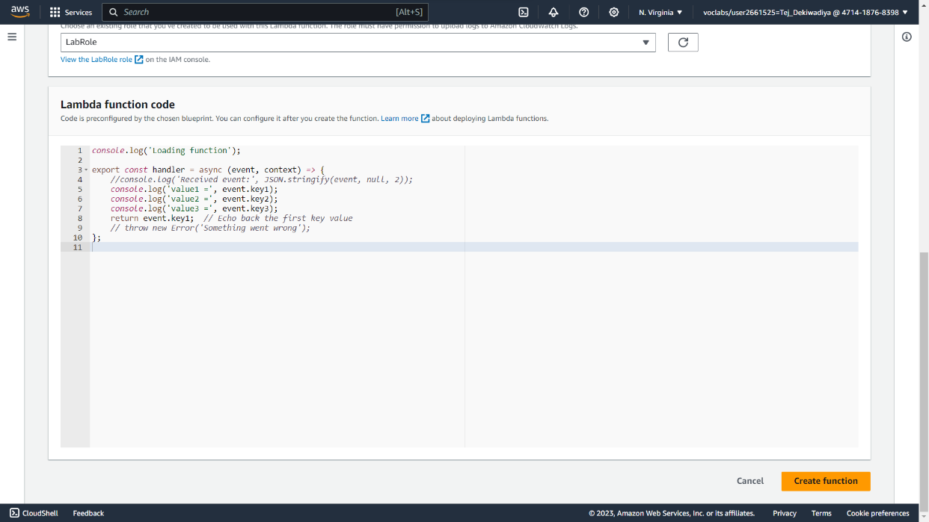

**Step 04 :** Test >> Configure Test Event

**Snapshot :**

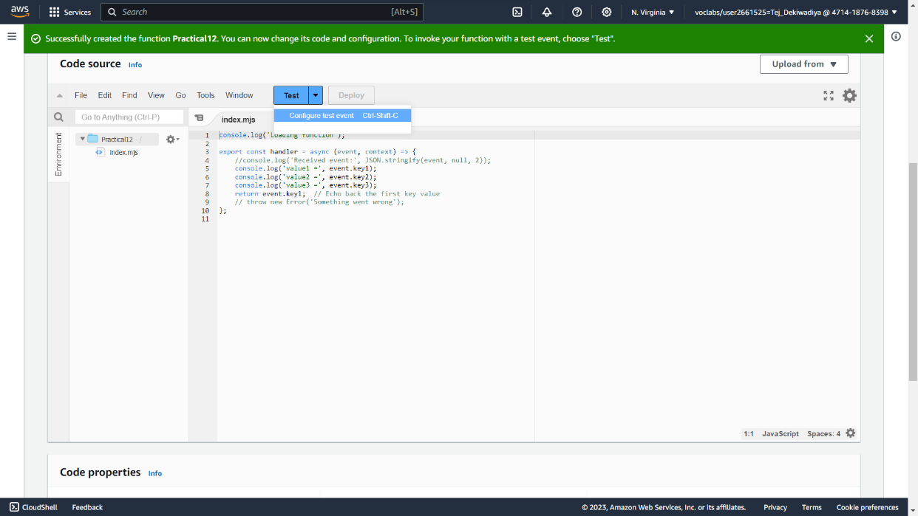

**Step 05 :** Create a Configure Test Event

**Snapshot :**

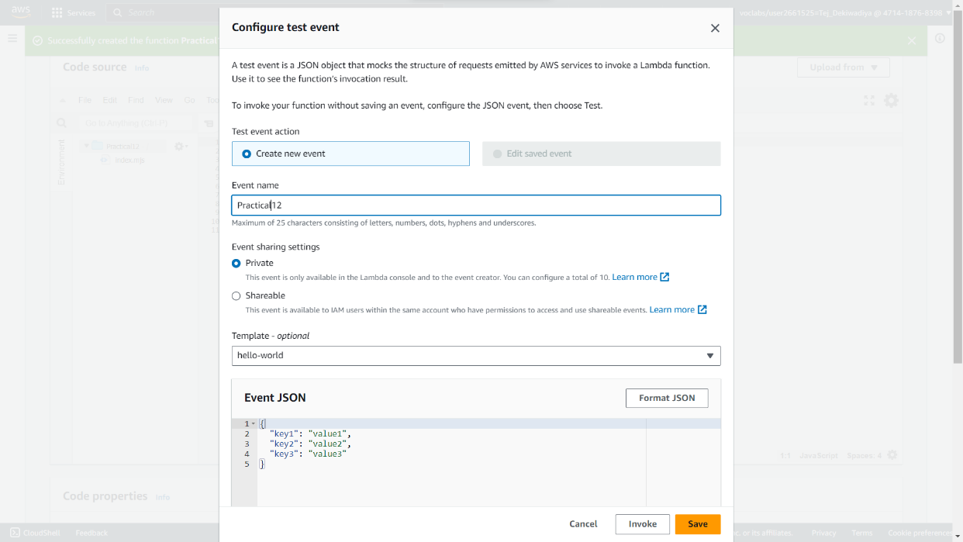

**Step 06 :** Click on Test to check config.

**Snapshot :**



